Figure S1 Identification of sequences shared by multiple genes to form a library of nucleotide- and peptide-based tools capable of simultaneously targeting key cancer pathways or other diseases with a strong genetic background. Rather than searching for conserved protein domains and functional sites using alignment algorithms, the search was performed by dividing each cDNA or protein of interest into a matrix of multiple cells of 12 nucleotides or 4 amino acids (A), respectively, and then, a script was run to search for repeated cells (B). This method increases the sensitivity of the search by removing the negative influence of non-common flanking sequences in alignment algorithms. Sequences were searched from a collection of 308 gene and 1105 peptide sequences related to cancer, and 72 gene and 344 peptide sequences related to immune disorders.

A
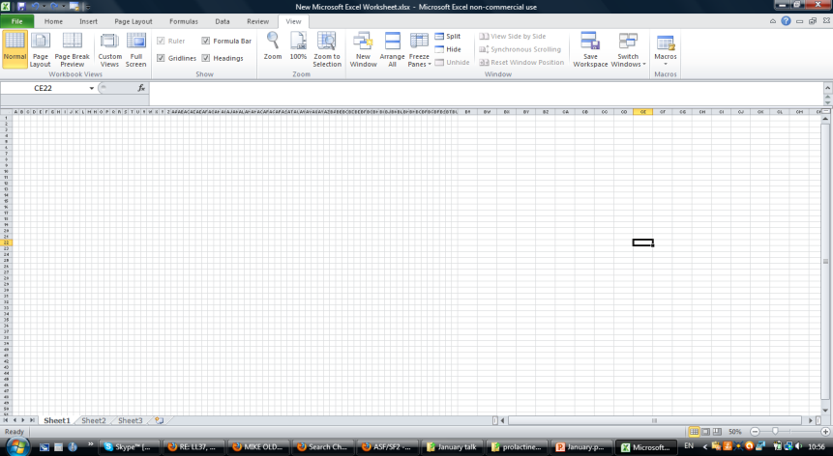
GGTTCAGCCATTGAGT
mRNA of gene #1
mRNA of gene #2


B
GGTTCAGCCATTGAGT

