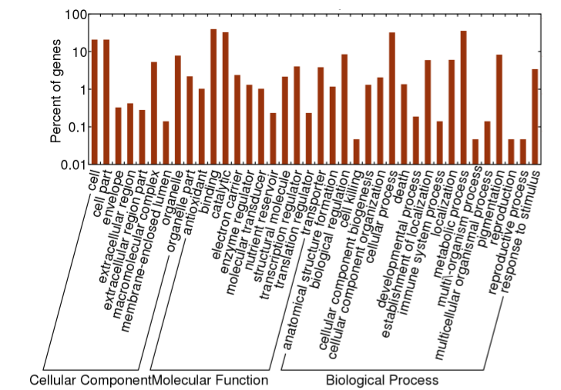

Figure S1 Gene ontology characterization of candidate genes at significant loci associated with soybean cyst nematode resistance.

