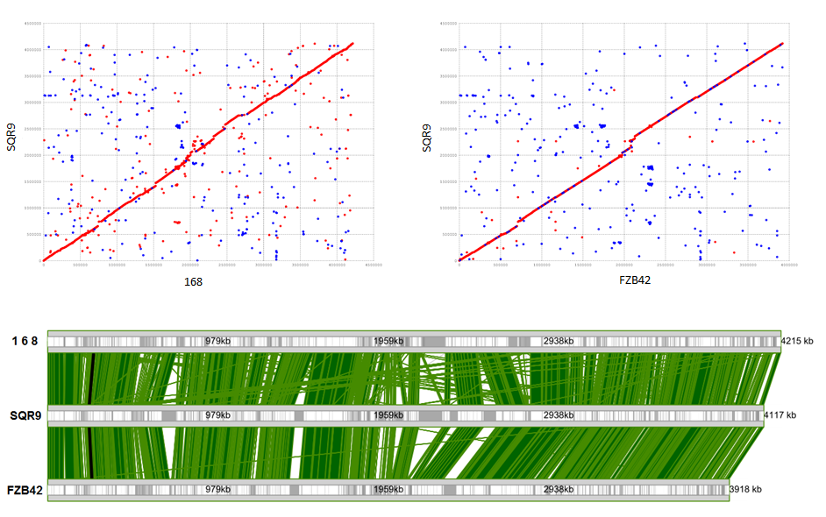
B
C
A

Figure S2 Comparison of the genomes of Bacillus amyloliquefaciens strains SQR9 and FZB42 and Bacillus subtilis 168. (A and B) Matches of the SQR9 genome with those of B. subtilis 168 (A) and B. amyloliquefaciens FZB42 (B). Synteny plots show the comparison at the nucleotide level of the B. amyloliquefaciens SQR9 genome (a and b, vertical axis) with the genomes of B. subtilis 168 (A, horizontal axis) and B. amyloliquefaciens FZB42 (B, horizontal axis). Forward matches are plotted in red and reverse matches in blue. (C) Global alignment of the three strains built by the M-GCAT program.

