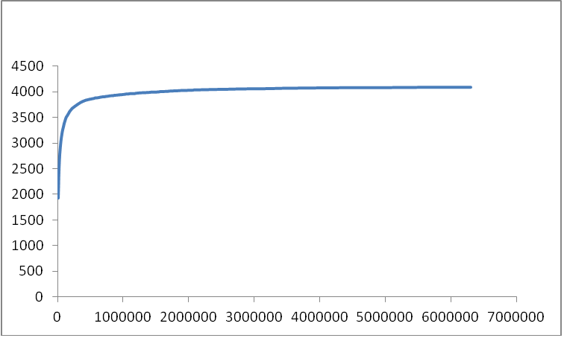
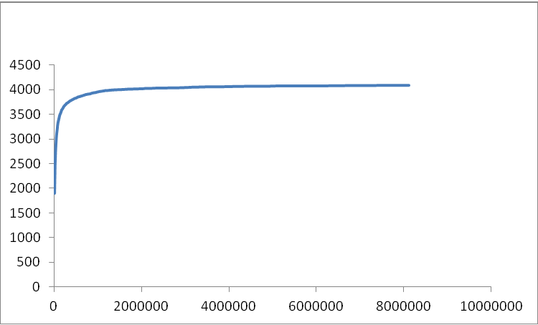
Maize exudates_24-h
Control_24-h

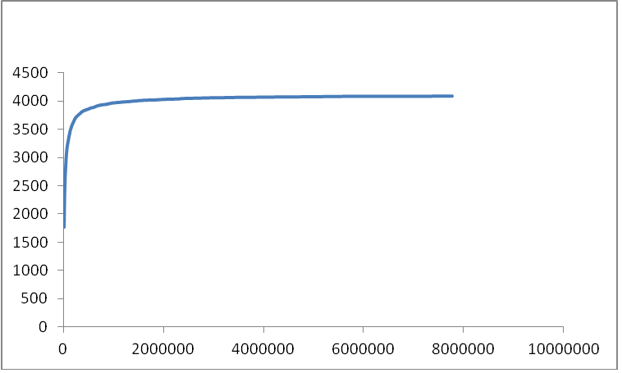
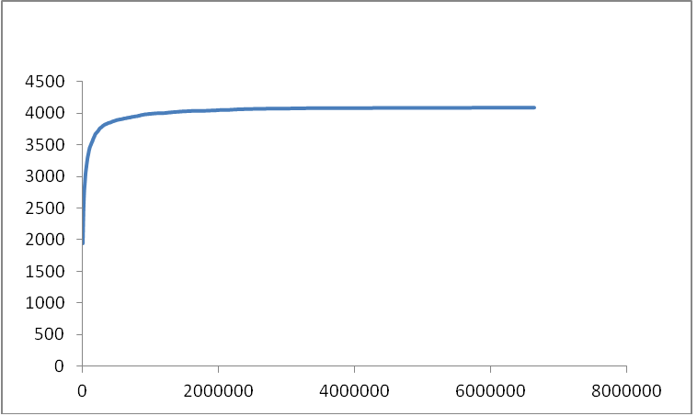
Maize exudates_48-h
Control_48-h

Figure S5 Saturation curves of the Illumina RNA-Seq data. The X-axis represents the number of reads. The Y-axis represents the number of open reading frames covered by the reads obtained.

