Supplementary Figure 1

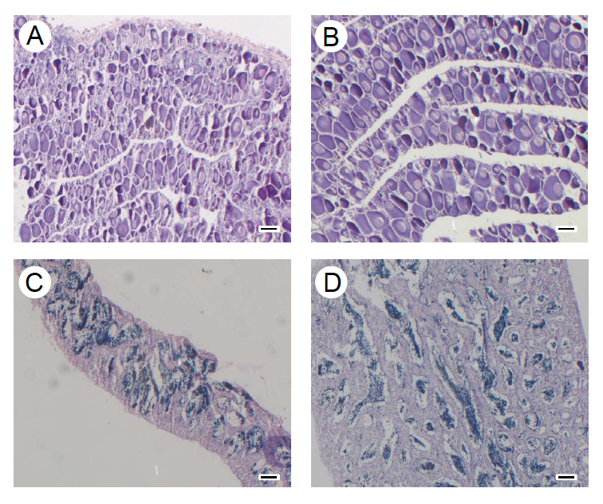

Supplementary Figure 1. Photomicrographs of cross sections of one-year-old European sea bass gonads. A) Low temperature females; B) High temperature females; C) Low temperature males; D) High temperature males. Scale bar = 50 µm.

Supplementary Figure 2

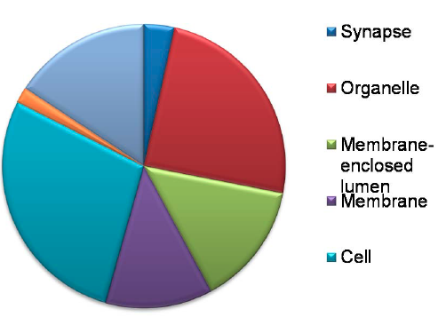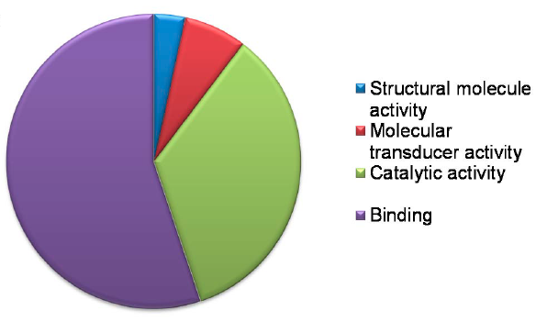
A
B

Supplementary Figure 2. GO terms results and classification in two main categories of the upregulated genes in the high temperature (HT) group. A) Molecular function (MF); B) Cell component (CC).

Supplementary Figure 3

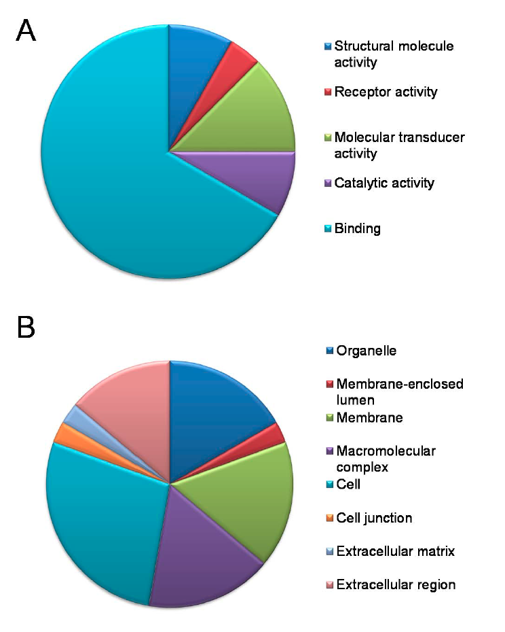
Supplementary Figure 3. GO terms results and classification in two main categories of the downregulated genes in the high temperature (HT) group. A) Molecular function (MF); B) cell component (CC).

Supplementary Figure 4
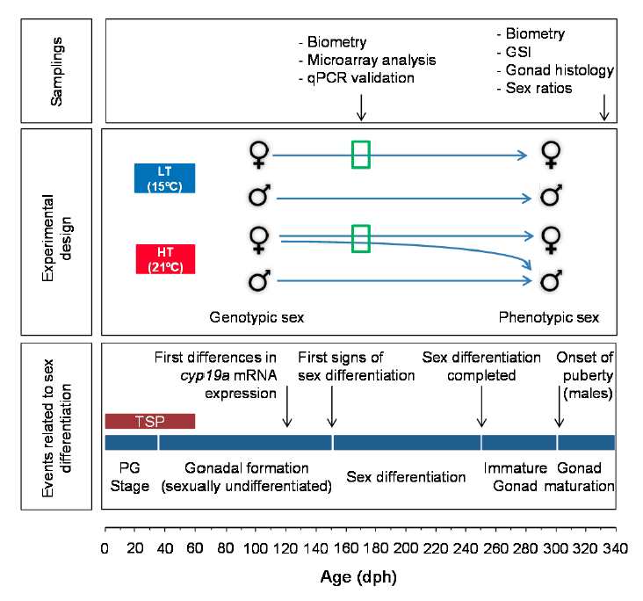
Supplementary Figure 4. Diagram on European sea bass sex differentiation events, experimental design and sampling strategy. On a calibrated age scale, the bottom panel illustrates the main events related to gonadal sex differentiation, from the pregonadal (PG) stage until the onset of puberty. The middle panel depicts the low (LT) and high (HT) temperature periods, within the thermosensitive period (TSP). The open green boxes indicate the sampling for transcriptomic analysis in relation to age and events of sex differentiation, meaning that in both groups females were targeted since fish with the highest cyp19a1a mRNA levels were chosen in each case. The top panel highlights the two main samplings of the experiment and the type of the analyses carried out in each one of them.

