Additional file 3: Figure S1. Differential gene expression in larvae of Chymomyza costata exposed to Long Day (LD), Short Day (SD) and Transfer (T) from LD to SD photoperiodic conditions. The heat maps show log2 fold transformed differences in mRNA relative abundances obtained by DeSEQ2 analysis of RNAseq (Illumina) sequencing data. Genes representing four functional clusters identified by enrichment analysis: (A) lipid metabolism; (B) detoxification metabolism; (C) protein processing in ER, chaperones and heat shock proteins; and (D) cuticle development.

T17 vs LD17
SD1 vs LD1
SD13 vs LD17
T13 vs LD17

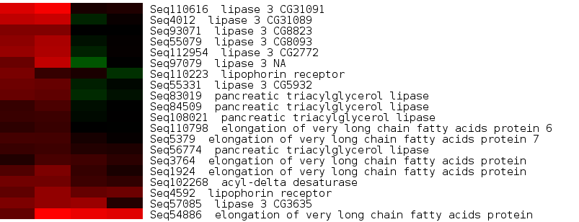
A

LIPIDS

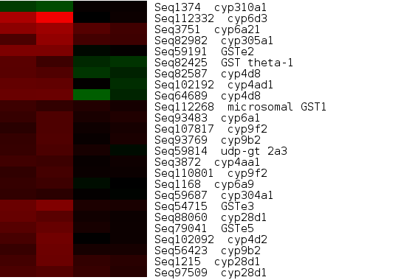
B

DETOXIFICATION
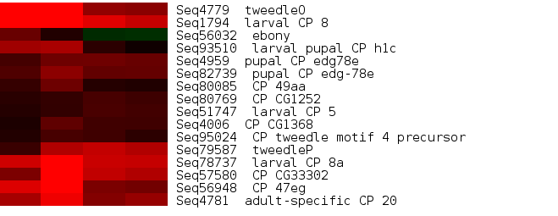
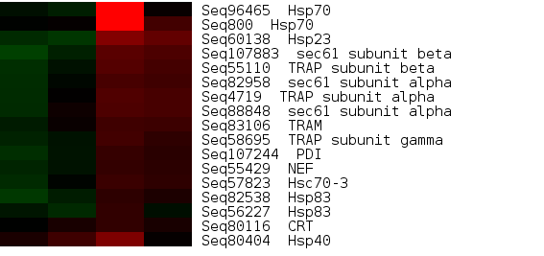
CUTICLE
D
ER PROCESSING & HSPs
C
SD13 vs LD17
SD1 vs LD1
T13 vs LD17
T17 vs LD17

