Artificial chromosome #1
Callus, meristem, and seedling reads
De novo assembly #1
Flower and trichome
reads mapped
Annotation
Reads from each library mapped
Callus, meristem and seedling reads used for assembly #1
De novo assembly #2
Artificial chromosome #2
Calculation of expression abundances (FPKM)
Reads not aligning/Novel reads
(From flower and trichome libraries)
Reads that align
De Novo assembly #2
Annotation
Artificial chromosome #2
Calculation of expression abundances (FPKM)
Reads from each
library mapped
Figure 2. Assembly and expression analysis work flow used for the ‘total’ P. axillaris, P. exserta and P. integrifolia transcriptomes.

Figure S1. Work flow used for assemblies allowing incorporation of reads from all 5 tissue libraries while removing redundancy.

Figure S2. Distributions of the number of isoforms for each transcript.

Figure S3. SNP discovery pipeline with reads aligned to P. axillaris reference transcriptome assembly.

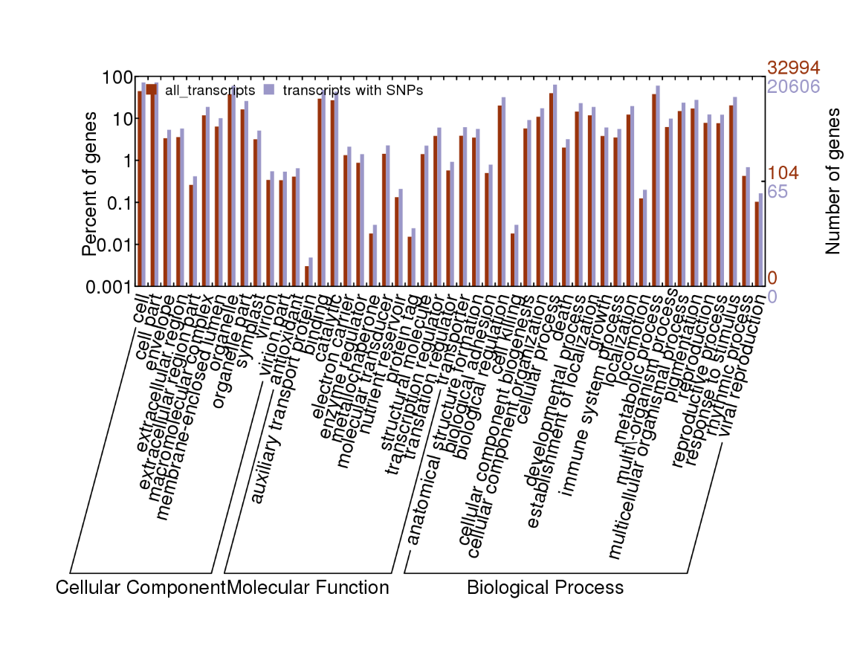
Figure S4. Gene Ontology (GO) categories of the unigenes and unigenes with SNPs. Distribution of the GO categories assigned to the unigenes were annotated in three categories: cellular components, molecular functions, and biological processes.

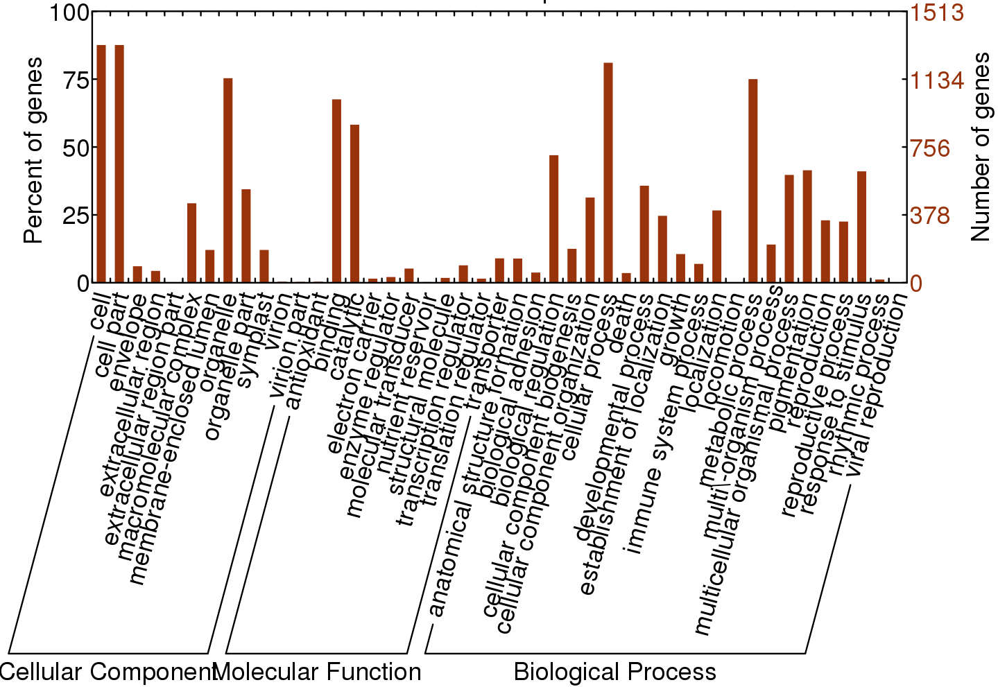

Figure S5. Gene Ontology (GO) categories of the unigenes with more than ten SNPs. Distribution of the GO categories assigned to the unigenes were annotated in three categories: cellular components, molecular functions, and biological processes.

 | Primer name | Petunia axillaris Unigene name | SNP position | Primer sequence
1 | V_Locus_4442_F | Locus_4442_Transcript_14/22_Confidence_0.191_Length_3860 | 2496 | TTGGGGGAATTTAGGGTTTC
2 | V_Locus_4442_R | Locus_4442_Transcript_14/22_Confidence_0.191_Length_3860 | 2496 | GCAAAGGGTAGTCAGGCAAA
3 | V_Locus_4493_F | Locus_4493_Transcript_4/5_Confidence_0.615_Length_2780 | 1620 | CCAGATGCCGAAACCTTAAA
4 | V_Locus_4493_R | Locus_4493_Transcript_4/5_Confidence_0.615_Length_2780 | 1620 | ACGAAGCAGCTCCACAAGAT
5 | V_Locus_4955_F | Locus_4955_Transcript_2/4_Confidence_0.667_Length_1169 | 417 | TCCAGCTGAAAACACCTTCA
6 | v_Locus_4955_R | Locus_4955_Transcript_2/4_Confidence_0.667_Length_1169 | 417 | TGCAATACGACCATCAGCAT
7 | V_Locus_5011_F | Locus_5011_Transcript_6/7_Confidence_0.467_Length_4097 | 985 | GCTCCTGAACAGGGTTTGTC
8 | V_Locus_5011_R | Locus_5011_Transcript_6/7_Confidence_0.467_Length_4097 | 985 | TGGTACCTGGAACTGCATCA
9 | V_Locus_5128_F | Locus_5128_Transcript_1/1_Confidence_1.000_Length_8389 | 3775 | CATCGTCCGATGAGCATAAA
10 | V_Locus_5128_R | Locus_5128_Transcript_1/1_Confidence_1.000_Length_8389 | 3775 | GGGGAGGTTCATGGTTTCTT
11 | V_Locus_5244_F | Locus_5244_Transcript_5/6_Confidence_0.643_Length_5153 | 2995 | GCCACAACTTCATCAGCAAG
12 | V_Locus_5244_R | Locus_5244_Transcript_5/6_Confidence_0.643_Length_5153 | 2995 | TGGGATTTTTGCAAGAGGTT
13 | V_Locus_5665_F | Locus_5665_Transcript_1/1_Confidence_1.000_Length_2440 | 1404 | TGGCTTCCGGATGAAAATAG
14 | V_Locus_5665_R | Locus_5665_Transcript_1/1_Confidence_1.000_Length_2440 | 1404 | TGAATGGTCTTGTCAACCAAA
15 | V_Locus_6193_F | Locus_6193_Transcript_5/5_Confidence_0.667_Length_4558 | 2635 | CAAGGCCGATGACAAGAAAA
16 | V_Locus_6193_R | Locus_6193_Transcript_5/5_Confidence_0.667_Length_4558 | 2635 | GGAGCAGGTGTAGGCTTTTG
17 | V_Locus_6590_F | Locus_6590_Transcript_4/5_Confidence_0.714_Length_2397 | 373 | CATCGGGTTCGGAATACTTG
18 | V_Locus_6590_R | Locus_6590_Transcript_4/5_Confidence_0.714_Length_2397 | 373 | GGAAAAATGGGACATTACGC
19 | V_Locus_6907_F | Locus_6907_Transcript_4/4_Confidence_0.625_Length_3310 | 1366 | TCAGTGCAAAGTCCCATTTG
20 | V_Locus_6907_R | Locus_6907_Transcript_4/4_Confidence_0.625_Length_3310 | 1366 | TGGAAATTAGGGTGCATGTG
21 | V_Locus_6970_F | Locus_6970_Transcript_6/6_Confidence_0.643_Length_2915 | 1796 | GACAATTTGCAGAGCCCACT
22 | V_Locus_6970_R | Locus_6970_Transcript_6/6_Confidence_0.643_Length_2915 | 1796 | AAATTCACCACCACCAGGAA
23 | V_Locus_7169_F | Locus_7169_Transcript_1/1_Confidence_1.000_Length_1778 | 461 | ATCGTCTCCCGAAACTTCCT
24 | V_Locus_7169_R | Locus_7169_Transcript_1/1_Confidence_1.000_Length_1778 | 461 | GAAAGCCAAAAATGCAGCAG
25 | V_Locus_7225_F | Locus_7225_Transcript_9/10_Confidence_0.458_Length_3974 | 2129 | AACACCATCCAAAATGGAACA
26 | V_Locus_7225_R | Locus_7225_Transcript_9/10_Confidence_0.458_Length_3974 | 2129 | GAAGCATCTTGCAATCAGCA
27 | V_Locus_7293_F | Locus_7293_Transcript_3/4_Confidence_0.625_Length_2999 | 310 | TCTTTTGCATTCCCTCTCTG
28 | V_Locus_7293_R | Locus_7293_Transcript_3/4_Confidence_0.625_Length_2999 | 310 | CCAACACTGCACACAATTCA
29 | V_Locus_8156_F | Locus_8156_Transcript_1/1_Confidence_1.000_Length_817 | 402 | GAGGCGGAAATTGATCGTAA
30 | V_Locus_8156_R | Locus_8156_Transcript_1/1_Confidence_1.000_Length_817 | 402 | TTTTTCCAATTTCCAAGCTCA
31 | V_Locus_8764_F | Locus_8764_Transcript_3/5_Confidence_0.615_Length_2955 | 812 | CACCCTTTGTCCCAATCTAAG
32 | V_Locus_8764_R | Locus_8764_Transcript_3/5_Confidence_0.615_Length_2955 | 812 | TCCAGCCCCTCCTTTTTATT
33 | V_Locus_9135_F | Locus_9135_Transcript_1/1_Confidence_1.000_Length_2393 | 863 | CAACAACATTCCTTCATCATCA
34 | V_Locus_9135_R | Locus_9135_Transcript_1/1_Confidence_1.000_Length_2393 | 863 | CCCCACTTTGTTGACTTGGT
35 | V_Locus_9276_F | Locus_9276_Transcript_1/1_Confidence_1.000_Length_1898 | 1425 | CTTCACGCCTAACTGAGCTG
36 | V_Locus_9276_R | Locus_9276_Transcript_1/1_Confidence_1.000_Length_1898 | 1425 | GGACTTCCACACCATGTCCT
37 | V_Locus_9589_F | Locus_9589_Transcript_1/1_Confidence_1.000_Length_3088 | 1425 | TTTGGTCCCATCGTCAATTT
38 | V_Locus_9589_R | Locus_9589_Transcript_1/1_Confidence_1.000_Length_3088 | 1425 | TGTTTGGAGCATTTGTTGGA
39 | V_Locus_9778_F | Locus_9778_Transcript_3/4_Confidence_0.667_Length_4071 | 3465 | TATGCATGGATTACGCTGCT
40 | V_Locus_9778_R | Locus_9778_Transcript_3/4_Confidence_0.667_Length_4071 | 3465 | GAAGGAATAGGGGCGGTAAG
41 | V_Locus_10068_F | Locus_10068_Transcript_7/10_Confidence_0.380_Length_4003 | 2207 | AATCCCCGTCTTTCAGGAAC
42 | V_Locus_10068_R | Locus_10068_Transcript_7/10_Confidence_0.380_Length_4003 | 2207 | CGAATCACCACCAAGGTTTC
43 | V_Locus_10804_F | Locus_10804_Transcript_6/6_Confidence_0.611_Length_2053 | 1014 | TTGACTGGTGGCACTGTTCT
44 | V_Locus_10804_R | Locus_10804_Transcript_6/6_Confidence_0.611_Length_2053 | 1014 | GCTAAATGAAGCAGCGGAAG
45 | V_Locus_11475_F | Locus_11475_Transcript_1/1_Confidence_1.000_Length_3121 | 2086 | AAGCAGGGGTATAGCATCCA
46 | V_Locus_11475_R | Locus_11475_Transcript_1/1_Confidence_1.000_Length_3121 | 2086 | TAAGGGGAAAAACCATGAGC
47 | V_Locus_12184_F | Locus_12184_Transcript_2/8_Confidence_0.579_Length_2441 | 971 | CCTCCCTGCAAAACATTCAT
48 | V_Locus_12184_R | Locus_12184_Transcript_2/8_Confidence_0.579_Length_2441 | 971 | CCTCTCTCCTCCCTGGTCTT
49 | V_Locus_12561_F | Locus_12561_Transcript_4/6_Confidence_0.647_Length_2250 | 1315 | CCCTGTCCACCTTTTCAATG
50 | V_Locus_12561_R | Locus_12561_Transcript_4/6_Confidence_0.647_Length_2250 | 1315 | GATGTGGATGCCGAATTTCT
51 | V_Locus_13610_F | Locus_13610_Transcript_5/6_Confidence_0.688_Length_1938 | 1303 | AGGGGACACTGATCCAAGAG
52 | V_Locus_13610_R | Locus_13610_Transcript_5/6_Confidence_0.688_Length_1938 | 1303 | GCAATTTGCACACAACAAGC
53 | V_Locus_13631_F | Locus_13631_Transcript_7/8_Confidence_0.414_Length_2572 | 1107 | CAATGTTGGGAAAGTAACTGGA
54 | V_Locus_13631_R | Locus_13631_Transcript_7/8_Confidence_0.414_Length_2572 | 1107 | AACATACCGCCTTTGCTCAG
55 | V_Locus_13652_F | Locus_13652_Transcript_2/4_Confidence_0.600_Length_3106 | 1636 | TTCCTTCAGTTGGAGAATTGG
56 | V_Locus_13652_R | Locus_13652_Transcript_2/4_Confidence_0.600_Length_3106 | 1636 | GGAGCTCGTGAAGAACTGCT
57 | V_Locus_13922_F | Locus_13922_Transcript_5/8_Confidence_0.560_Length_1829 | 753 | TCACCATCCCTCATTTCCAT
58 | V_Locus_13922_R | Locus_13922_Transcript_5/8_Confidence_0.560_Length_1829 | 753 | TTTTTCAAAGGGACGGAACA
59 | V_Locus_14239_F | Locus_14239_Transcript_1/1_Confidence_1.000_Length_3442 | 1427 | CAAATGCAGGTTTGCTGTCA
60 | V_Locus_14239_R | Locus_14239_Transcript_1/1_Confidence_1.000_Length_3442 | 1427 | CCAGCTTTCTTTGAGGCAAC
61 | P_404_F | Locus_404_Transcript_2/4_Confidence_0.625_Length_2043 | 1638 | GATGCTGGGCAGGAATTTAT
62 | P_404_R | Locus_404_Transcript_2/4_Confidence_0.625_Length_2043 | 1638 | TGGCCAAACAAGAAATTTGA
63 | P_560_F | Locus_560_Transcript_2/9_Confidence_0.704_Length_3640 | 2850 | CCGCATGGATGGTAGGTAAC
64 | P_560_R | Locus_560_Transcript_2/9_Confidence_0.704_Length_3640 | 2850 | AGAACGATGCACGAGTTCAC
65 | P_587_F | Locus_587_Transcript_4/9_Confidence_0.690_Length_7892 | 7535 | CACCCTCCAAAAATCCCATA
66 | P_587_R | Locus_587_Transcript_4/9_Confidence_0.690_Length_7892 | 7535 | TTTAGCCTGTTTGGGTGAGC
67 | P_841_F | Locus_841_Transcript_1/2_Confidence_0.750_Length_2089 | 483 | TTCATTGGAGGAATGGAAGG
68 | P_841_R | Locus_841_Transcript_1/2_Confidence_0.750_Length_2089 | 483 | ACTTAGCGCCATACGGACAT
69 | P_1379_F | Locus_1379_Transcript_1/1_Confidence_1.000_Length_1789 | 1035 | GCCACAACTTCCATGAAACC
70 | P_1379_R | Locus_1379_Transcript_1/1_Confidence_1.000_Length_1789 | 1035 | CAGCAGCTCGTCGATTACAA
71 | P_1400_F | Locus_1400_Transcript_1/3_Confidence_0.667_Length_1585 | 799 | CTGCTCGTGCAAACAACAAT
72 | P_1400_R | Locus_1400_Transcript_1/3_Confidence_0.667_Length_1585 | 799 | TGTGGTGGAGTCCCTTCTTC
73 | P_1485_F | Locus_1485_Transcript_1/2_Confidence_1.000_Length_2427 | 928 | TGGGACATCATCCACAAAAA
74 | P_1485_R | Locus_1485_Transcript_1/2_Confidence_1.000_Length_2427 | 928 | TTTAAGCAGGCGAGTTGGTC
75 | P_2713_F | Locus_2713_Transcript_1/1_Confidence_1.000_Length_2288 | 1872 | TTTCTCATTCCAACCACAACC
76 | P_2713_R | Locus_2713_Transcript_1/1_Confidence_1.000_Length_2288 | 1872 | GGCCTTTTGTTTCCCAAAAT
77 | P_3046_F | Locus_3046_Transcript_1/1_Confidence_1.000_Length_4433 | 3835 | TCCTTGGGAAATCCCTTTTC
78 | P_3046_R | Locus_3046_Transcript_1/1_Confidence_1.000_Length_4433 | 3835 | ACCAAGATATTGGCGAATGC
79 | P_3260_F | Locus_3260_Transcript_8/10_Confidence_0.655_Length_4253 | 1152 | GCTCAATTCCAAGGAACCAA
80 | P_3260_R | Locus_3260_Transcript_8/10_Confidence_0.655_Length_4253 | 1152 | CTCCCTCCAGCAATGAGTTC
81 | P_4136_F | Locus_4136_Transcript_1/6_Confidence_0.385_Length_3340 | 1054 | CCCTGATGTGCTTCCAAACT
82 | P_4136_R | Locus_4136_Transcript_1/6_Confidence_0.385_Length_3340 | 1054 | AAGGTGGAAAAGCAACTGGA
83 | P_4252_F | Locus_4252_Transcript_1/1_Confidence_1.000_Length_1682 | 563 | AGCCCAATCTTTTCCCCATA
84 | P_4252_R | Locus_4252_Transcript_1/1_Confidence_1.000_Length_1682 | 563 | GTGACACAACGTCTGCTGCT
85 | P_4439_F | Locus_4439_Transcript_1/1_Confidence_1.000_Length_1584 | 576 | GCCTACAAATCACAGGCACA
86 | P_4439_R | Locus_4439_Transcript_1/1_Confidence_1.000_Length_1584 | 576 | CCAGGCTCAGTGGCTTACAT
87 | P_1960_F | Locus_1960_Transcript_1/2_Confidence_0.750_Length_4367 | 1233 | AATCACATGGCATGAGGTGA
88 | P_1960_R | Locus_1960_Transcript_1/2_Confidence_0.750_Length_4367 | 1233 | TTGCTCAGGATCGGTAGGTT
89 | P_2011_F | Locus_2011_Transcript_2/3_Confidence_0.333_Length_3731 | 1554 | ATACGCAACGCAAGCCTTAT
90 | P_2011_R | Locus_2011_Transcript_2/3_Confidence_0.333_Length_3731 | 1554 | AATGAAGGAGGCAGTCATGG
91 | P_2053_F | Locus_2053_Transcript_3/6_Confidence_0.688_Length_3798 | 1576 | GGGGCATTTTGATTTTTGAA
92 | P_2053_R | Locus_2053_Transcript_3/6_Confidence_0.688_Length_3798 | 1576 | AGACCCCGAAAGGTGAGAGT
93 | P_4219_F | Locus_4219_Transcript_7/10_Confidence_0.581_Length_4920 | 633 | CCTAAGCTTGGCAAAGGAAA
94 | P_4219_R | Locus_4219_Transcript_7/10_Confidence_0.581_Length_4920 | 633 | TCCATCCAGATGAAGCTCAG
95 | P_4440_F | Locus_4440_Transcript_1/2_Confidence_1.000_Length_2844 | 1692 | TCTGTGAGGCAGCTTGAATG
96 | P_4440_R | Locus_4440_Transcript_1/2_Confidence_1.000_Length_2844 | 1692 | CCGGAACCCATAAAGTTCAA
97 | P_5868_F | Locus_5868_Transcript_4/5_Confidence_0.500_Length_3236 | 734 | CAGTGCTGAATGAGCAGGAA
98 | P_5868_R | Locus_5868_Transcript_4/5_Confidence_0.500_Length_3236 | 734 | GGAGTGCAGAAAGGAAATGG
99 | P_8450_F | Locus_8450_Transcript_1/2_Confidence_0.750_Length_3636 | 2962 | GAGCACCATTCGAAAAGCTC
100 | P_8450_R | Locus_8450_Transcript_1/2_Confidence_0.750_Length_3636 | 2962 | TTCTGAATCGGCGGTTTTT

Table S1. Primer sequences used for SNP validation by Sanger sequencing.

Marker name | Petunia axillaris transcript | Forward sequence | Reverse sequence | Restriction enzyme
Pax7774 | Locus_7774_Transcript_1/1_Confidence_1.000_Length_3771 | TCTGAAGGCGAGGAAGATCC | GTTGAAGTCTGTGAGGCTGG | TaqI
Pax28305 | Locus_28305_Transcript_3/3_Confidence_0.600_Length_4234 | GAGTGGAAAAGGCTGGTCCA | ACTTTTTCTCAAGTTTGGTGAGGT | AflII
Pax17737 | Locus_17737_Transcript_3/3_Confidence_0.667_Length_3550 | CCGTCCAGGAAGGTGAAG | TAGCCTATGGTGCCCAAAAC | Hpy188III
Pax17054 | Locus_17054_Transcript_3/3_Confidence_0.600_Length_2365 | AGTGAGGCCAAACAAGCTTG | TTGGTGGAGGCCATGATTATG | AluI
Pax4307 | Locus_4307_Transcript_1/3_Confidence_0.667_Length_2763 | GGTACCACGAAGACCAACGA | GGCTCTTCAACCAAAGATAATAGCA | AluI
Pax2898 | Locus_2898_Transcript_1/1_Confidence_1.000_Length_2484 | CCACCTCGAGATGGCAAGTT | TGTCTTCTCATGCTTTTCACCA | TaqI
Pax2128 | Locus_2128_Transcript_1/2_Confidence_0.833_Length_3063 | GCCACATCAAATGAGGAGAAA | CAATCTGCTTTGGTGCATGT | MaeIII
Pax23917 | Locus_23917_Transcript_1/1_Confidence_1.000_Length_2956 | TCCAGCTCACCTTACTTCCC | TCCTTTGCCAACTTCTGTGC | TaqI
Pax34631 | Locus_34631_Transcript_2/2_Confidence_0.750_Length_962 | GAGATGGCATGTCAATCGGG | GGGCATCAGTCTGAATGCAG | AluI
Pax1735 | Locus_1735_Transcript_5/6_Confidence_0.538_Length_4646 | CCTCTTCATGTTGCAGCTGG | TTCCATGCTTCAACTGCCAC | RsaI
Pax11501 | Locus_11501_Transcript_1/4_Confidence_0.625_Length_1639 | ATGGGCTCAGCAACTCAGAA | CGGAGAAGAAGACCCAGATG | HinfI
Pax30395 | Locus_30395_Transcript_1/2_Confidence_0.750_Length_1427 | CCAAATACTAGAGAATCCGAGCA | AGGGTCGGTTCCTTGATTCC | AluI
Pax6323 | Locus_6323_Transcript_2/3_Confidence_0.667_Length_3369 | GTTCCTCGATCGGCAATTCC | ACTCAGGGATCTCAAGCCTG | AluI

Table S2. Primer sequences for CAPS markers developed from plastochron-related genes.

