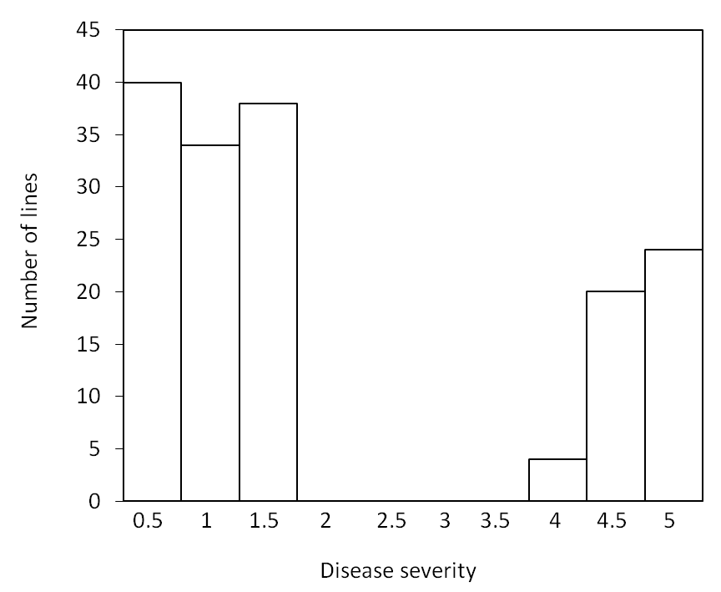

Supplementary Fig.S1 Distribution of FCR severity in the subpopulation containing 160 lines. Disease severity was scored using a scale of 0 (no obvious symptom) to 5 (whole plant severely to completely nectrotic).

