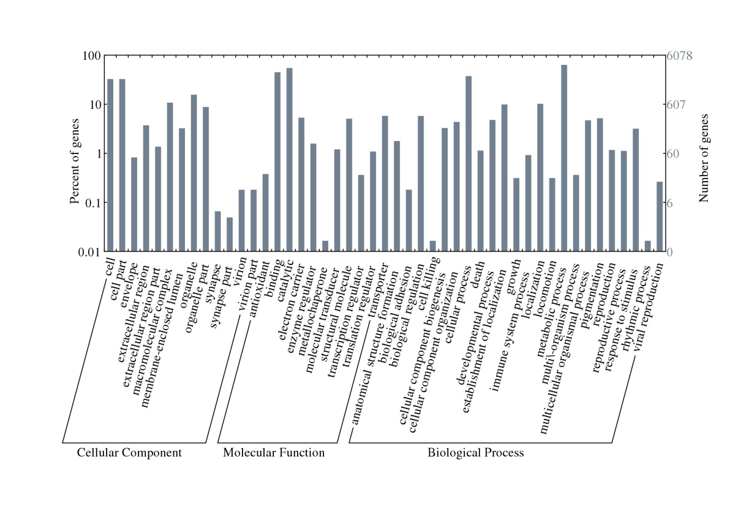
Additional file 7 – Distribution of gene ontologies (GO) assigned to the transcriptome of susceptible and lufenuron-resistant strains of S. frugiperda

