Additional file 1

Multimodular type I polyketide synthases in algae evolve
by module duplications and displacement of AT domains
in trans

Ekaterina Shelest, Natalie Heimerl, Maximilian Fichtner, Severin Sasso

Contents:

Table S1 Overview of available algal genome sequences
Table S3 Overview of conserved amino acid motifs in selected algal type I PKSs
Figure S1 Comparison of the phylogenetic tree from Fig. 3(MUSCLE/PhyML) with a consensus tree from trees constructed by four different methods (MUSCLE/PhyML, MUSCLE/NJ, Clustal/PhyML, Clustal/NJ)
Figure S2 Detailed phylogenetic trees of KS domains from different classes of Chlorophyta. (a) Chlorophyceae (Chlamydomonas reinhardtii, Volvox carteri) and Trebouxiophyceae (Chlorella variabilis, Coccomyxa subellipsoidea). (b) Prasinophyceae (Micromonas sp. RCC299, Ostreococcus lucimarinus, Ostreococcus tauri).
Additional references

Additional file 1: Table S1 Overview of available algal genome sequences

Species | Description | Genome size (Mb) | Gene number | Reference | Internet portal or NCBI accession number | Current version
Chlorophyta
Asterochloris sp. Cgr/DA1pho ¹⁾ | lichen photobiont | 55.8 | 7,159 | accessible online | http://genome.jgi-psf.org/Astpho2 | v3
Bathycoccus prasinos ¹⁾ | marine picoeukaryote | 15.1 | 7,847 | [1] | http://bioinformatics.psb.ugent.be/genomes/view/Bathycoccus-prasinos
Chlamydomonas reinhardtii ¹⁾ | model species, freshwater | 111.1 | 17,741 | [2] | http://phytozome.jgi.doe.gov/pz/portal.html#!info?alias=Org_Creinhardtii | v5.5
Chlorella variabilis ¹⁾ | Paramecium symbiont | 46.2 | 9,791 | [3] | http://genome.jgi-psf.org/ChlNC64A_1 | v1.0
Coccomyxa subellipsoidea ¹⁾ | Chlorella relative | 49 | 9,627 | [4] | http://genome.jgi-psf.org/Coc_C169_1 | v2.0
Micromonas sp. CCMP1545 ¹⁾ | marine picoeukaryote | 21.9 | 10,672 | [5] | http://genome.jgi-psf.org/MicpuC3 | v3.0
Micromonas sp. RCC299 ¹⁾ | marine picoeukaryote | 21 | 10,109 | [5] | http://genome.jgi-psf.org/MicpuN3 | v3.0
Monoraphidium neglectum ¹⁾ | microalgae with increased lipid production | ca. 68 | 16,761 | [6] | AYTC01000000
Ostreococcus lucimarinus ¹⁾ | marine picoeukaryote | 13.2 | 7,651 | [7] | http://genome.jgi-psf.org/Ost9901_3 | v2.0
Ostreococcus tauri ¹⁾ | marine picoeukaryote | 12.6 | 7,725 | [8] | http://genome.jgi-psf.org/Ostta4 | v2.0
Ostreococcus sp. RCC809 | marine picoeukaryote | 13.3 | 7,492 | accessible online | http://genome.jgi-psf.org/OstRCC809_2 | v2.0
Volvox carteri ¹⁾ | simple multicellular relative of C. reinhardtii | 131.2 | 14,971 | [9] | http://phytozome.jgi.doe.gov/pz/portal.html#!info?alias=Org_Vcarteri | v2.0
Rhodophyta
Chondrus crispus ¹⁾ | multicellular seaweed, source of carrageenan | 105 | 9,606 | [10] | http://www.sb-roscoff.fr/en-abiotic-stress-research-topics/1681-the-chondrus-crispus-genome-project.html
Cyanidioschyzon merolae ¹⁾ | thermo-acidophile | 16.5 | 5,331 | [11] | http://merolae.biol.s.u-tokyo.ac.jp
Galdieria sulphuraria | thermo-acidophile | 13.7 | 6,623 | [12] | http://genomics.msu.edu/galdieria
Porphyridium purpureum | mesophilic unicellular alga | 19.7 | 8,355 | [13] | http://cyanophora.rutgers.edu/porphyridium
Pyropia (Porphyra) yezoensis ¹⁾ | multicellular seaweed, susabi-nori | ca. 43 | 10,327 | [14] | http://nrifs.fra.affrc.go.jp/ResearchCenter/5_AG/genomes/nori
Glaucophyta
Cyanophora paradoxa ¹⁾ | freshwater alga with peptidoglycan-surrounded plastid | ca. 70 | 27,921 | [15] | http://cyanophora.rutgers.edu/cyanophora
Species | Description | Genome size (Mb) | Gene number | Reference | Internet portal or NCBI accession number | Current version
Chlorarachniophyta
Bigelowiella natans ¹⁾ | marine alga | 94.7 | 21,708 | [16] | http://genome.jgi.doe.gov/Bigna1 | v1.0
Heterokontophyta
Aureococcus anophagefferens | harmful algal bloom-forming marine pelagophyte | 56.7 | 11,501 | [17] | http://genome.jgi-psf.org/Auran1 | v1.0
Ectocarpus siliculosus | brown alga (multicellular seaweed) | 214 | 16,256 | [18] | http://bioinformatics.psb.ugent.be/webtools/bogas/overview/Ectsi
Fragilariopsis cylindrus ¹⁾ | marine psychrophilic diatom | 80.5 | 27,137 | accessible online | http://genome.jgi-psf.org/Fracy1 | v1.0
Nannochloropsis gaditana B-31 ¹⁾ | marine lipid-accumulating alga | 28.5 | 10,486 | [19] | http://www.nannochloropsis.org
Nannochloropsis gaditana  CCMP526 ¹⁾ | marine lipid-accumulating alga | 29 | 8,892 | [20] | http://www.nannochloropsis.org
Nannochloropsis oceanica  LAMB0001 | marine lipid-accumulating alga | ca. 30 | 11,129 | [21] | AEUM00000000
Nannochloropsis oceanica  CCMP1779 | marine lipid-accumulating alga | 28.7 | 11,973 | [22] | https://bmb.natsci.msu.edu/about/directory/faculty/christoph-benning/nannochloropsis-oceanica-ccmp1779
Phaeodactylum tricornutum ¹⁾ | marine pennate diatom | 27.4 | 10,402 | [23] | http://genome.jgi-psf.org/Phatr2 | v2.0
Pseudo-nitzschia multiseries | neurotoxin-producing diatom | 218.7 | 19,703 | accessible online | http://genome.jgi.doe.gov/Psemu1 | v1.0
Thalassiosira oceanica ¹⁾ | oceanic diatom | 81.6 | 29,306 | [24] | AGNL00000000
Thalassiosira pseudonana ¹⁾ | marine centric diatom | 32.4 | 11,776 | [25] | http://genome.jgi-psf.org/Thaps3 | v3.0
Dinoflagellates
Symbiodinium minutum ¹⁾ | unicellular symbiotic alga (photosynthetic) | ca. 1,500  (616 Mb sequenced) | ca. 42,000 | [26] | http://marinegenomics.oist.jp/genomes/viewer?project_id=21&current_assembly_version=symb_aug_v1.120123 | v1.  120123
Haptophyta
Emiliania huxleyi | marine coccolithophore | 167.7 | 30,569 | [27] | http://genome.jgi-psf.org/Emihu1 | v1.0
Species | Description | Genome size (Mb) | Gene number | Reference | Internet portal or NCBI accession number | Current version
Cryptophyta
Guillardia theta¹⁾ | marine alga | 87.2 | 24,840 | [16] | http://genome.jgi.doe.gov/Guith1 | v1.0
Charophyta
Klebsormidium flaccidum¹⁾ | filamentous terrestrial alga | ca. 117.1 | 16,063 | [28] | http://www.plantmorphogenesis.bio.titech.ac.jp/~algae_genome_project/klebsormidium/index.html | v1.0

¹⁾ Genome size and gene number refer to the nuclear genome; in all other cases it was not defined.

Additional file 1: Table S3 Overview of conserved amino acid motifs in selected algal type I PKSs. Abbreviations are as in Figure 4.

KS domain | 1st motif | 2nd motif | Comment
AanPKS2 | DTACSTA | HGTGT
CpaPKS1-KS2 | DTACSSS | HGTGT
CpaPKS1-KS3 | DAACASS | HGTGT
CpaPKS1-KS4 | DTACSSS | HGTGT
CpaPKS1-KS7 | DTACSSS | HGTGT
CrePKS1-KS10 | DTACSSS | HGTGT
CrePKS1-KS11 | DTACSAS | HANGT | Terminal domain
CsuPKS10 | DTACSSS | HGTGT
CsuPKS1-KS10 | DTACSSS | HGTGT
CsuPKS1-KS2 | DTACSSS | HGTGT
CsuPKS1-KS9 | DTACSSS | HGTGT
CsuPKS2 | DTACSSS | HGTGT
CsuPKS3 | DTACSSS | HGTGT
CsuPKS5 | DTACSSS | HGTGT
CsuPKS6 | DTACSSA | HGTGT
CvaPKS1-KS8 | DTACSSS | HGTGT
CvaPKS1-KS9 | DTACSAS | HSNGT | Terminal domain
CwaPKS1 | DTTCSSS | HGTGT
EhuPKS10-KS1 | DTACSAA | AANGS
EhuPKS11-KS1 | DTACSAA | HGTGT
EhuPKS3-KS1 | DAACASS | HGTGT
EhuPKS3-KS2 | DAACASA | HATGT
EhuPKS7-KS1 | DTACSSA | HGTGT
EhuPKS9-KS1 | DTACSSS | HGTGT
EsiPKS1 | DTACSSS | HGTGT
GviPKS1 | DAACASS | HGTGT
GviPKS2 | DAACASS | HGTGT
MaePKS1-KS1 | DTACSSS | HGTGT
MicPKS1-KS4 | DTACSSS | HGTGT
MicPKS2-KS4 | DTACSSS | HGTGT
MicPKS2-KS5 | DTACSSS | HGTGT
MicPKS2-KS9 | DCASASA | SGLGE | Terminal domain
NgaPKS3 | DTACSSS | HGTGT
NocPKS1 | ETACSSS | HATGT
NocPKS2 | ETACSSS | HATGT
NocPKS3 | ETACSSS | HATGT
NocPKS5 | DTACSSS | -----
NpuPKS1 | DTACSSS | HGTGT
NpuPKS2 | DTACSSS | HGTGT
NpuPKS3 | DAACASS | HGTGT
NpuPKS4 | DAACASS | HGTGT
OluPKS1-KS4 | DTACSSS | HGTGT
OluPKS2-KS1 | DTACSSS | HGTGT
OluPKS3-KS10 | DTACSSS | HGTGT
OluPKS3-KS11 | DTACSSS | HGTGT
OluPKS3-KS14 | DCASASG | SGLGE | Terminal domain
OluPKS3-KS4 | DTACSSA | HGTGT
OluPKS3-KS7 | DTACSSS | HGTGT
OtaPKS1-KS3 | DTACSSS | HGTAT
OtaPKS1-KS6 | DTACSSS | HGTGT
OtaPKS1-KS8 | DTACSSS | HGTGT
OtaPKS1-KS9 | DCASASG | SGLGE | Terminal domain
OtaPKS2-KS4 | DTACSSS | HGTGT
OtaPKS3-KS2 | DTACSSS | HGTGT
OtaPKS4-KS2 | DTACSSA | HGTGT
OtaPKS5-KS4 | DTACSSS | HGTGT
OtaPKS6-KS1 | DTACSSS | HGTGT
VcaPKS1-KS10 | DTACSSS | HGTGT
VcaPKS1-KS11 | DTACSSS | HANGT | Terminal domain

Additional file 1: Figure S1 Comparison of the phylogenetic tree from Figure 4 (MUSCLE/PhyML) with a consensus tree from trees constructed by four different methods (MUSCLE/PhyML, MUSCLE/NJ, Clustal/PhyML, Clustal/NJ). See Methods for details.

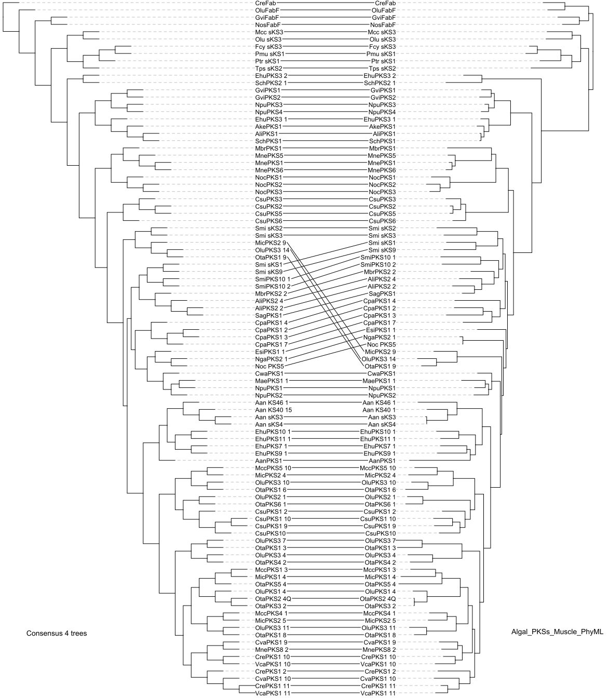

Additional file 1: Figure S2 Detailed phylogenetic trees of KS domains from different classes of Chlorophyta. (A) Chlorophyceae (Chlamydomonas reinhardtii, Volvox carteri) and Trebouxiophyceae (Chlorella variabilis, Coccomyxa subellipsoidea). (B) Prasinophyceae (Micromonas sp. RCC299, Ostreococcus lucimarinus, Ostreococcus tauri). The scale bar indicates substitutions per site.
(A)
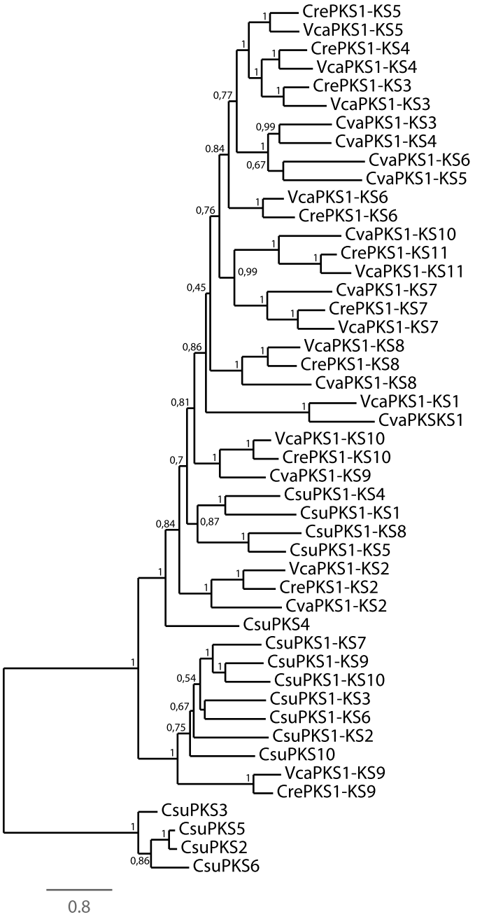

(B)
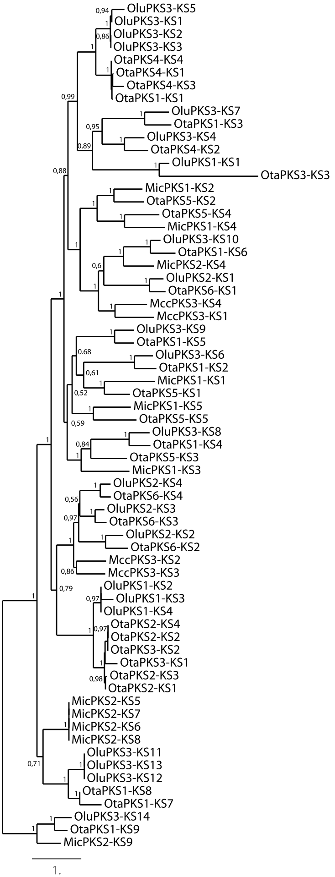

Additional file 1: Additional references

1. Moreau H, Verhelst B, Couloux A, Derelle E, Rombauts S, Grimsley N et al. Gene functionalities and genome structure in Bathycoccus prasinos reflect cellular specializations at the base of the green lineage. Genome Biol 2012, 13:R74.
2. Merchant SS, Prochnik SE, Vallon O, Harris EH, Karpowicz SJ, Witman GB et al. The Chlamydomonas genome reveals the evolution of key animal and plant functions. Science 2007, 318:245-251.
3. Blanc G, Duncan G, Agarkova I, Borodovsky M, Gurnon J, Kuo A et al. The Chlorella variabilis NC64A genome reveals adaptation to photosymbiosis, coevolution with viruses, and cryptic sex. Plant Cell 2010, 22:2943-2955.
4. Blanc G, Agarkova I, Grimwood J, Kuo A, Brueggeman A, Dunigan DD et al. The genome of the polar eukaryotic microalga Coccomyxa subellipsoidea reveals traits of cold adaptation. Genome Biol 2012, 13:R39.
5. Worden AZ, Lee J-H, Mock T, Rouzé P, Simmons MP, Aerts AL et al. Green evolution and dynamic adaptations revealed by genomes of the marine picoeukaryotes Micromonas. Science 2009, 324:268-272.
6. Bogen C, Al-Dilaimi A, Albersmeier A, Wichmann J, Grundmann M, Rupp O et al. Reconstruction of the lipid metabolism for the microalga Monoraphidium neglectum from its genome sequence reveals characteristics suitable for biofuel production. BMC Genomics 2013, 14:926.
7. Palenik B, Grimwood J, Aerts A, Rouzé P, Salamov A, Putnam N et al. The tiny eukaryote Ostreococcus provides genomic insights into the paradox of plankton speciation. Proc Natl Acad Sci U S A 2007, 104:7705-7710.
8. Derelle E, Ferraz C, Rombauts S, Rouzé P, Worden AZ, Robbens S et al. Genome analysis of the smallest free-living eukaryote Ostreococcus tauri unveils many unique features. Proc Natl Acad Sci U S A 2006, 103:11647-11652.
9. Prochnik SE, Umen J, Nedelcu AM, Hallmann A, Miller SM, Nishii I et al. Genomic analysis of organismal complexity in the multicellular green alga Volvox carteri. Science 2010, 329:223-226.
10. Collén J, Porcel B, Carre W, Ball SG, Chaparro C, Tonon T et al. Genome structure and metabolic features in the red seaweed Chondrus crispus shed light on evolution of the Archaeplastida. Proc Natl Acad Sci U S A 2013, 110:5247-5252.
11. Matsuzaki M, Misumi O, Shin-i T, Maruyama S, Takahara M, Miyagishima S et al. Genome sequence of the ultrasmall unicellular red alga Cyanidioschyzon merolae 10D. Nature 2004, 428:653-657.
12. Schönknecht G, Chen W-H, Ternes CM, Barbier GG, Shrestha RP, Stanke M et al. Gene transfer from bacteria and archaea facilitated evolution of an extremophilic eukaryote. Science 2013, 339:1207-1210.
13. Bhattacharya D, Price DC, Chan CX, Qiu H, Rose N, Ball S et al. Genome of the red alga Porphyridium purpureum. Nat Commun 2013, 4:1941.
14. Nakamura Y, Sasaki N, Kobayashi M, Ojima N, Yasuike M, Shigenobu Y et al. The first symbiont-free genome sequence of marine red alga, susabi-nori (Pyropia yezoensis). PLoS ONE 2013, 8:e57122.
15. Price DC, Chan CX, Yoon HS, Yang EC, Qiu H, Weber APM et al. Cyanophora paradoxa genome elucidates origin of photosynthesis in algae and plants. Science 2012, 335:843-847.
16. Curtis BA, Tanifuji G, Burki F, Gruber A, Irimia M, Maruyama S et al. Algal genomes reveal evolutionary mosaicism and the fate of nucleomorphs. Nature 2012, 492:59-65.
17. Gobler CJ, Berry DL, Dyhrman ST, Wilhelm SW, Salamov A, Lobanov AV et al. Niche of harmful alga Aureococcus anophagefferens revealed through ecogenomics. Proc Natl Acad Sci U S A 2011, 108:4352-4357.
18. Cock JM, Sterck L, Rouzé P, Scornet D, Allen AE, Amoutzias G et al. The Ectocarpus genome and the independent evolution of multicellularity in brown algae. Nature 2010, 465:617-621.
19. Corteggiani Carpinelli E, Telatin A, Vitulo N, Forcato C, D'Angelo M, Schiavon R et al. Chromosome scale genome assembly and transcriptome profiling of Nannochloropsis gaditana in nitrogen depletion. Mol Plant 2014, 7:323-335.
20. Radakovits R, Jinkerson RE, Fuerstenberg SI, Tae H, Settlage RE, Boore JL et al. Draft genome sequence and genetic transformation of the oleaginous alga Nannochloropis gaditana. Nat Commun 2012, 3:686.
21. Pan K, Qin J, Li S, Dai W, Zhu B, Jin Y et al. Nuclear monoploidy and asexual propagation of Nannochloropsis oceanica (Eustigmatophyceae) as revealed by its genome sequence. J Phycol 2011, 47:1425-1432.
22. Vieler A, Wu G, Tsai C-H, Bullard B, Cornish AJ, Harvey C et al. Genome, functional gene annotation, and nuclear transformation of the heterokont oleaginous alga Nannochloropsis oceanica CCMP1779. PLoS Genet 2012, 8:e1003064.
23. Bowler C, Allen AE, Badger JH, Grimwood J, Jabbari K, Kuo A et al. The Phaeodactylum genome reveals the evolutionary history of diatom genomes. Nature 2008, 456:239-244.
24. Lommer M, Specht M, Roy A-S, Kraemer L, Andreson R, Gutowska MA et al. Genome and low-iron response of an oceanic diatom adapted to chronic iron limitation. Genome Biol 2012, 13:R66.
25. Armbrust EV, Berges JA, Bowler C, Green BR, Martinez D, Putnam NH et al. The genome of the diatom Thalassiosira pseudonana: Ecology, evolution, and metabolism. Science 2004, 306:79-86.
26. Shoguchi E, Shinzato C, Kawashima T, Gyoja F, Mungpakdee S, Koyanagi R et al. Draft assembly of the Symbiodinium minutum nuclear genome reveals dinoflagellate gene structure. Curr Biol 2013, 23:1399-1408.
27. Read BA, Kegel J, Klute MJ, Kuo A, Lefebvre SC, Maumus F et al. Pan genome of the phytoplankton Emiliania underpins its global distribution. Nature 2013, 499:209-213.
28. Hori K, Maruyama F, Fujisawa T, Togashi T, Yamamoto N, Seo M et al. Klebsormidium flaccidum genome reveals primary factors for plant terrestrial adaptation. Nat Commun 2014, 5:3978.

