Additional file 1

A gtf file of the annotation, fasta files of the protein and transcripts and genetic linkage map is available in:
https://www.dropbox.com/sh/in3vtr4utlntjpo/AAAnD369B65hfAM93WUUTp63a?dl=0

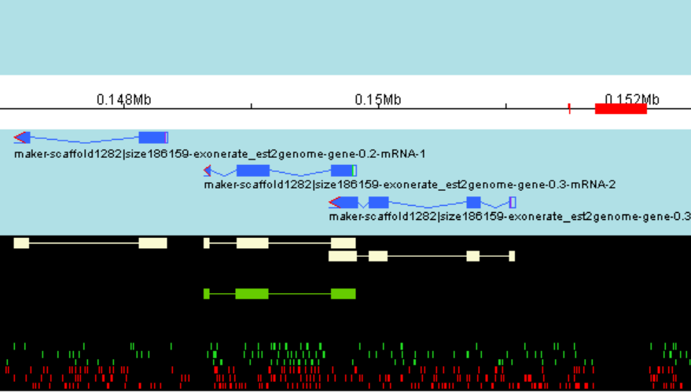
Figure S1. Illurstration of Structural Annotation of scaffold1282

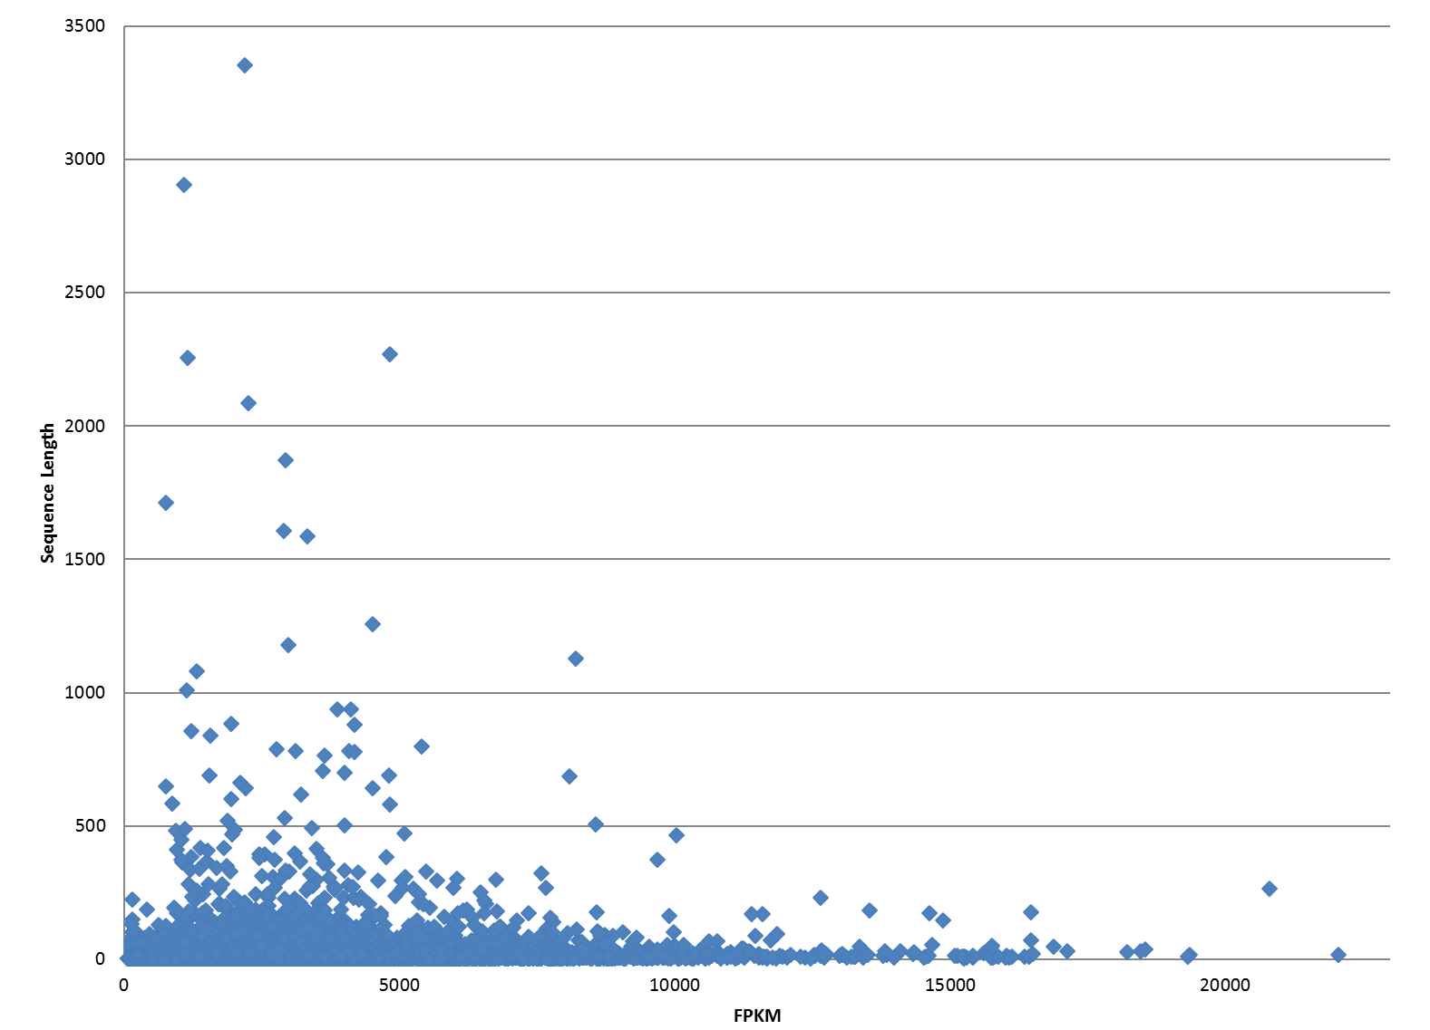
Figure S2.Relationship between the length and abundance of assembled Unigenes.

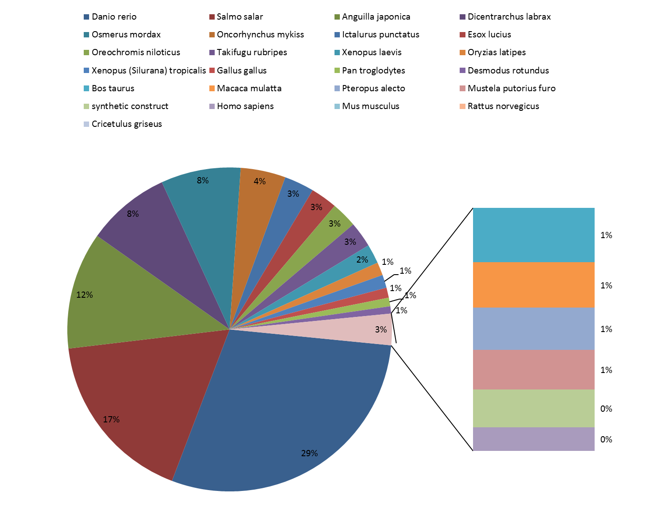
Figure S3.Species distribution of top BLASTx results.

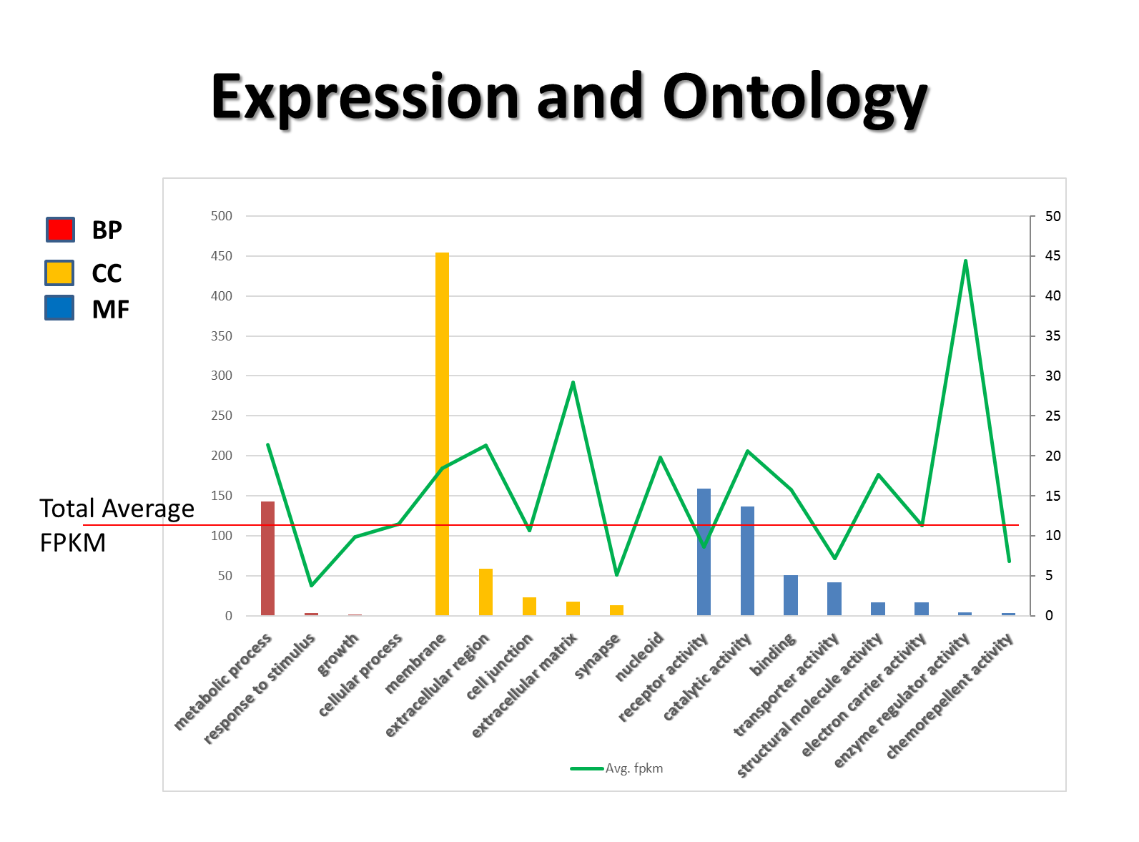
Figure S4. Gene ontology classifications of assembled Unigenes.
In this figure, amounts of unigenes associated with GO terms were illustrated in the value of y axis. The green line represent the average FPKM of the unigenes associated with the terms illustrated in x axis.

Figure S5.KEGG Orthology (KO) classification of assembled unigenes.
In this figure, amounts of unigenes associated with KEGG Orthology terms were illustrated in the value of y axis. The orange line represent the average FPKM of the unigenes associated with the terms illustrated in x axis.

Figure S6. Distribution of transcripts on KEGG Orthology (KO) pathways

Fig S7. Histogram presentation of clusters of orthologous groups (COG) classification
In this figure, amounts of unigenes associated with clusters of orthologous groups (COG) terms were illustrated in the value of y axis. The orange line represent the average FPKM of the unigenes associated with the terms illustrated in x axis.

Fig S8. Histogram presentation of Pfam classification
In this figure, amounts of unigenes associated with Pfam conserve domains were illustrated in the value of y axis. The orange line represent the average FPKM of the unigenes associated with the Pfam family illustrated in x axis.

TABLES
Table S1 Summary of the Illumina HiSeqTM 2000 sequencing result as well as quality control (QC)
 | Read Amount
Total read | 85,233,812.00
Read after QC | 77,939,562
 | Read Length (Nucleotides)
Read Length | 101
Average Read Length after QC | 99.575

Table S2 Length (nucleotides) of the de novo assembled transcripts
Assembly Tool | SOAPdenovo | Trinity | Oases | Clustered Unigenes
Total Length | 167,769,859 | 151,865,571 | 201,936,793 | 60,135,484
N50 | 150 | 1294 | 2,395 | 3,734
N90 | 100 | 296 | 510 | 1,024
Mean | 150 | 766 | 1,212 | 1,867
Max | 3,196 | 16,604 | 22,550 | 22,064
Min | 100 | 201 | 100 | 100
Median | 105 | 414 | 619 | 931

Table S3 Composition of the assembled Unigenes in length
Assembly Tool | SOAPdenovo | Trinity | Oases | Clustered Unigenes
Number of Unigenes<300b | 93.68% | 32.52% | 28.22% | 25.50%)
Number of Unigenes>=300b | 6.32% | 67.48% | 71.78% | 74.50%
Number of Unigenes>=1kb | 0.14% | 21.76% | 37.58% | 49.12%
Number of Unigenes>=2kb | 0.01% | 8.28% | 19.56% | 36.91%

Table S4 Summary of annotation, amount of assembled Unigenes
Annotation | Amount of Unigenes
BLASTx against NR | 16106
BLASTx against Swissprot | 15,263
GO terms | 13,434
RPSBLAST against CDD | 10,848
COG domains | 3,594
Pfam domains | 9,600
KEGG ORTHOLOGY | 5,641

