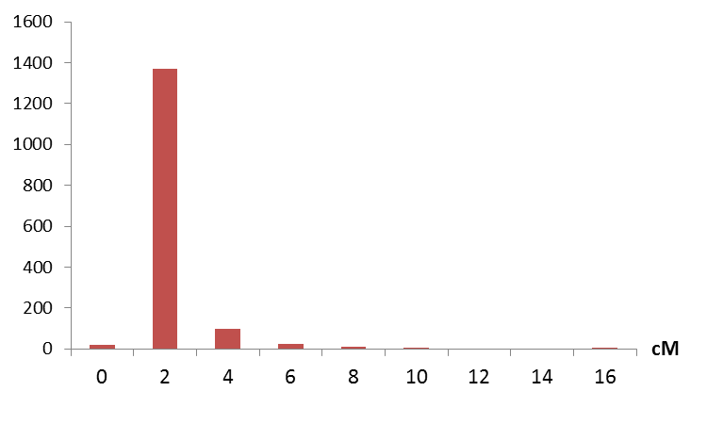

Figure S1. Distributions of the interval distances between adjacent markers on the genetic map.

Figure S2. Length distributions of the anchored scaffolds.

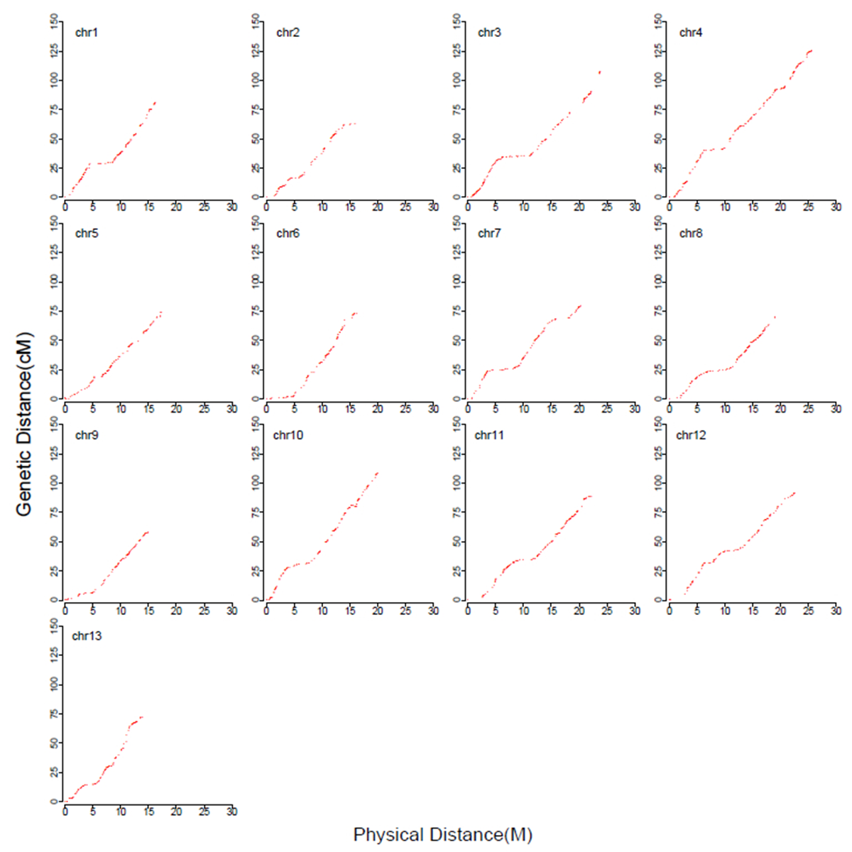
Physical distance (Mb)

Figure S3. Genetic distance vs. physical distance. The genetic position of the genetic markers was plotted against the corresponding physical position.

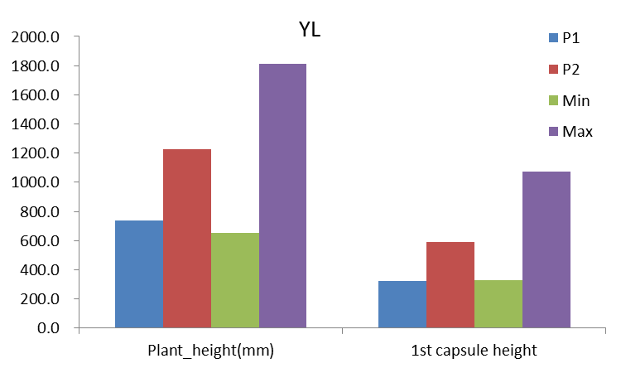

Figure S4. Variations in sesame plant height and the height of the first capsule-bearing node in the two parents and RILs.

Plant height
Height of 1st capsule-bearing node
Tip length without capsule
Internode length
Capsule zone length
Node number

Figure S5. Boxplots of sesame plant height and related traits of the population across three trial sites. WC:Wuchang; PY: Pingyu; YL: Yangluo.

Figure S6.Histograms of the segregation of sesame plant height and related traits across three field trials. WC:Wushang; PY: Pingyu; YL: Yangluo.

Figure S7. Distributions of the L*, a*, and b* color space values across two trial sites. PY: Pingyu; YL: Yangluo.

