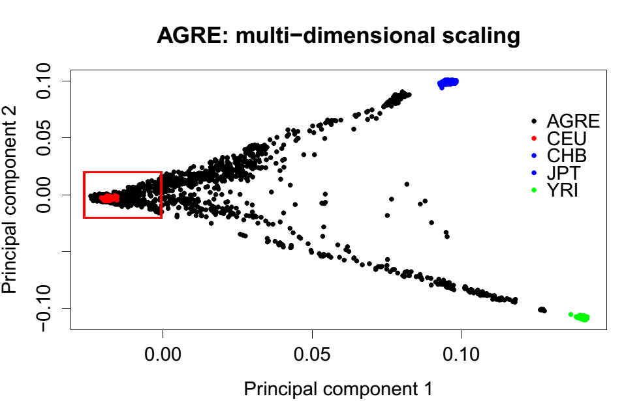
Additional file 1 - Two-dimensional Multidimensional Scaling (MDS) plot of the AGRE population. Black dots represent AGRE individuals; colored dots represent HAPMAP3 project populations. CEU: Utah residents with Northern and Western European ancestry from the CEPH collection; CHB: Han Chinese in Beijing; JPT: Japanese in Tokyo; YRI: Yoruba in Ibadan, Nigeria.

