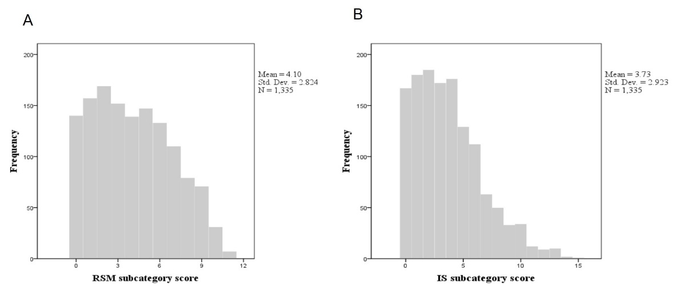
Additional file 5 – Distribution of RSM subcategory scores (left) and IS subcategory scores (right) in the AGRE sample

