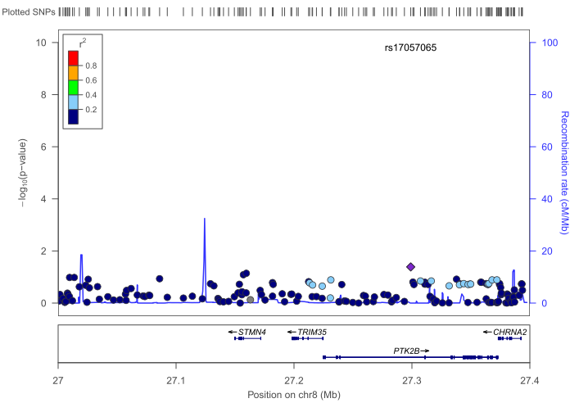

Additional file 7. Regional plot showing association mapping results for SNPs located within chromosome 8p21.1-8p21.2 region for RSM/IS in SSC dataset. Each filled circle represents the P-value for one SNP, with the top SNP, represented by a purple diamond and additional associated SNPs represented by colors showing their degree of linkage disequilibrium (r²) with the top SNP (as estimated internally by the Locus Zoom program based on data from CEU (Utah residents of Northern and Western European ancestry HapMap haplotypes) population. Genes within the region are shown in the lower panel, and the unbroken blue line indicates the recombination rate within the region.

