.
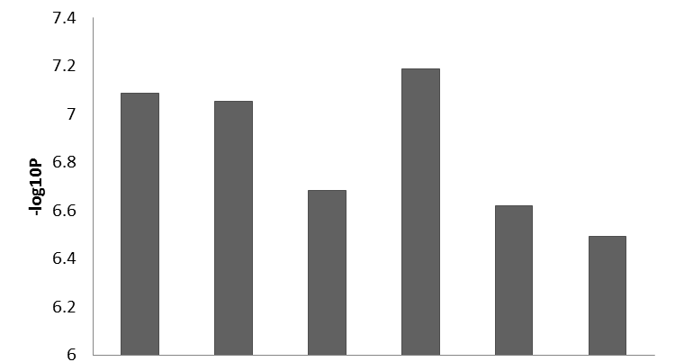

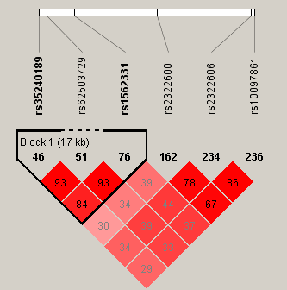

Additional file 8. Haploview linkage disequilibrium (LD) plots for genotyped SNPs and the top three associated SNPs in Table 5 of the manuscript. (top) Bar plot shows the –log10 transformed GEMMA P-values of the genotyped SNPs and the top three SNPs in Table 5. (bottom) LD block comprising the 6 SNPs. Each box contains the estimated value of the pairwise r² LD constant, with the intensity of the red color representing stronger LD. : Genotyped SNPs.

