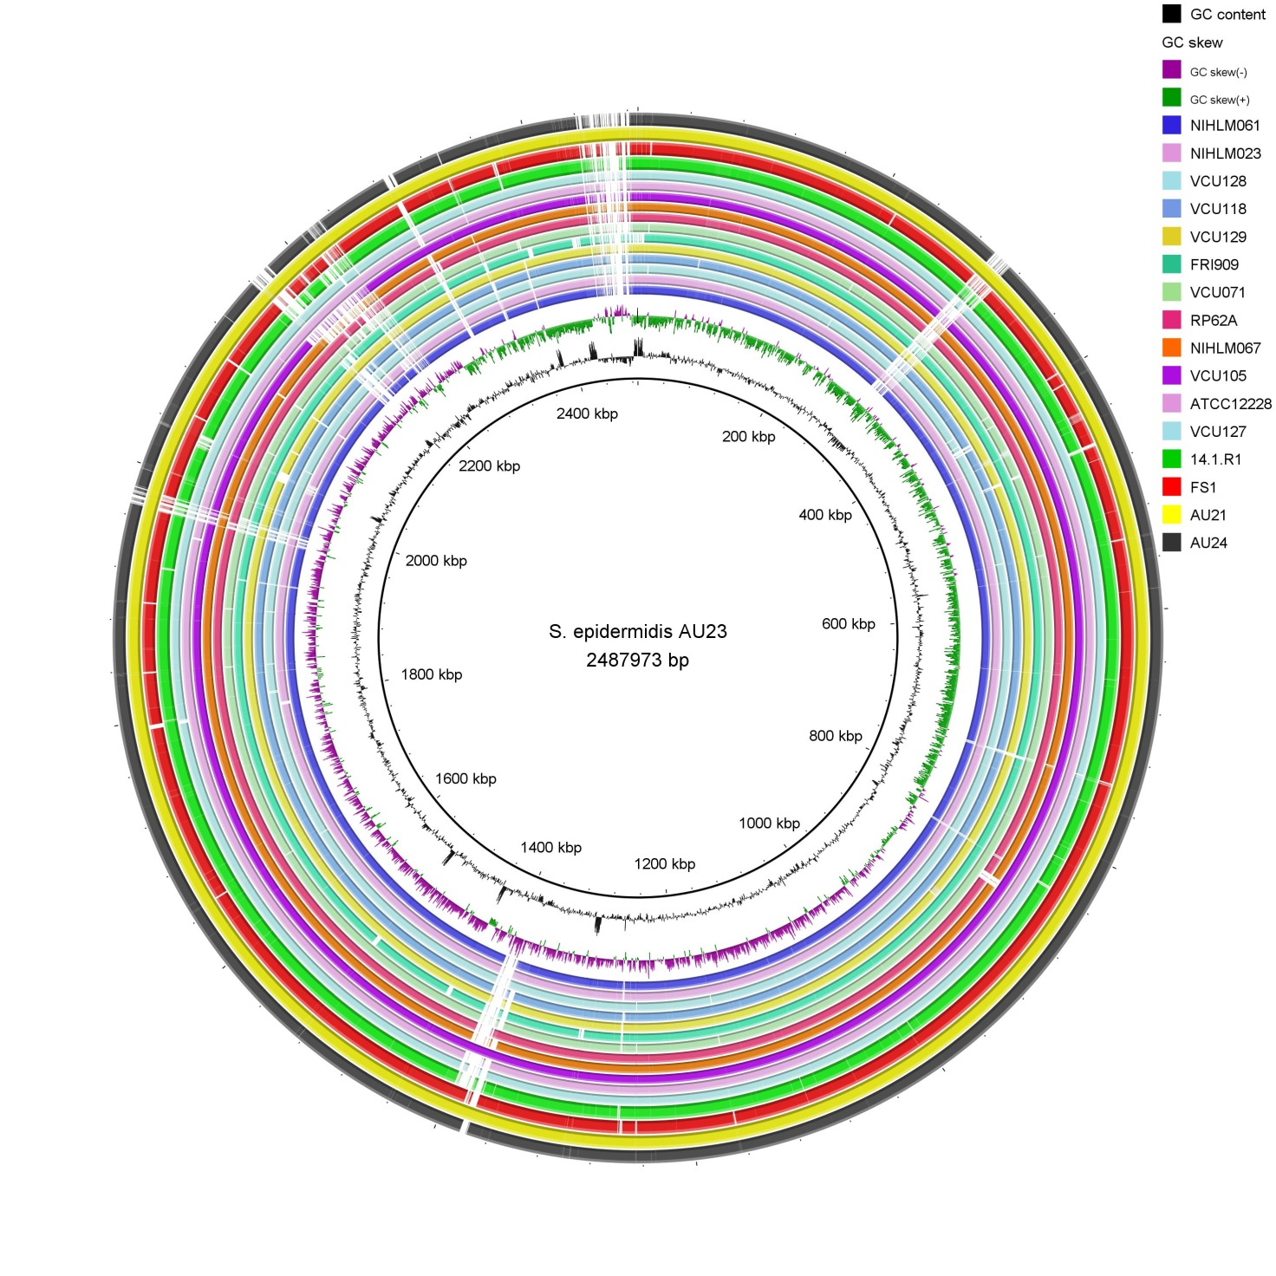
1
7
6
5
4
3
2
Additional file 6A. Genome comparison of 17 S. epidermidis strains with strain AU23 as reference
Newly sequenced genomes were included (FS1, AU21, AU24). The other 13 genomes were selected based on their position in the phylogenetic core genome tree (Figure 2).Regions of genomic variability (1-7) can be detected (see Additional file 7A for their gene content). The BRIG program was used to generate the figure.

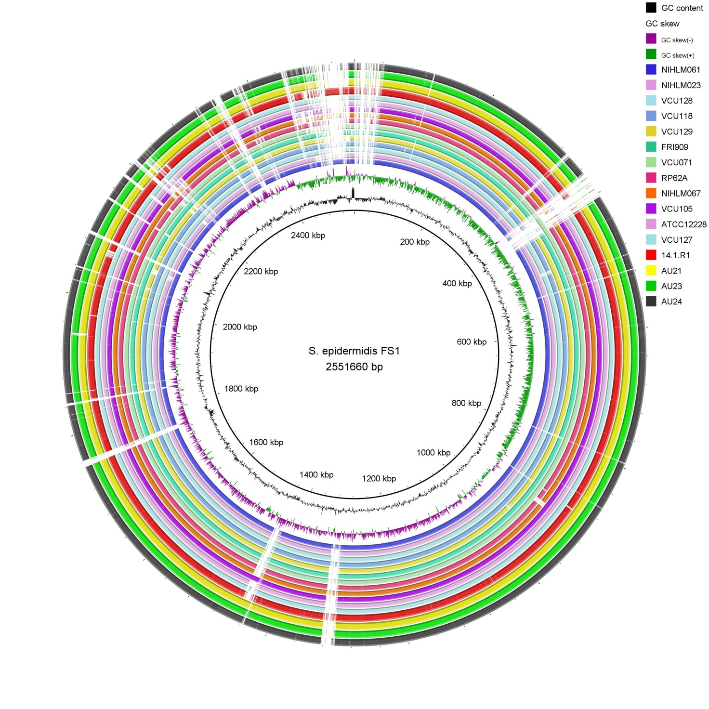
8
1
10
9
7
4
3
2
6
5

Additional file 6B. Genome comparison of 17 S. epidermidis strains with strain FS1 as reference
Newly sequenced genomes were included (AU21, AU23, AU24). The other 13 genomes were selected based on their position in the phylogenetic core genome tree (Figure 2). Regions of genomic variability can be detected (see Additional file 7B for their gene content). The BRIG program was used to generate the figure.

