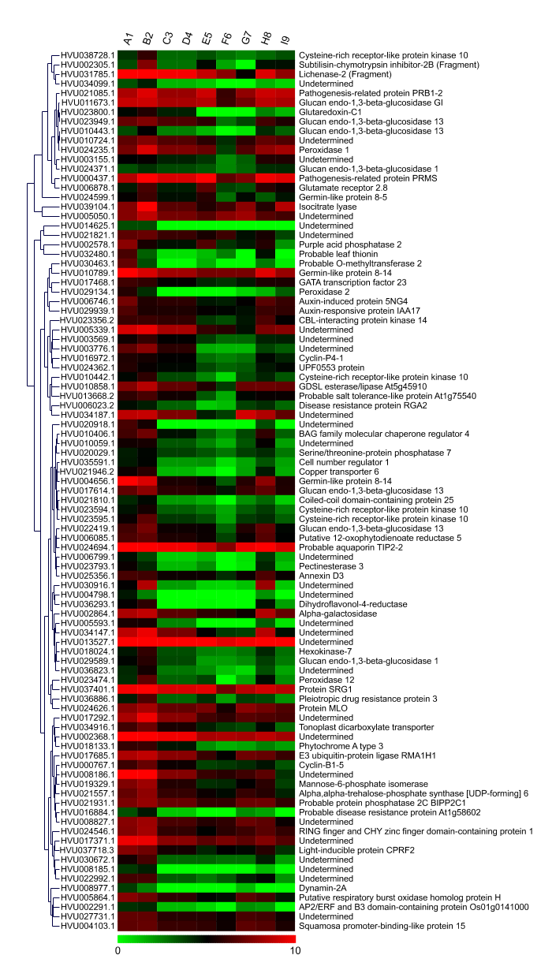
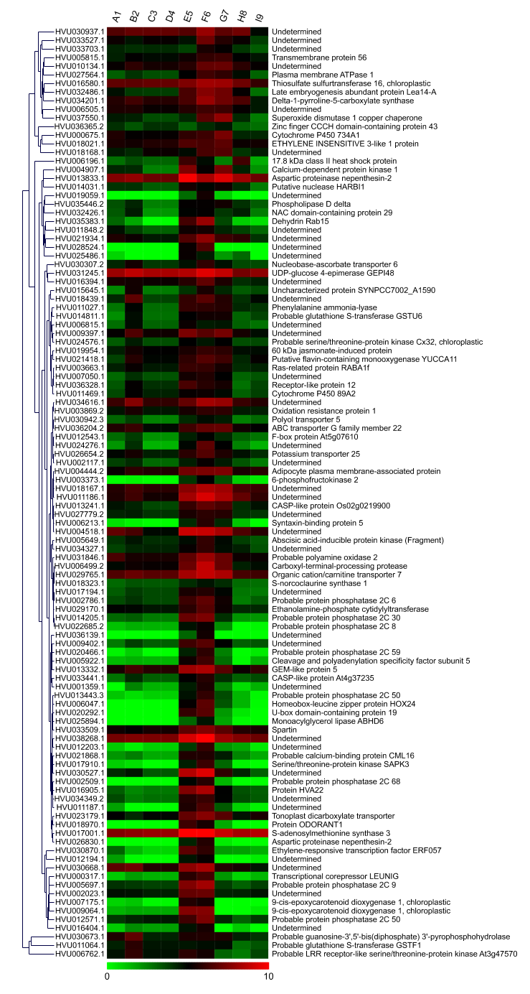
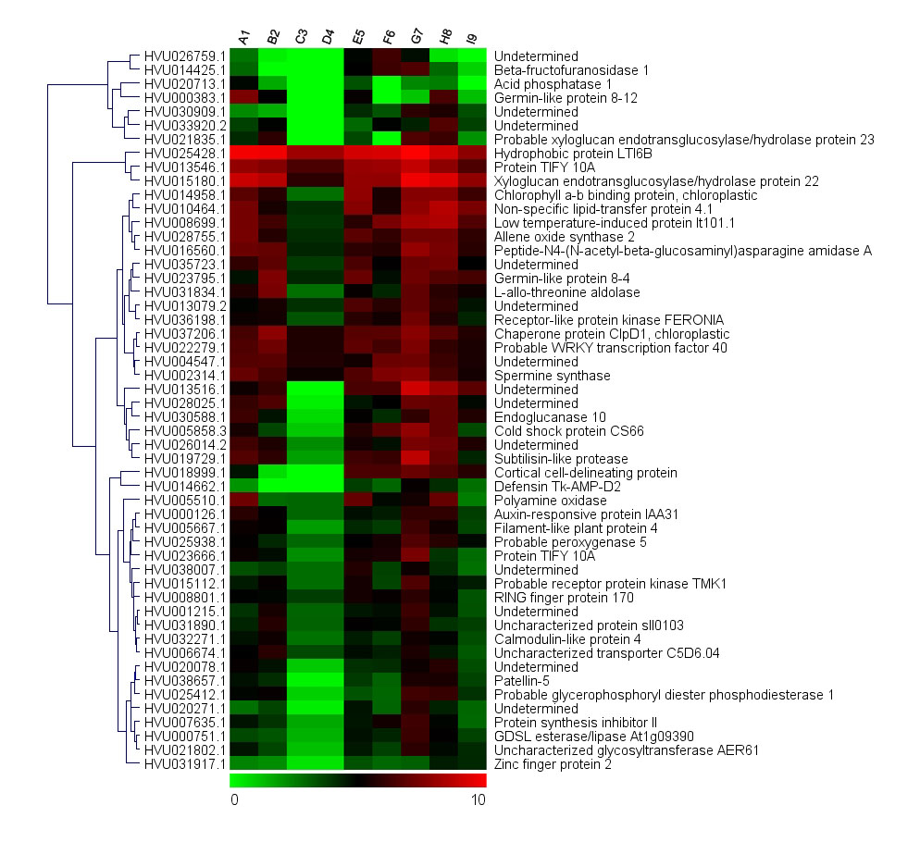
Supplementary Figure 1a
Supplementary Figure 1b
Supplementary Figure 1c
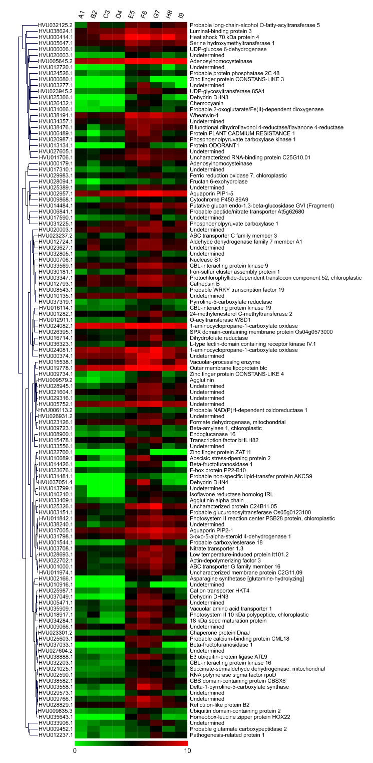
Supplementary Figure 1d

Additional file 1: Figure S1. Gene expression for the cluster, IV (a), VI (b), VII (c), and VIII (d) showing down-regulated pattern under drought stress. The columns show the 9 samples A1, B2, C3, D4, E5, F6, G7, H8, I9, while the rows show the log-transformed RPKM values of 93 genes in cluster IV, l08 genes in cluster VI, 52 genes in cluster VII, and 119 genes in cluster VIII, respectively. Hierarchical clustering of expression pattern for genes in was shown at the left of heat-map figure.

