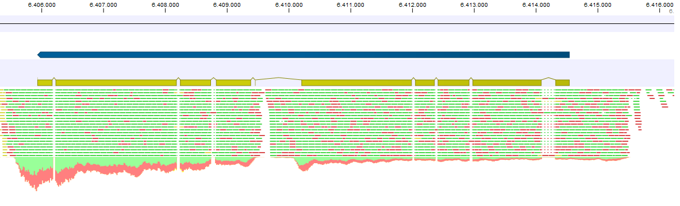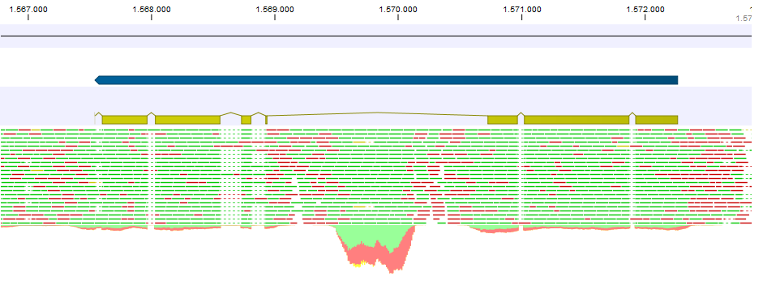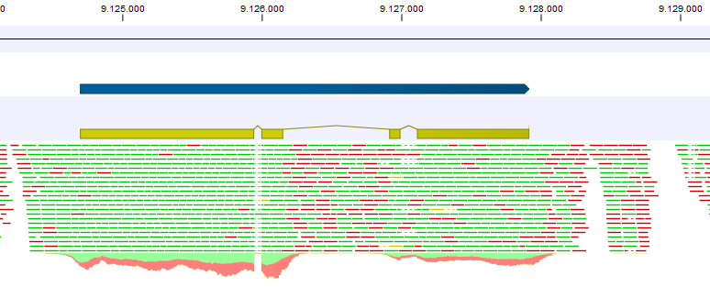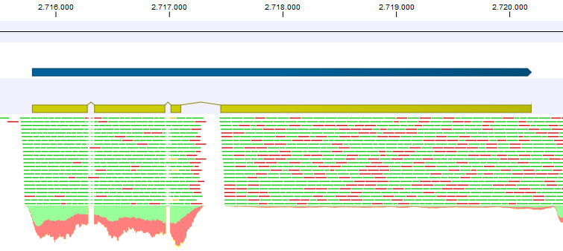Additional file 1 – Fragmented BUSCOs in F. poae and F. graminearum. A: Fusarium poae predicted proteins that were identified as fragmented by the BUSCO analysis. The top track corresponds to the predicted gene model, the second track shows the predicted coding features and the bottom track shows the TopHat mapping of the RNAseq reads. Arrows indicate likely sites of miss-annotation (likely fusion of two separate genes). From top to bottom: g7865, g6381, g8721 and g6717.
A
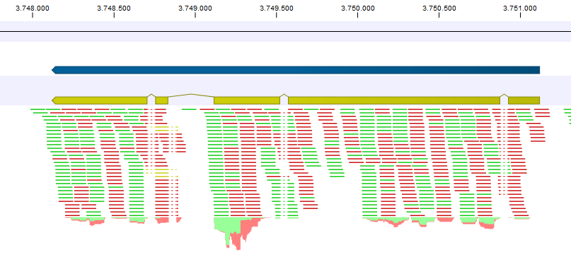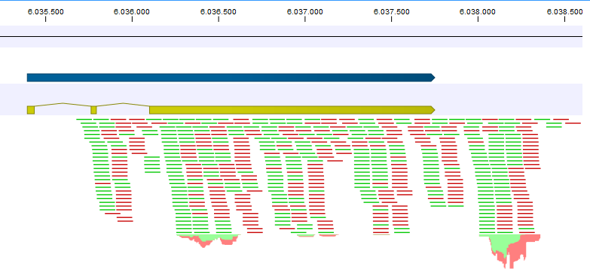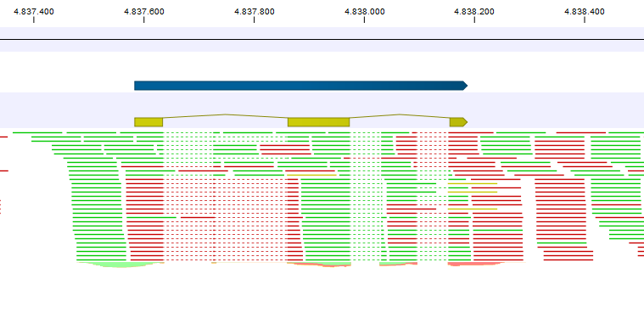
B
Additional file 1 – Fragmented BUSCOs in F. poae and F. graminearum. B: Predicted proteins in the F. graminearum set that were identified as fragmented by the BUSCO analysis. The top track corresponds to the predicted gene model, the second track shows the predicted coding features and the bottom track shows the TopHat mapping of the RNAseq reads. Arrows indicate likely sites of miss-annotation From top to bottom: FGRRES_16573 (likely fusion of two neighboring genes), FGRRES_10897 (likely addition of two exons), FGRRES_06268 (likely two exons missed). RNAseq data described in Zhao et al. (2014) were used.
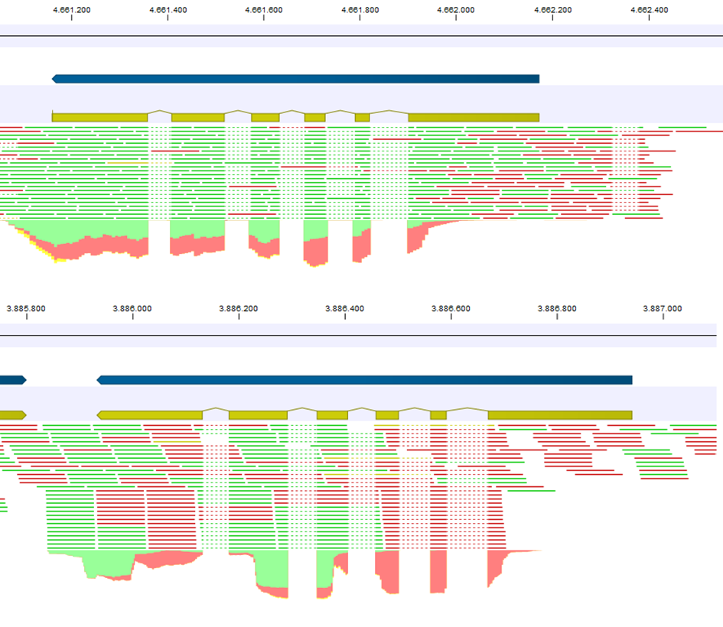
C
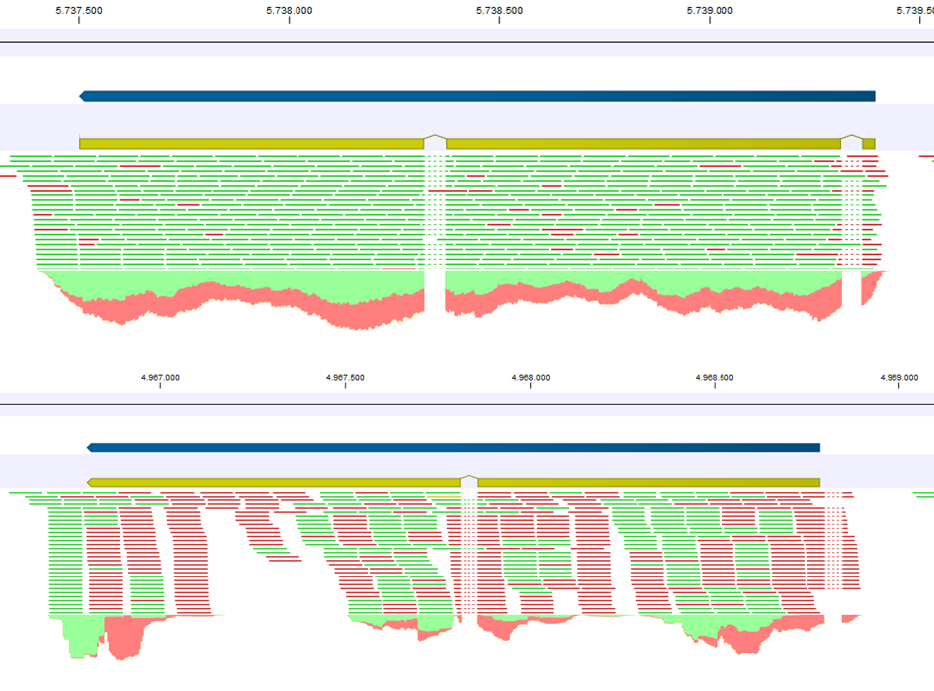
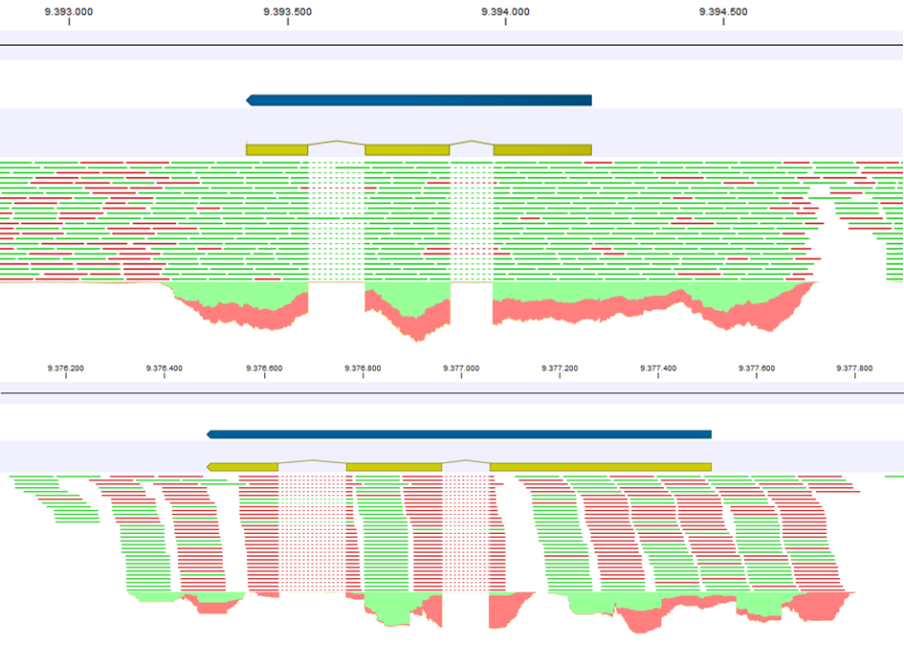
Additional file 1 – Fragmented BUSCOs in F. poae and F. graminearum. C: Predicted proteins in the F. poae and F. graminearum set that were identified as fragmented by the BUSCO analysis and are shared between the two species. The top track corresponds to the predicted gene model, the second track shows the predicted coding features and the bottom track shows the TopHat mapping of the RNAseq reads. From top to bottom: g1567/FGRRES_05972, g1914/FGRRES_06308, g8796/FGRRES_09970. The first of the two visualizations corresponds to F. poae, the second corresponds to F. graminearum.

