Supplementary Material
Supplmental Figures

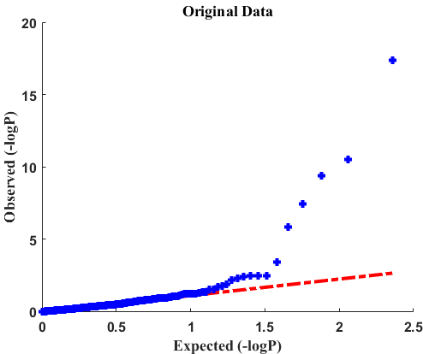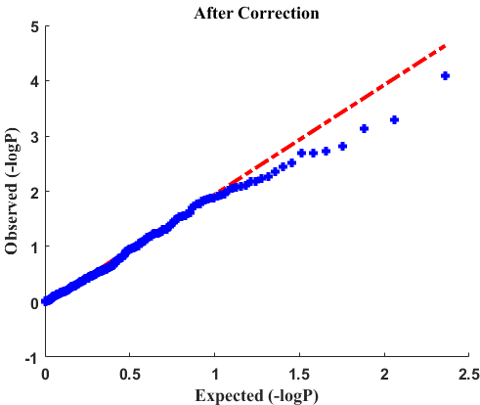
Additional file 1: Figure S1: Effect of storage time correction. Left: QQ plot of p-values of bivariate correlation between original metabolite features and storage time; Right: QQ plot of p-values of bivariate correlation between metabolite features and storage time after correcting effects of storage time based on HCs.

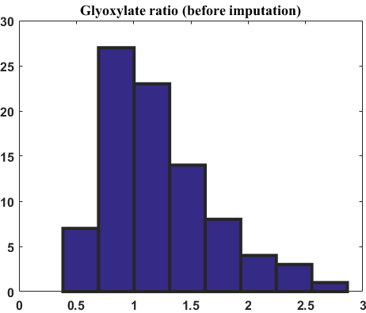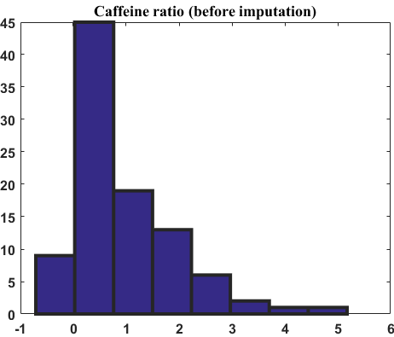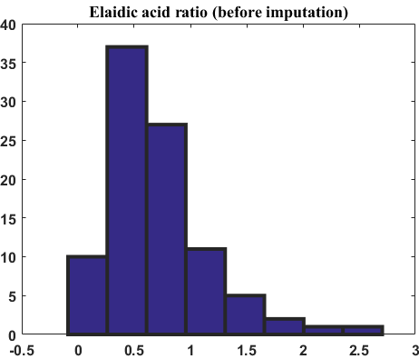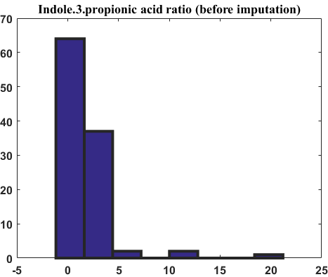
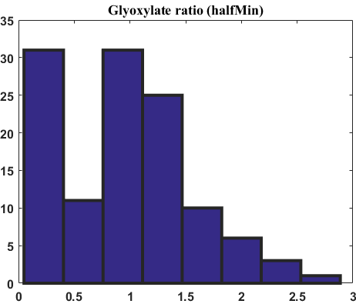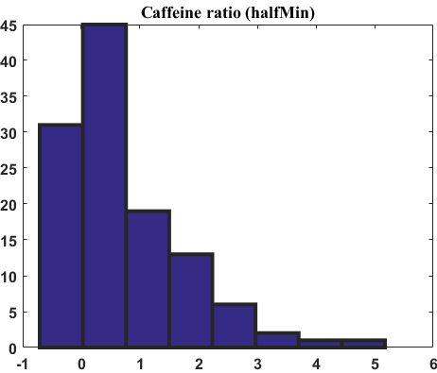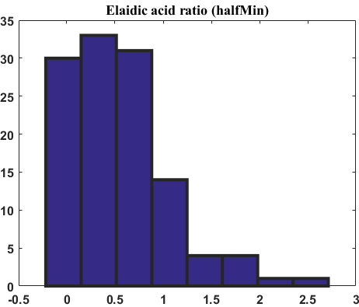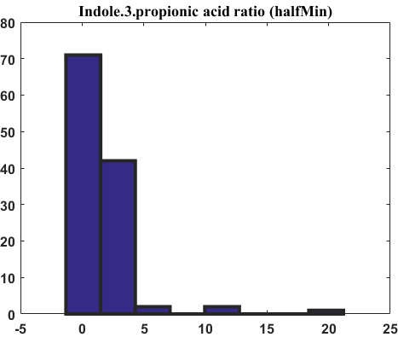
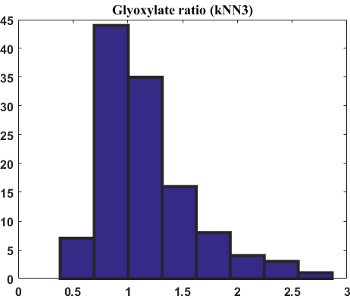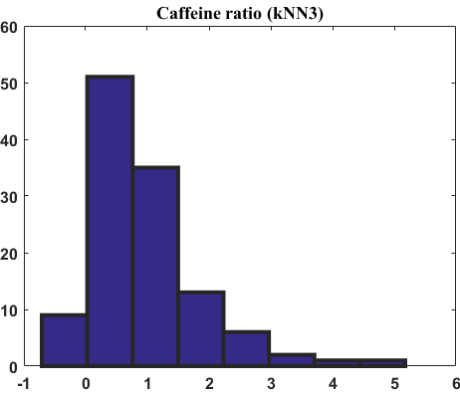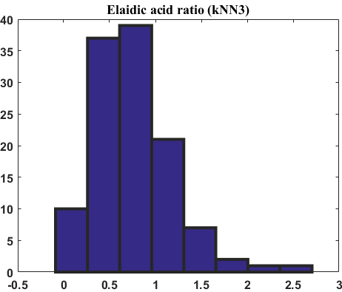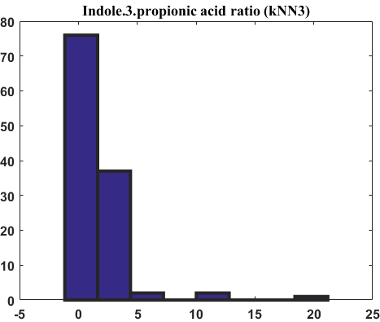
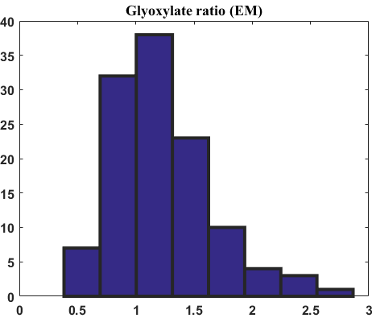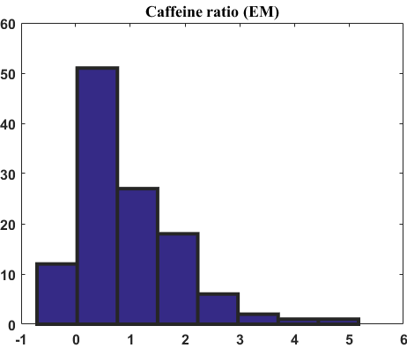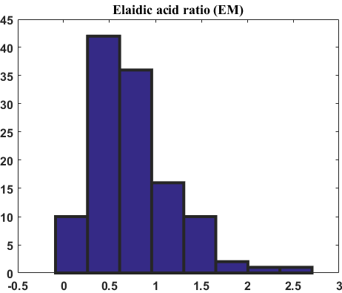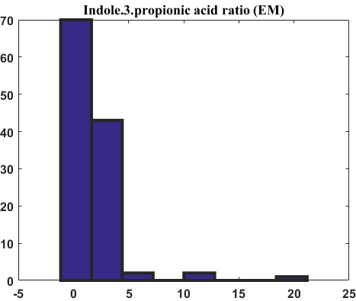
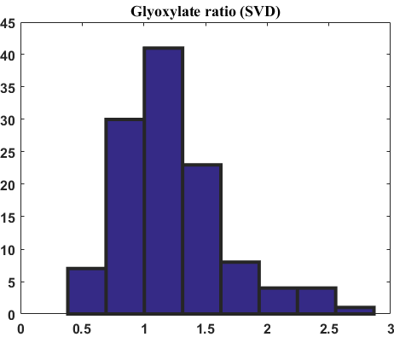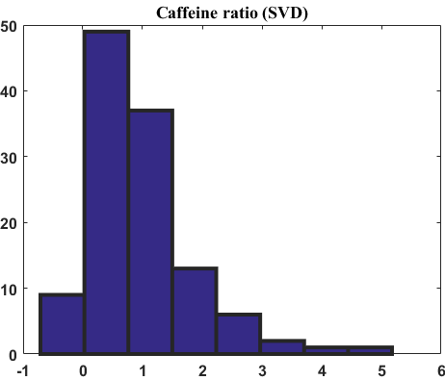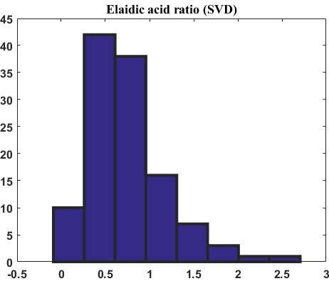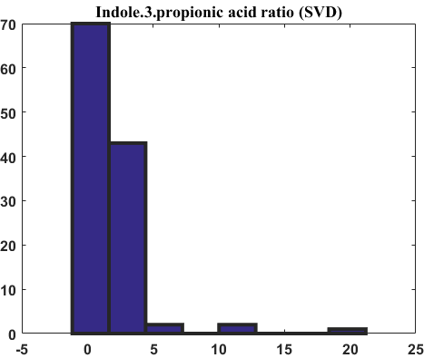
Additional file 1: Figure S2: The distributions of original and imputed metabolite features: Glyoxylate ratio, Caffeine ratio, Elaidicacid ratio and Indole 3 propionic acid ratio. The first row corresponds to the distribution of original feature values; the second row corresponds to the distribution of feature values imputed by the halfMin methods; the third row corresponds to the distribution of feature values imputed by the kNN3; the fourth row corresponds to the distribution of feature values imputed by the EM; the fifth row corresponds to the distribution of feature values imputed by the SVD.

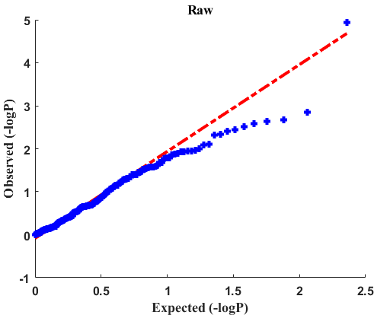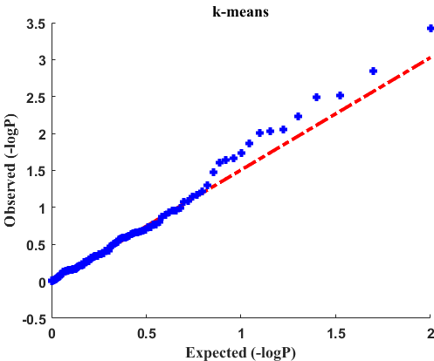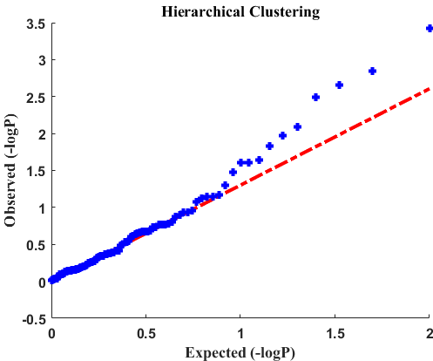
Additional file 1: Figure S3. QQ plots of the p-values of the two-sample t-tests on raw features, k-means and hierarchical clustering representatives. The missing values in the data set are imputed via kNN3 method.

Supplemental Tables

Additional file 1: Table S1. Classification performance obtained by Random Forest on metabolite data using the standard undersampling technique. We compare 2 imputation methods, half of minimum values (halfMin) and K-nearest-neighborhood (K=3, kNN3). We compare 4 feature selection methods including T-test, Fisher Information (Fisher), Gini, and stability selection (Stability).
Raw Features
Imputation | halfMin |  |  |  | kNN3 |  |  |  | EM |  |  |  | SVD
FS method | Fisher | Gini | T-test | Stability | Fisher | Gini | T-test | Stability | Fisher | Gini | T-test | Stability | Fisher | Gini | T-test | Stability
Accuracy | 73.60% | 72.76% | 73.60% | 71.39% | 74.54% | 73.73% | 74.54% | 73.04% | 73.30% | 71.88% | 73.30% | 71.82% | 73.26% | 71.81% | 73.26% | 71.71%
Sensitivity | 67.22% | 66.89% | 67.22% | 66.06% | 66.67% | 65.28% | 66.67% | 66.17% | 63.78% | 63.67% | 63.78% | 64.67% | 63.61% | 62.56% | 63.61% | 64.22%
Specificity | 75.14% | 74.15% | 75.14% | 72.67% | 76.36% | 75.66% | 76.36% | 74.66% | 75.44% | 73.73% | 75.44% | 73.46% | 75.41% | 73.87% | 75.41% | 73.40%
Cluster-Representatives (K-means)
Imputation | halfMin |  |  |  | kNN3 |  |  |  | EM |  |  |  | SVD
FS method | Fisher | Gini | T-test | Stability | Fisher | Gini | T-test | Stability | Fisher | Gini | T-test | Stability | Fisher | Gini | T-test | Stability
Accuracy | 73.44% | 73.28% | 73.44% | 71.35% | 73.52% | 72.71% | 73.52% | 72.09% | 70.72% | 70.64% | 70.72% | 68.25% | 73.32% | 72.81% | 73.32% | 72.07%
Sensitivity | 68.33% | 70.61% | 68.33% | 68.00% | 72.67% | 69.67% | 72.67% | 70.00% | 64.11% | 64.56% | 64.11% | 64.94% | 67.61% | 66.94% | 67.61% | 66.06%
Specificity | 74.73% | 74.07% | 74.73% | 72.20% | 73.88% | 73.57% | 73.88% | 72.72% | 72.34% | 72.16% | 72.34% | 69.13% | 74.73% | 74.30% | 74.73% | 73.56%
Cluster-Representatives (Hierarchical Clustering)
Imputation | halfMin |  |  |  | kNN3 |  |  |  | EM |  |  |  | SVD
FS method | Fisher | Gini | T-test | Stability | Fisher | Gini | T-test | Stability | Fisher | Gini | T-test | Stability | Fisher | Gini | T-test | Stability
Accuracy | 68.64% | 67.65% | 68.64% | 67.49% | 72.16% | 70.88% | 72.16% | 70.87% | 67.21% | 66.60% | 67.21% | 64.71% | 69.66% | 69.17% | 69.66% | 67.57%
Sensitivity | 66.89% | 63.00% | 66.89% | 65.50% | 71.22% | 67.72% | 71.22% | 69.50% | 63.06% | 63.89% | 63.06% | 61.11% | 66.06% | 65.89% | 66.06% | 65.11%
Specificity | 69.27% | 68.87% | 69.27% | 68.10% | 72.55% | 71.79% | 72.55% | 71.41% | 68.34% | 67.47% | 68.34% | 65.76% | 70.69% | 70.13% | 70.69% | 68.36%

Additional file 1: Table S2. Classification performance obtained by Support Vector Machines on metabolite data using the standard undersampling technique. We compare 2 imputation methods, half of minimum values (halfMin) and K-nearest-neighborhood (K=3, kNN3). We compare 4 feature selection methods including T-test, Fisher Information (Fisher), Gini, and stability selection (Stability).
Raw Features
Imputation | halfMin |  |  |  | kNN3 |  |  |  | EM |  |  |  | SVD
FS method | Fisher | Gini | T-test | Stability | Fisher | Gini | T-test | Stability | Fisher | Gini | T-test | Stability | Fisher | Gini | T-test | Stability
Accuracy | 64.27% | 67.32% | 63.62% | 65.70% | 64.26% | 69.09% | 64.53% | 67.44% | 65.38% | 67.73% | 65.38% | 67.44% | 66.02% | 68.06% | 61.11% | 65.63%
Sensitivity | 57.22% | 62.17% | 58.39% | 57.11% | 57.06% | 63.17% | 56.06% | 57.78% | 57.56% | 60.22% | 57.56% | 58.28% | 58.83% | 61.67% | 51.44% | 59.50%
Specificity | 66.01% | 68.60% | 65.02% | 67.81% | 66.00% | 70.52% | 66.53% | 69.77% | 67.27% | 69.49% | 67.27% | 69.64% | 67.74% | 69.60% | 63.27% | 67.14%
Cluster-Representatives (K-means)
Imputation | halfMin |  |  |  | kNN3 |  |  |  | EM |  |  |  | SVD
FS method | Fisher | Gini | T-test | Stability | Fisher | Gini | T-test | Stability | Fisher | Gini | T-test | Stability | Fisher | Gini | T-test | Stability
Accuracy | 69.27% | 69.39% | 69.27% | 70.15% | 68.64% | 71.37% | 68.64% | 68.43% | 66.37% | 66.53% | 66.37% | 66.19% | 69.72% | 69.88% | 66.54% | 67.10%
Sensitivity | 61.94% | 69.94% | 61.94% | 62.11% | 63.61% | 68.28% | 63.61% | 60.61% | 61.28% | 62.94% | 61.28% | 65.44% | 68.00% | 64.28% | 61.72% | 68.28%
Specificity | 70.98% | 69.50% | 70.98% | 72.07% | 69.93% | 72.28% | 69.93% | 70.31% | 67.71% | 67.59% | 67.71% | 66.44% | 70.30% | 71.30% | 67.91% | 67.09%
Cluster-Representatives (Hierarchical Clustering)
Imputation | halfMin |  |  |  | kNN3 |  |  |  | EM |  |  |  | SVD
FS method | Fisher | Gini | T-test | Stability | Fisher | Gini | T-test | Stability | Fisher | Gini | T-test | Stability | Fisher | Gini | T-test | Stability
Accuracy | 67.80% | 67.98% | 67.80% | 65.79% | 68.31% | 72.47% | 68.31% | 66.51% | 66.36% | 65.18% | 66.36% | 64.84% | 69.07% | 68.28% | 69.07% | 65.96%
Sensitivity | 66.67% | 63.61% | 66.67% | 62.17% | 66.33% | 66.61% | 66.33% | 60.33% | 64.78% | 60.89% | 64.78% | 61.00% | 65.17% | 66.50% | 65.17% | 62.56%
Specificity | 68.29% | 69.17% | 68.29% | 66.72% | 68.91% | 73.98% | 68.91% | 68.02% | 66.94% | 66.33% | 66.94% | 65.87% | 70.13% | 68.94% | 70.13% | 66.96%

Additional file 1: Table S3. Top 30 individual metabolic features selected by different feature selection methods. The data is imputed by kNN3. The ensemble learning takes place on individual metabolites.

Additional file 1: Table S4. Top 30 individual metabolic features selected by different feature selection methods. The data is imputed by halfMin. The ensemble learning takes place on individual metabolites.

Additional file 1: Table S5. Top cluster-representatives (K-means) selected by different feature selection methods. The data is imputed by halfMin.

Additional file 1: Table S6. Top cluster-representatives (hierarchical clustering) selected by different feature selection methods. The data is imputed by kNN3.
Additional file 1: Table S7. Top cluster-representatives (hierarchical clustering) selected by different feature selection methods. The data is imputed by halfMin.

