Table S1. Significance tests of the orthologous gene profiles of microbial species against other species in the same genus. The non-parametric multivariate analysis MRPP (multi-response permutation procedure) based on Bray-Curtis dissimilarity distance was performed. Microbial strains in the genera with ≥2 species and each species with ≥5 strains were selected for significance tests.
Genus | Species | δ* | P
Bacillus | Bacillus thuringiensis | 0.234 | 0.001
Bacillus | Bacillus subtilis | 0.223 | 0.001
Bacillus | Bacillus anthracis | 0.25 | 0.002
Bacillus | Bacillus amyloliquefaciens | 0.194 | 0.001
Bacillus | Bacillus cereus | 0.233 | 0.001
Bifidobacterium | Bifidobacterium longum | 0.097 | 0.001
Bifidobacterium | Bifidobacterium animalis | 0.097 | 0.001
Chlamydia | Chlamydia trachomatis | 0.046 | 0.001
Chlamydia | Chlamydia psittaci | 0.046 | 0.001
Corynebacterium | Corynebacterium glutamicum | 0.117 | 0.001
Corynebacterium | Corynebacterium pseudotuberculosis | 0.125 | 0.001
Corynebacterium | Corynebacterium diphtheriae | 0.131 | 0.001
Lactobacillus | Lactobacillus rhamnosus | 0.275 | 0.003
Lactobacillus | Lactobacillus reuteri | 0.224 | 0.001
Lactobacillus | Lactobacillus plantarum | 0.237 | 0.001
Lactobacillus | Lactobacillus casei | 0.255 | 0.001
Mycoplasma | Mycoplasma gallisepticum | 0.154 | 0.001
Mycoplasma | Mycoplasma hyopneumoniae | 0.182 | 0.001
Mycoplasma | Mycoplasma genitalium | 0.199 | 0.001
Mycoplasma | Mycoplasma hyorhinis | 0.191 | 0.001
Mycobacterium | Mycobacterium tuberculosis | 0.097 | 0.002
Mycobacterium | Mycobacterium canettii | 0.097 | 0.002
Mycobacterium | Mycobacterium bovis | 0.096 | 0.024
Pseudomonas | Pseudomonas aeruginosa | 0.221 | 0.001
Pseudomonas | Pseudomonas fluorescens | 0.281 | 0.018
Pseudomonas | Pseudomonas stutzeri | 0.24 | 0.001
Pseudomonas | Pseudomonas putida | 0.243 | 0.001
Streptococcus | Streptococcus dysgalactiae | 0.233 | 0.001
Streptococcus | Streptococcus suis | 0.207 | 0.001
Streptococcus | Streptococcus pyogenes | 0.197 | 0.001
Streptococcus | Streptococcus thermophilus | 0.223 | 0.001
Streptococcus | Streptococcus pneumoniae | 0.19 | 0.001
Streptococcus | Streptococcus agalactiae | 0.221 | 0.001
*Statistic δ is the overall weighted mean of within-group means of the pairwise dissimilarities among sampling units. The significance test is the fraction of permuted δ that is less than the observed δ.

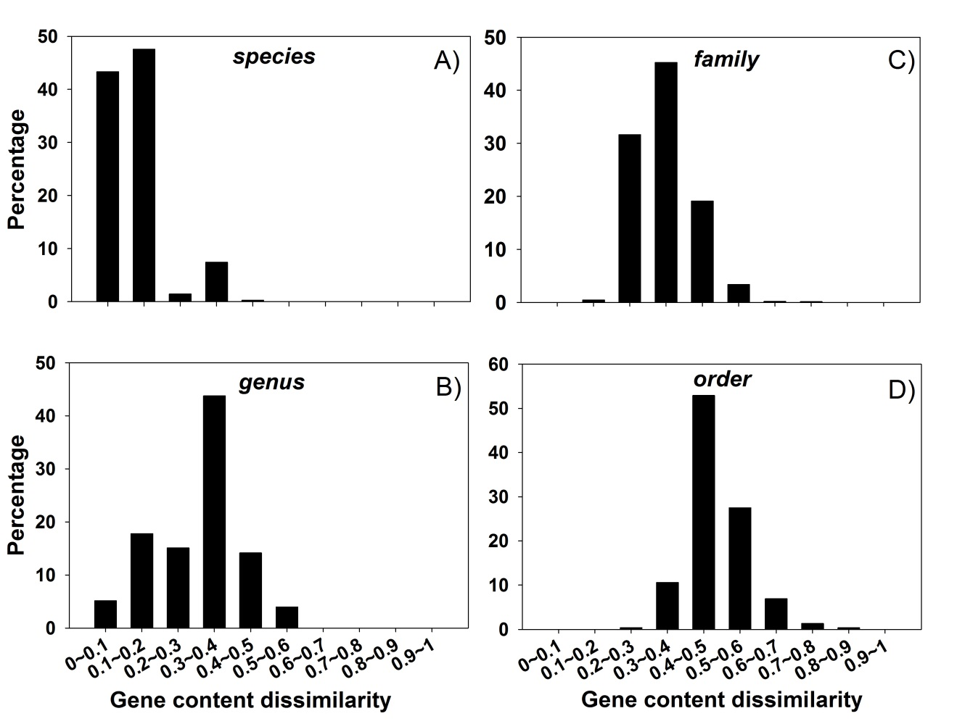
Figure S1. Distribution of gene content dissimilarity for the retrieved microbial genomes at different taxonomic levels, including species (A), genus (B), family (C), and order (D). Cutoffs of 0.2 and 0.4 were recommended for microbial species and family delineation, respectively. The eggNOG v4.5 database was used for orthologous group profiling.
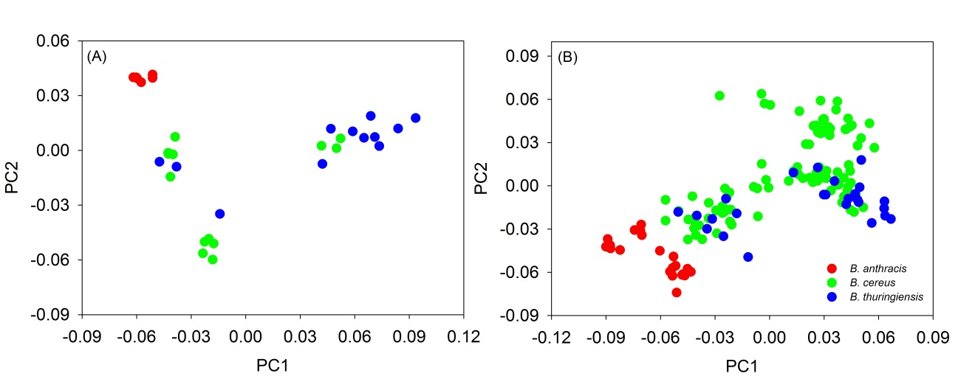
Figure S2. Application of gene content dissimilarity in classifying Bacillus cereus group strains. Two analyses were carried out here, including strains with complete genomes (A) and all strains with complete and draft genomes (B). Clear separation of B. anthracis from B. cereus and B. thuringiensis could be observed in both analyses.

