Figure S1. Plot of normalized mean counts versus log₂ fold change for the contrast NIKS versus EPE6.
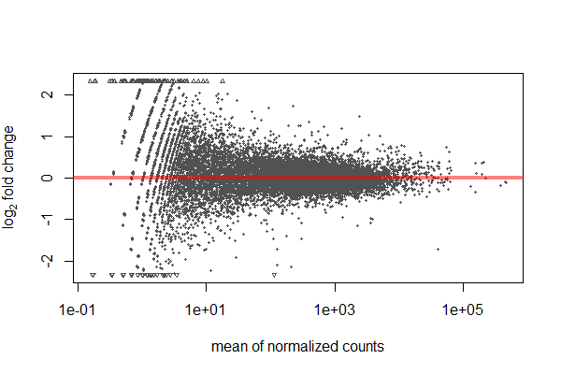
Figure S2. Plot of normalized mean counts versus log₂ fold change for the contrast NIKS versus AAE6. 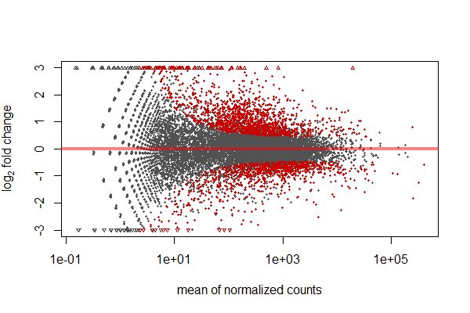
Figure S3. Plot of normalized mean counts versus log₂ fold change for the contrast EPE6 versus AAE6. 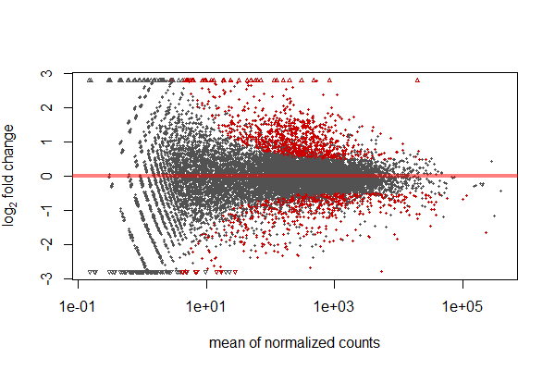
Figure S4. Empirical and fitted dispersion values plotted against the mean of the normalized human gene-level counts. 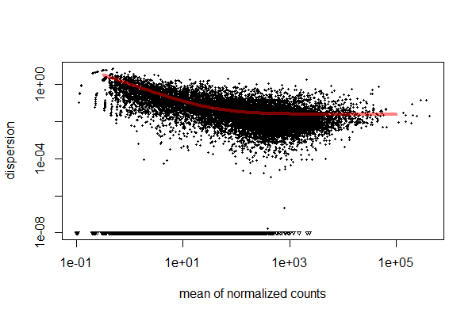
Figure S5. Heatmap of Euclidean distances between human gene-level counts of samples. Heatmap and clustering was performed after DESeq variance-stabilizing transformation of human gene-level count data.
