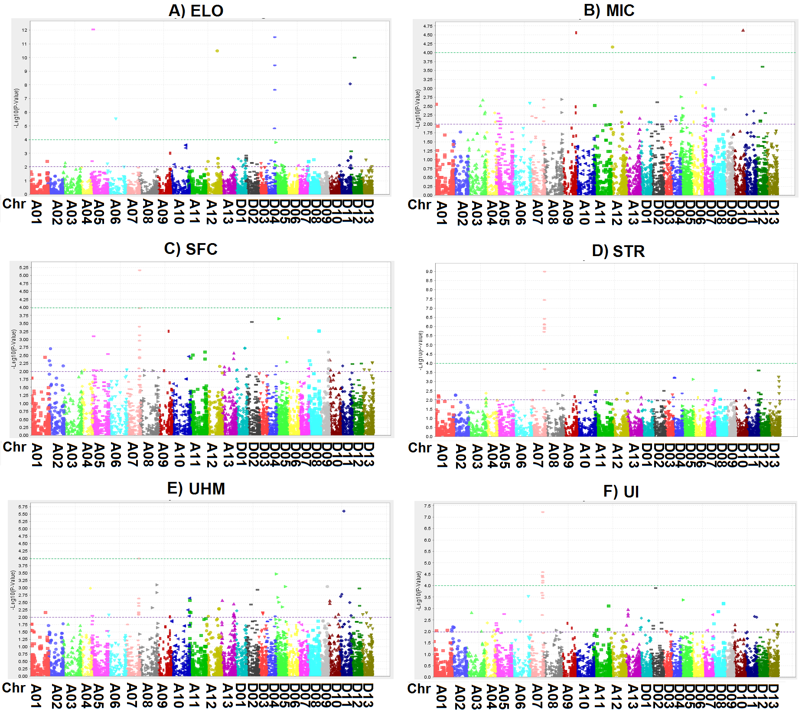
Additional file 11. Manhattan plots generated from TASSEL 5.0 software for six fiber quality traits, A) Elongation (ELO), B) Micronaire (MIC), C) Short fiber content (SFC), D) Fiber strength (STR), E) Upper half mean (UHM) fiber length, and F) Uniformity (UI). The negative log₁₀ transformed p values were plotted against the marker positions on the physical map of each of the 26 Upland cotton chromosome. The significant thresholds (p = 0.01 and 0.0001) are indicated by the purple and green horizontal dot line, respectively.

