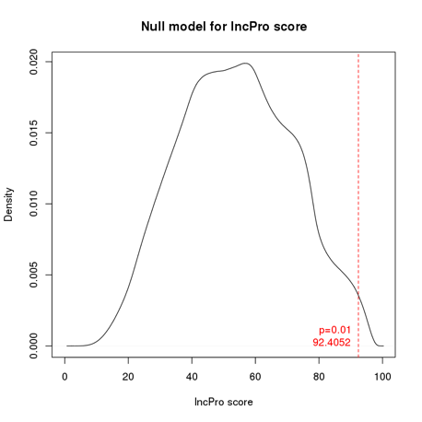
Figure S1. The empirical NULL distribution of interaction scores generated by random shuffling (calculated by lncPro). The red line is for the cutoff p value (0.01).

