Additional file 4: Figure S2
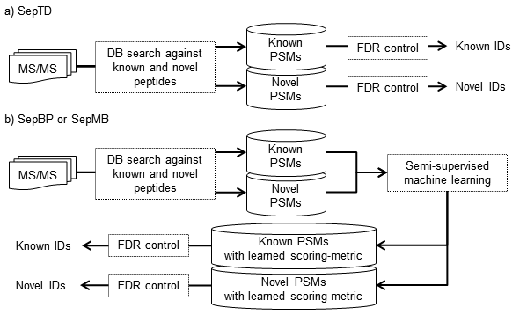
Figure S2. Workflow of separate filtering FDR methods. TD: target-decoy search strategy. BP: TD with a refined scoring-metric calculated by the self-boosted Percolator. MB: mixture model-based method. Here, SepTD, SepBP, and SepMB denote separate filtering of known and novel (or simulated novel) peptides with TD, BP, and MB, respectively. In SepTD, PMSs were divided into known and novel groups after database search. Then TD was applied to each PSM group separately. In SepBP or SepMB, semi-supervised machine learning techniques were applied to known and novel PSMs together after database search. Then the PSMs were divided into known and novel groups, and separately filtered by BP or MB.

