Additional file 7: Figure S5
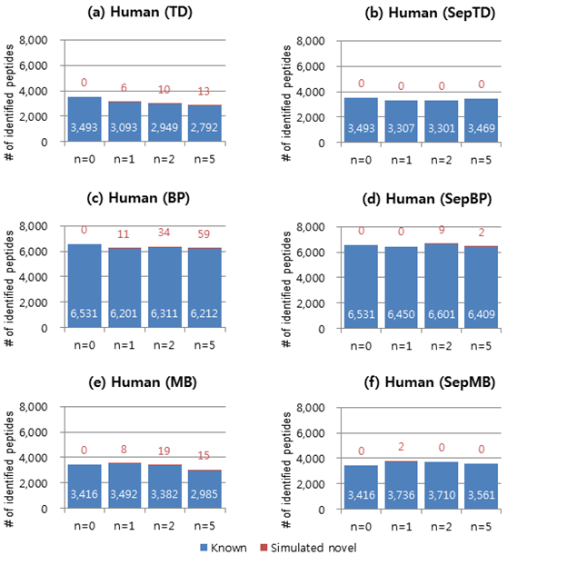
Figure S5. Peptide identification results from search against simulated proteogenomic databases for human (1TnD_{h}) using X!Tandem (n = 0, 1, 2, and 5). The number of peptides with charge 3+ at 1% FDR is shown. The six search-result validation methods were used. TD: target-decoy search strategy (a). BP: TD with a refined scoring-metric calculated by the self-boosted Percolator (c). MB: mixture model-based method (e). SepTD (b), SepBP (d), and SepMB (f) denote separate filtering of known and simulated novel peptides with TD, BP, and MB, respectively. The blue bars and numbers in white denote the number of known peptides. The red bars and numbers in red denote the number of simulated novel peptides.

