Figure S1: Volcano plots showing the expression difference of transcripts between males and females, and between males and each female morph (based on log₂ fold change- and p-values listed in Additional file 1, sheet 4-7).

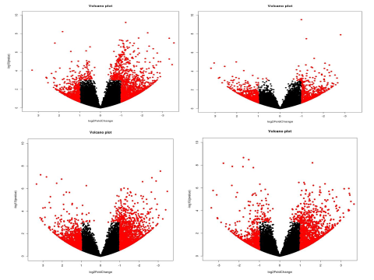
Figure S2 Carotenoid Pigmentation Pathway. Black colour denotes the substrate/product and red colour represents genes/enzymes. 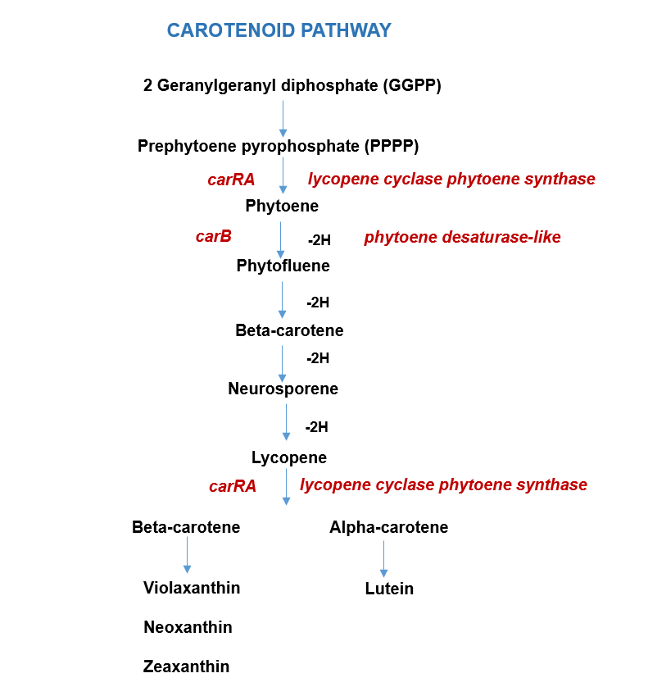

Note:
bifunctional lycopene cyclase phytoene synthase-like: up-regulated in males against androchrome
lycopene cyclase phytoene synthase: up-regulated in infuscans

Figure S3 Juvenile hormone biosynthesis pathway. Black colour denotes the substrate/product and red colour represents genes/enzymes.
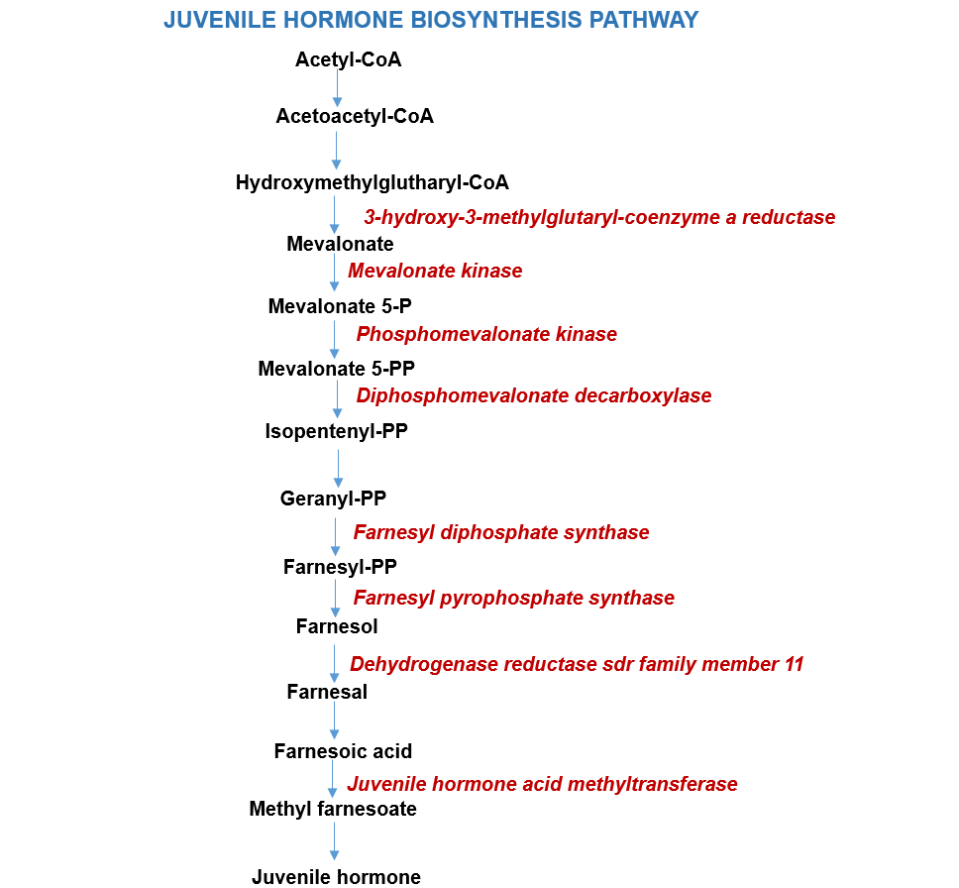

Note:
juvenile hormone acid methyltransferase: up-regulated in males against androchrome

Figure S4: Sex determination pathway. Black colour represents genes identified in assembled transcriptome.

