Systematic analysis of the lysine acetylome in Fusarium graminearum

Shanyue Zhouª, Qianqian Yang ª, Changfa Yin^{b}, Lin Liu^{c}, Wenxing Liang^{a,*}

ªCollege of Agronomy and plant Protection, The Key Lab of Integrated Crop Pests Management of Shandong Province, Qingdao Agricultural University, Qingdao 266109, China.
^{b}College of plant Protection, China Agricultural University, Beijing 100193, China.
^{c}College of Life Sciences, Shandong Province Key Laboratory of Applied Mycology, Qingdao Agricultural University, Qingdao 266109, China.

*Corresponding author: College of Agronomy and Plant Protection, Qingdao Agricultural University, No. 700 Changcheng Road, Chengyang, Qingdao, Shandong 266109, China; wliang1@qau.edu.cn

Fig. S1. Proteome-wide identification of lysine acetylation sites in F. graminearum. A, Mass error distribution of all identified peptides. B, Peptide length distribution.

Fig. S2. GO-based enrichment analysis of acetylated proteins.
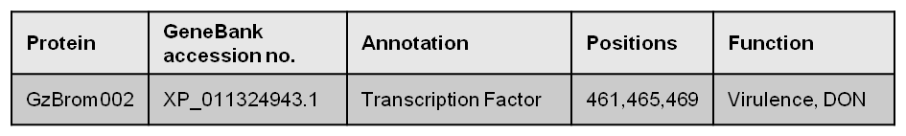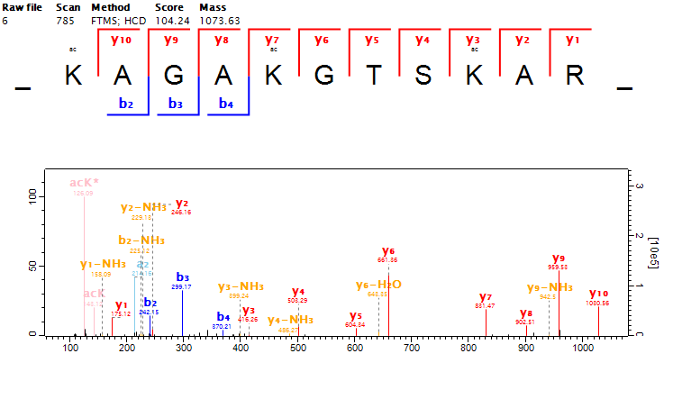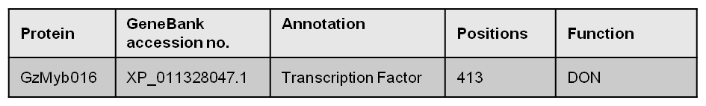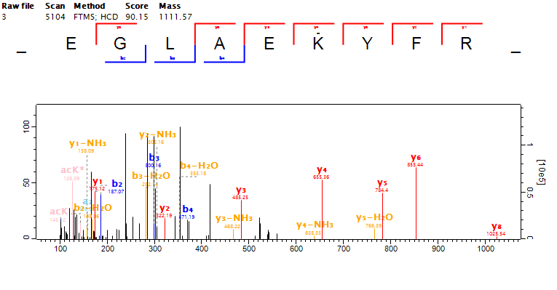

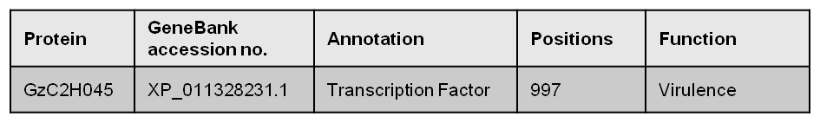
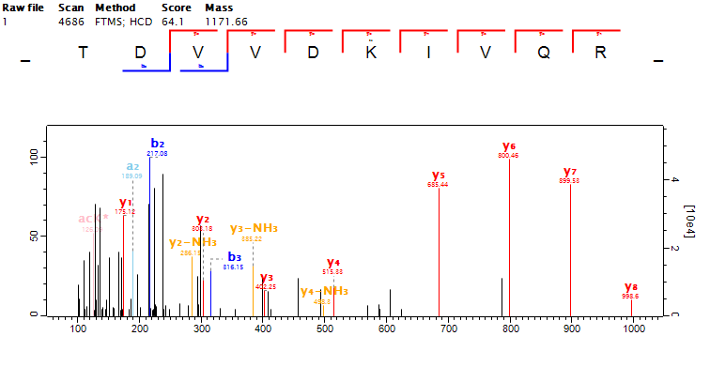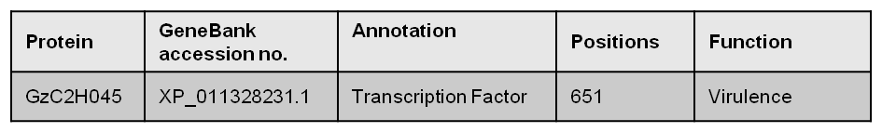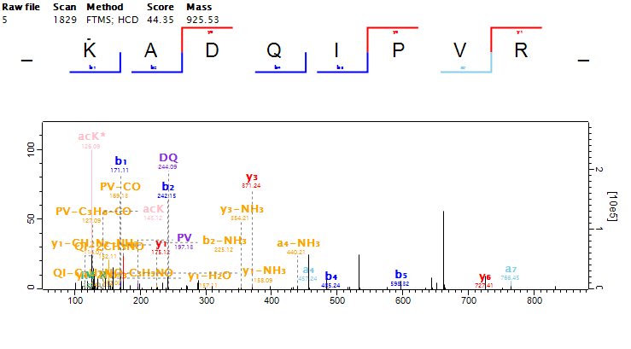

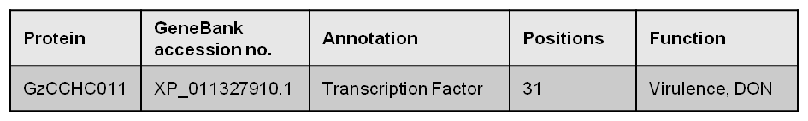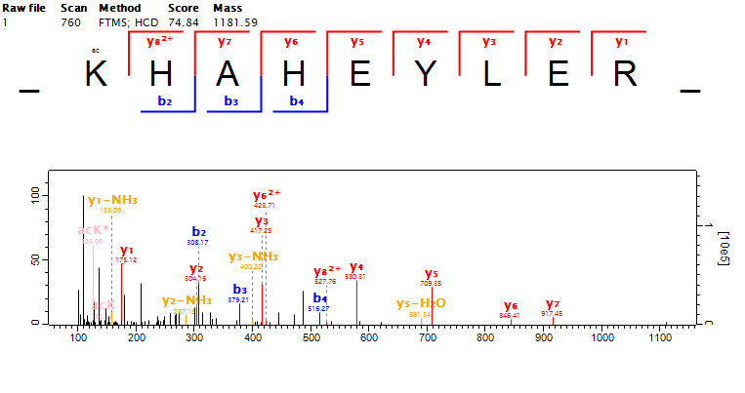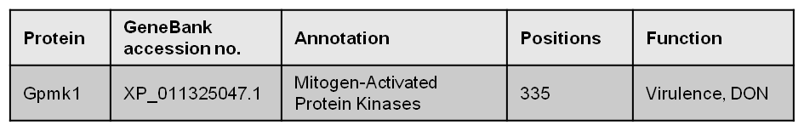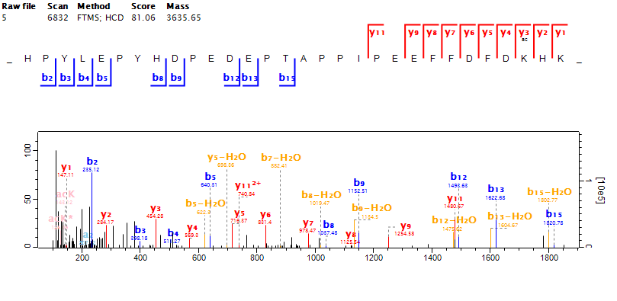

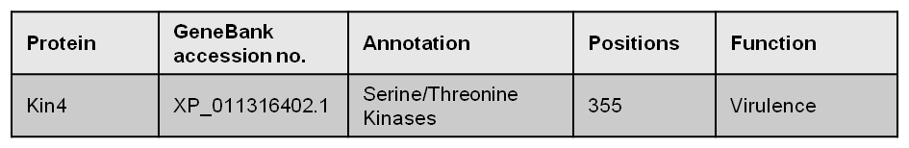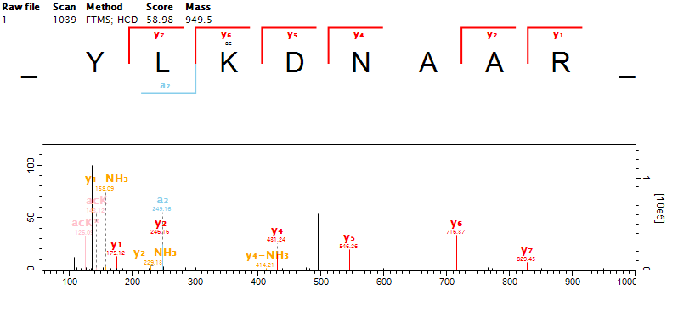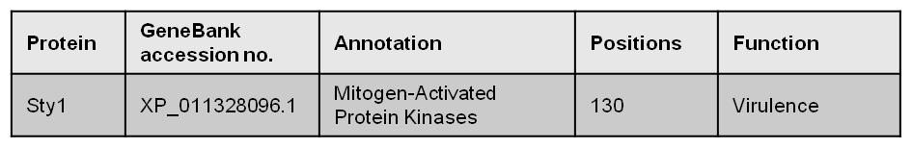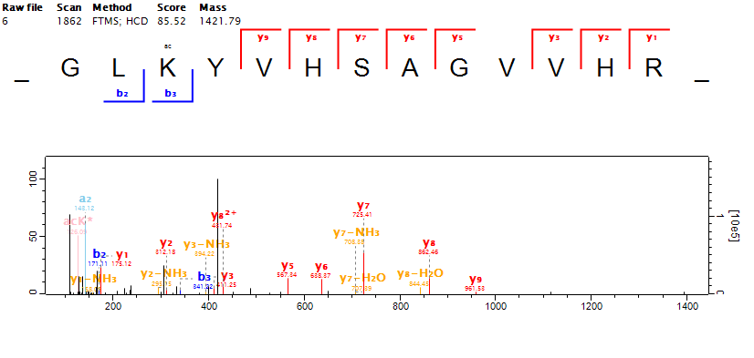

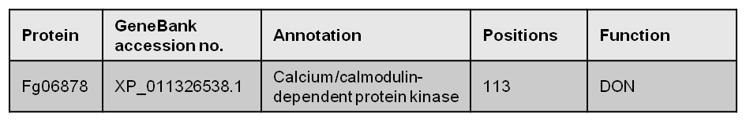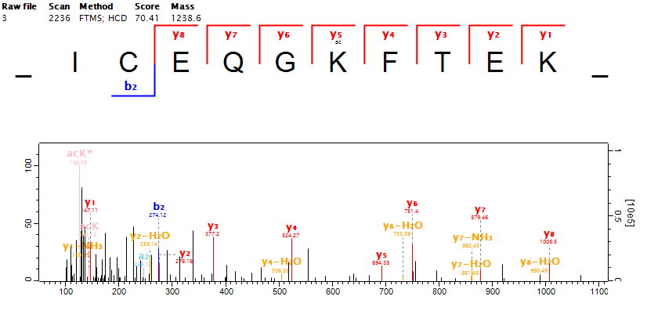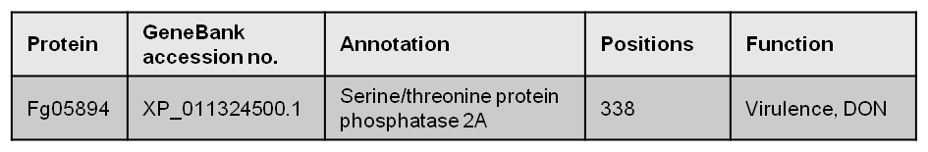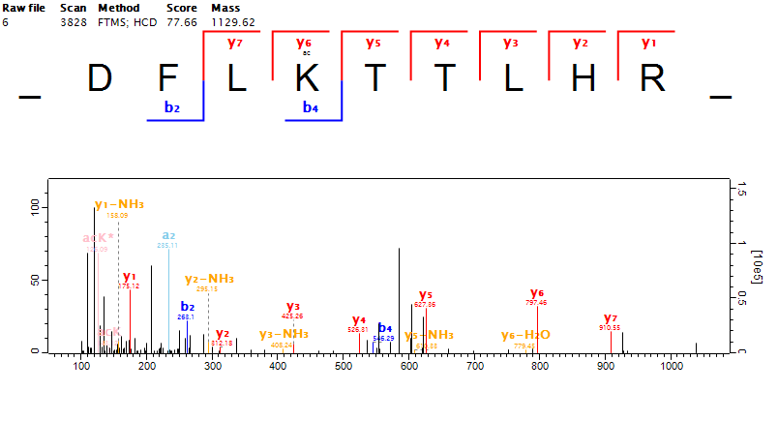

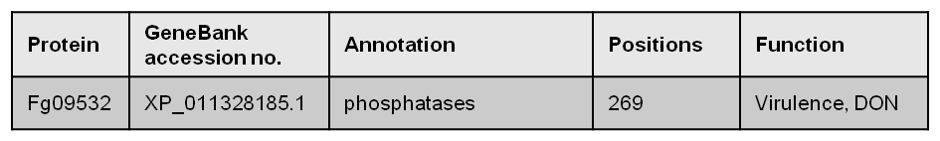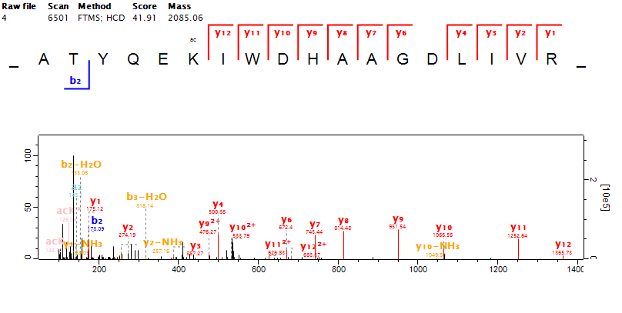
Fig. S3. The MS/MS spectra and peak assignments for the acetylated peptides involved in pathogenesis of F. graminearum.
.

Fig. S4. Interaction network of acetylated proteins associated with ribosome.

Fig. S5. Interaction network of acetylated proteins associated with glycolysis/gluconeogenesis.

Fig. S6. Interaction network of acetylated proteins associated with proteasome.

