Additional file 1

Table S1. Bowtie2 alignment results of 3,103,708 million GBS tags in absolute and relative (in parentheses) values.

GBS-Tassel pipeline pseudo-references | Non-aligned tags | Aligned tags
GBS-Tassel pipeline pseudo-references | Non-aligned tags | Overall alignment | Unique alignment | Non-unique alignment
Methyl-filtered sugarcane genome | 374,251  (12.06%) | 2,729,457 (87.94%) | 1,823,623 (58.76%) | 905,834  (29.18%)
Sorghum bicolor genome (v. 2.1) | 1,791,047 (57.71%) | 1,312,661 (42.29%) | 1,060,705 (34.17%) | 251,956 0  (8.12%)
RNA-seq sugarcane transcriptome | 1,907,985 (61.47%) | 1,195,723 (38.53%) | 1,099,697 (35.43%) | 96,026 0  (3.10%)
SUCEST project sequences | 2,362,171 (76.11%) | 741,537  (23.89%) | 256,450 0  (8.26%) | 485,087  (15.63%)

Table S2. Markers selected as cofactors for mapping through the composite interval mapping (CIM) model for the soluble solid content (BRIX, in °Brix), sucrose content of cane (POL%C, in %), fiber content (FIB, in %) and stalk diameter (SD, in mm) traits for the locations Araras-SP and Ipaussu-SP.
Location | Trait | LG | Marker selected as cofactors  for the CIM model | Location | Trait | LG | Marker selected as cofactors  for the CIM model
Araras | BRIX | 4 | mf60753_2013 | Araras | FIB | 122 | sb9_2129715
Araras | BRIX | 6 | mf62649_246 | Araras | FIB | 124 | mf333_8772
Araras | BRIX | 26 | sb8_1755137 | Araras | FIB | 167 | mf173642_165
Araras | BRIX | 42 | mf229549_282 | Ipaussu | FIB | 47 | sb3_72607370
Araras | BRIX | 47 | SCSFAM1074E10_287 | Ipaussu | FIB | 54 | sb3_63080136
Ipaussu | BRIX | 4 | mf60753_2013 | Ipaussu | FIB | 60 | mf39868_1370
Ipaussu | BRIX | 6 | mf62649_246 | Ipaussu | FIB | 124 | mf333_8772
Ipaussu | BRIX | 26 | sb8_1755137 | Ipaussu | FIB | 167 | mf173642_165
Ipaussu | BRIX | 42 | mf229549_282 | Araras | SD | 7 | sb1_60124665
Ipaussu | BRIX | 46 | mf209_8523 | Araras | SD | 35 | SCJFFL1C04F08_496
Ipaussu | BRIX | 98 | mf17470_1855:rna71385_1041 | Araras | SD | 106 | rna104430_132
Araras | POL%C | 4 | mf60753_2013 | Araras | SD | 133 | rna74863_164
Araras | POL%C | 6 | mf62649_246 | Araras | SD | 146 | sb10_12120909
Araras | POL%C | 26 | sb8_1755137 | Araras | SD | 150 | rna90367_978
Araras | POL%C | 42 | mf229549_282 | Araras | SD | 174 | mf56117_119
Araras | POL%C | 51 | sb3_72553815 | Araras | SD | 218 | rna42720_590
Ipaussu | POL%C | 4 | mf60753_2013 | Ipaussu | SD | 7 | sb1_60124665
Ipaussu | POL%C | 6 | mf62649_246 | Ipaussu | SD | 13 | sb1_3852034
Ipaussu | POL%C | 26 | sb8_1755137 | Ipaussu | SD | 35 | SCJFFL1C04F08_496
Ipaussu | POL%C | 42 | mf229549_282 | Ipaussu | SD | 96 | rna73797_179
Ipaussu | POL%C | 51 | sb3_72553815 | Ipaussu | SD | 106 | rna104430_132
Araras | FIB | 46 | rna90267_787 | Ipaussu | SD | 133 | rna74863_164
Araras | FIB | 47 | sb3_72607370 | Ipaussu | SD | 150 | rna90367_978
Araras | FIB | 60 | mf39868_1370 | Ipaussu | SD | 174 | rna43594_177

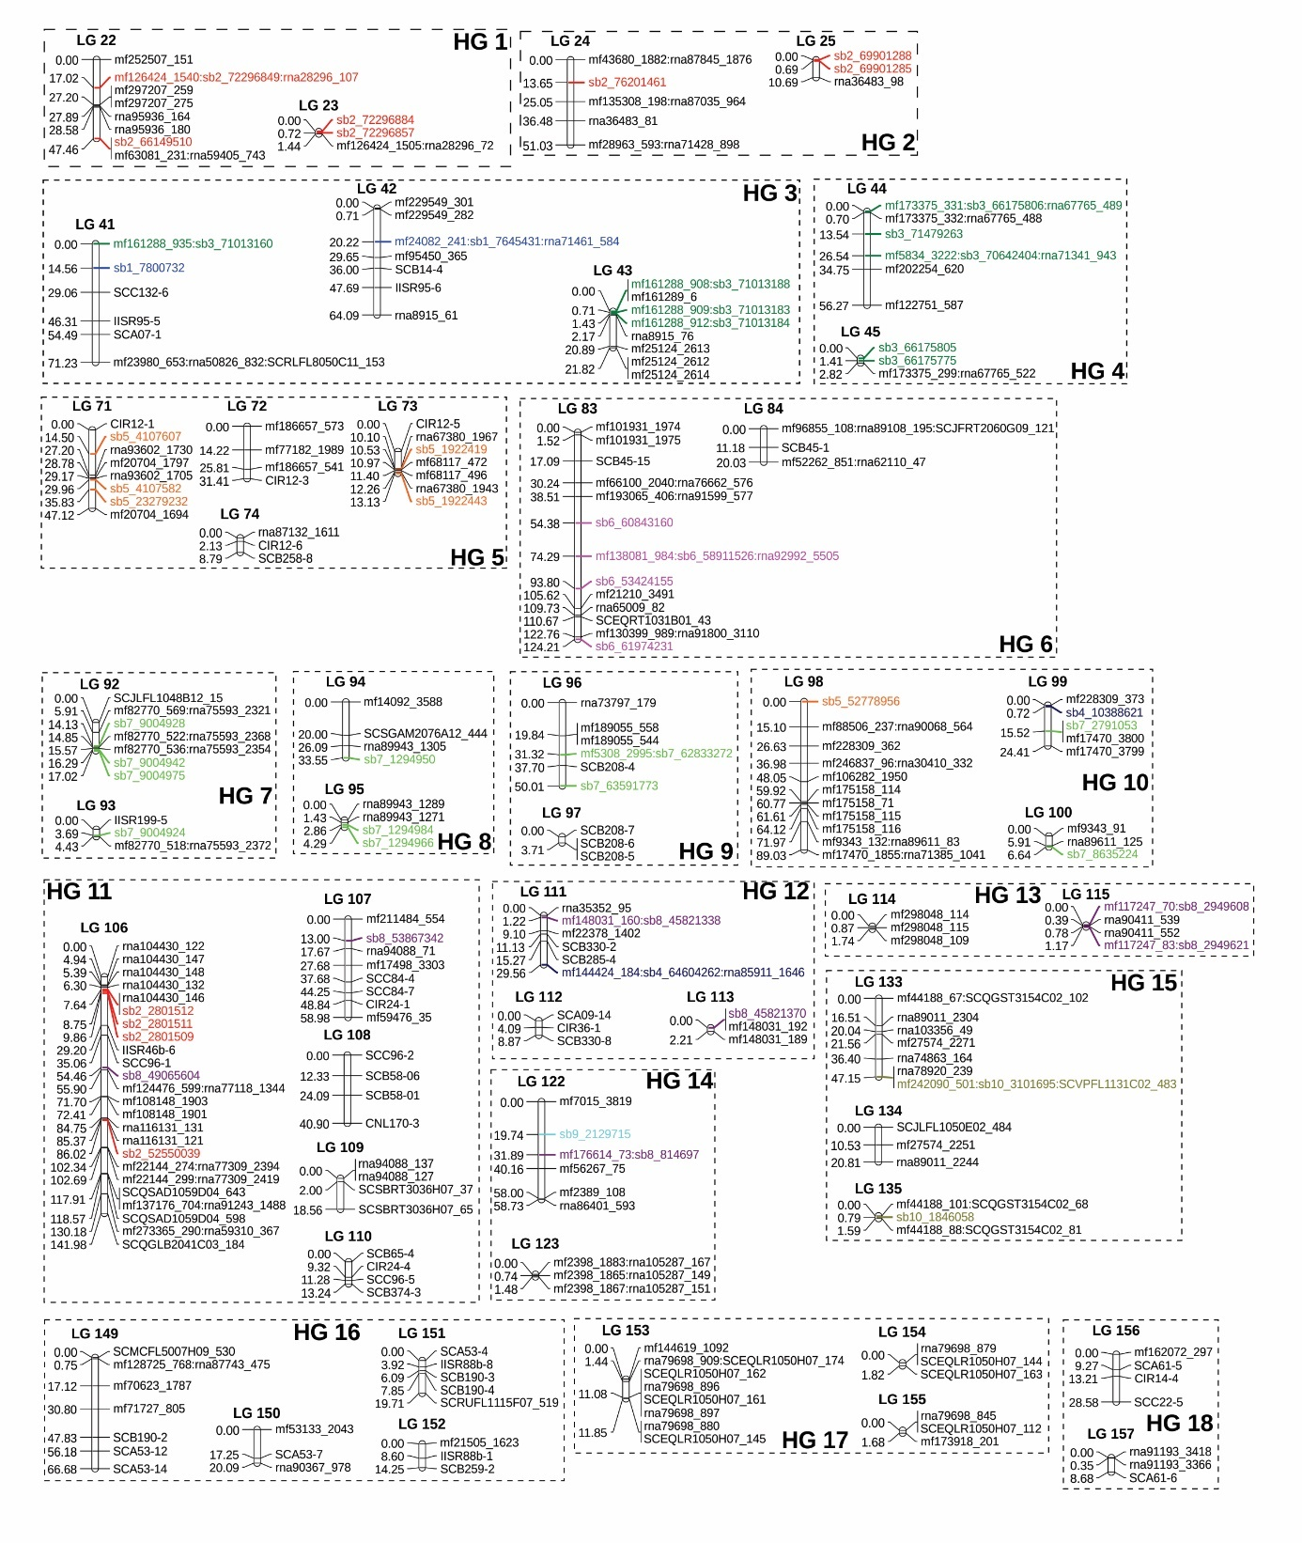
Figure S1. Genetic map of sugarcane that was generated with a population of 151 full sibs that originated from a commercial cross between the cultivars SP80-3280 and RB835486. The linkage groups (LGs) were separated into 18 homo(eo)logous groups (HGs). The numbers on the left of the LGs are the cumulative genetic distances in Kosambi centimorgans. The marker names are shown on the right. Markers corresponding to each sorghum chromosome are highlighted in different colors.

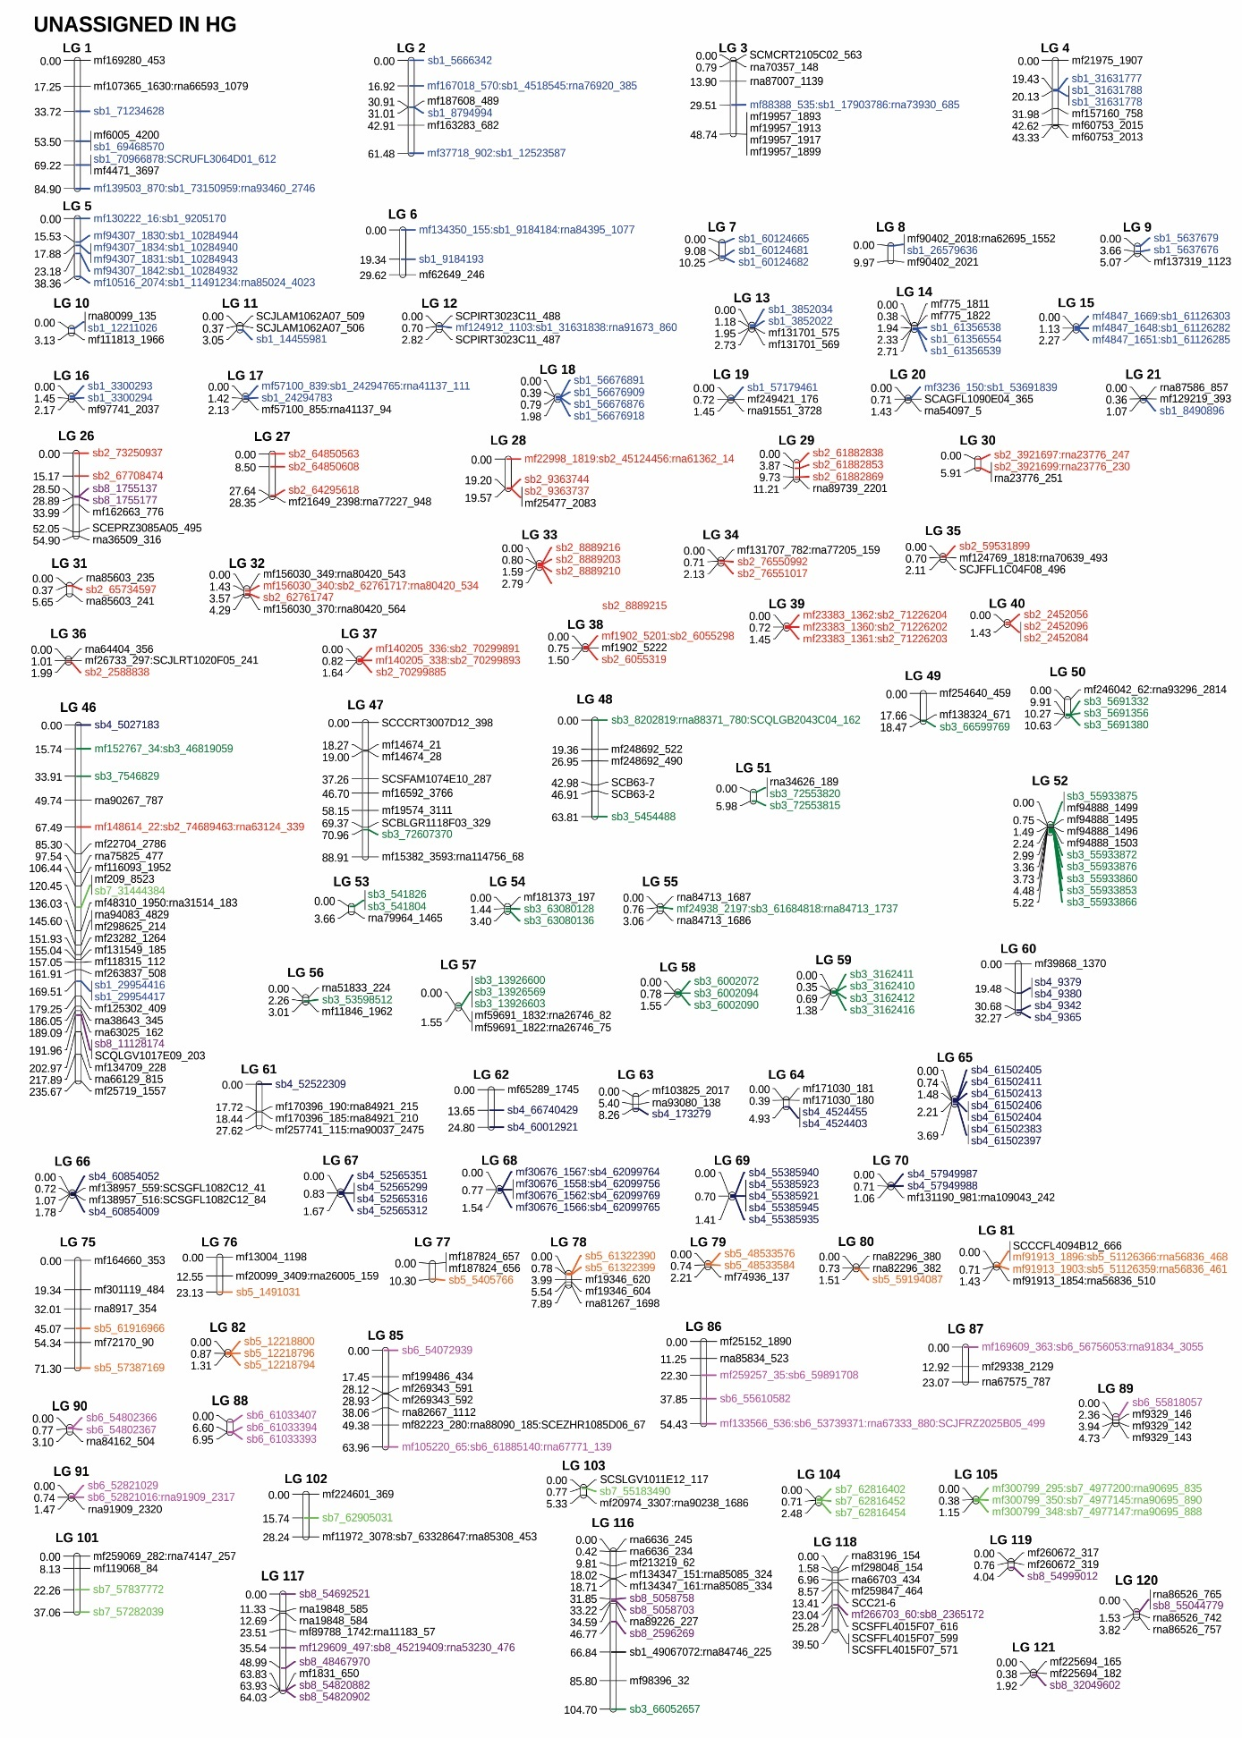
Figure S1. Continued.

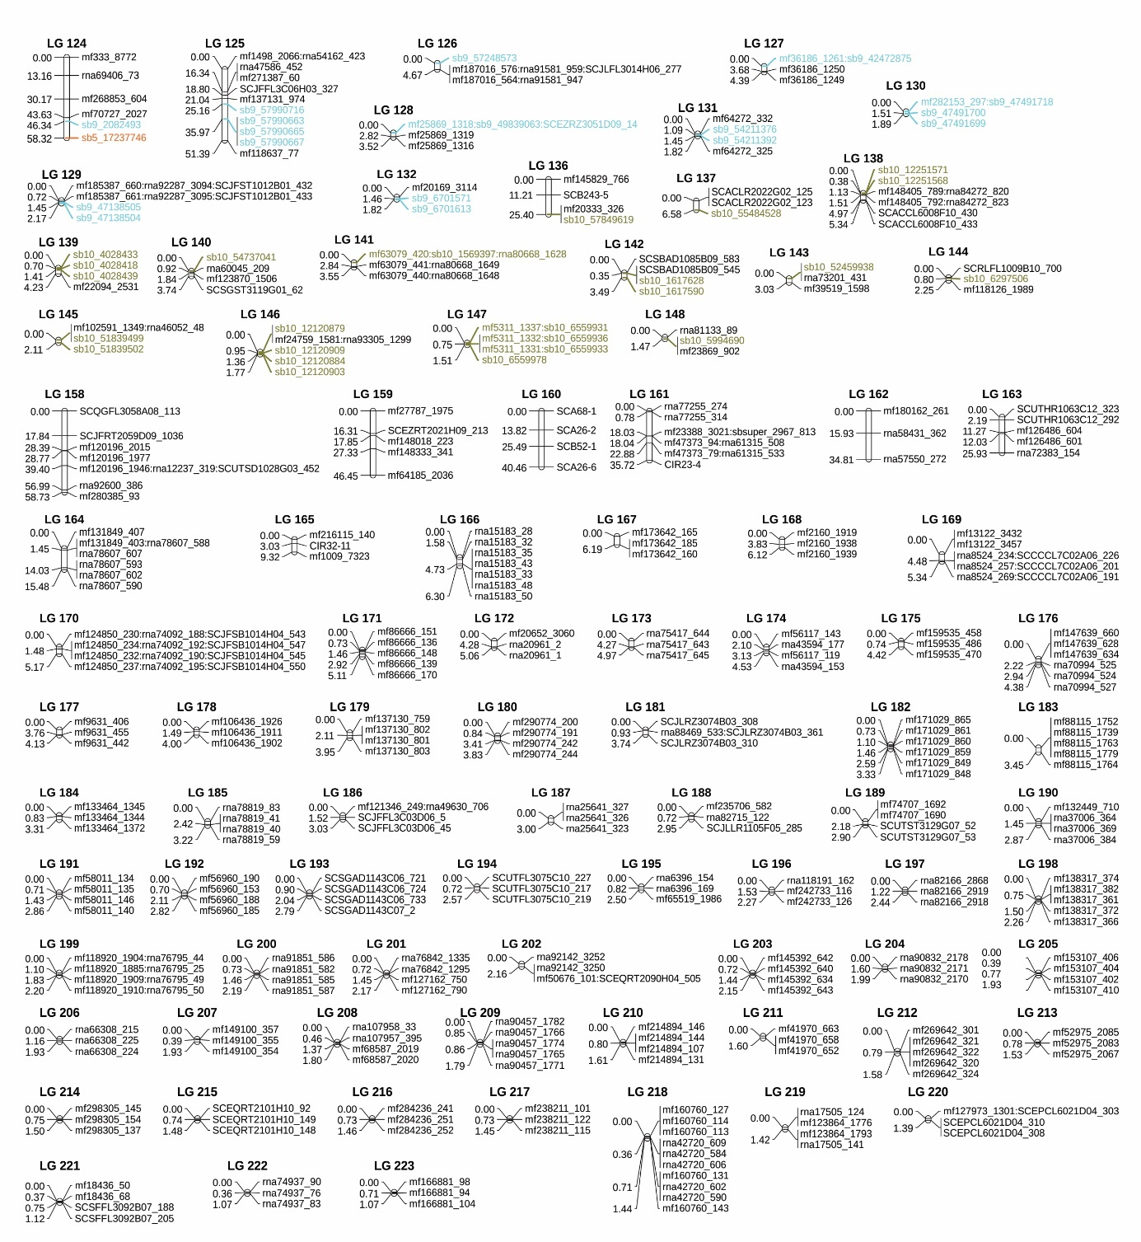
Figure S1. Continued.

