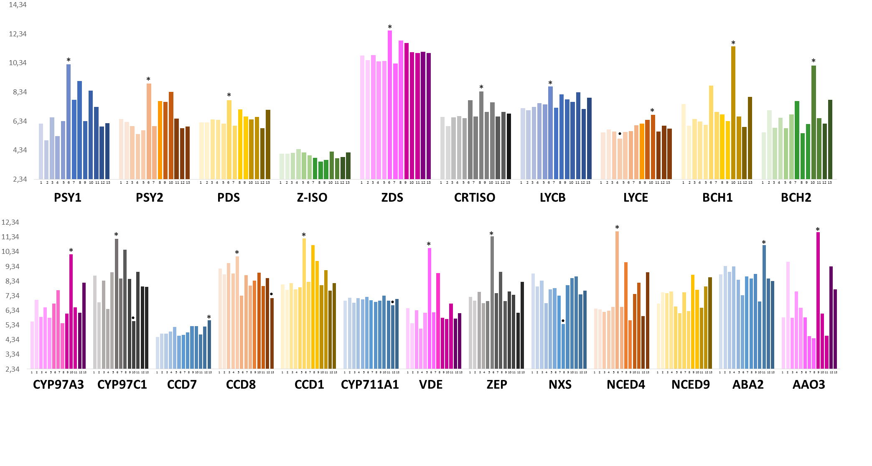
Developmental stages:
1 germinating seed, coleoptile 4 seedling, root 7 immature inflorescence 10 anthers, before anthesis
2 germinating seed, root 5 seedling, crown 8 floral bracts, before anthesis 11 3-5 DAP caryopsis
3 germinating seed, embryo 6 seedling, leaf 9 pistil, before anthesis 12 22 DAP embryo
13 22 DAP endosperm

Figure S1. Expression analysis from PLEXdb database of all key genes in carotenoid biosynthesis. The data of bread wheat cv. Chinese Spring are referred to a wide range of tissues and developmental stages (from 1 to 13) (x axes) in RMA normalization procedure (y axes) obtained by the Affymetrix Wheat Gene Chip. The asterisk and dot signals indicate respectively the values higher or lower than the mean values ± 2 SD.

