Additional file 1: Figure S1
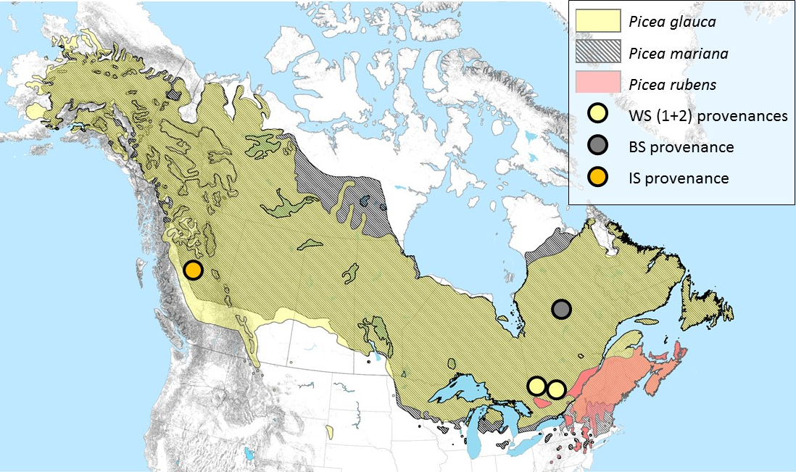
Species distribution and provenances for the different tested pedigrees: WS1, WS2, BS and IS (see main document for description).

