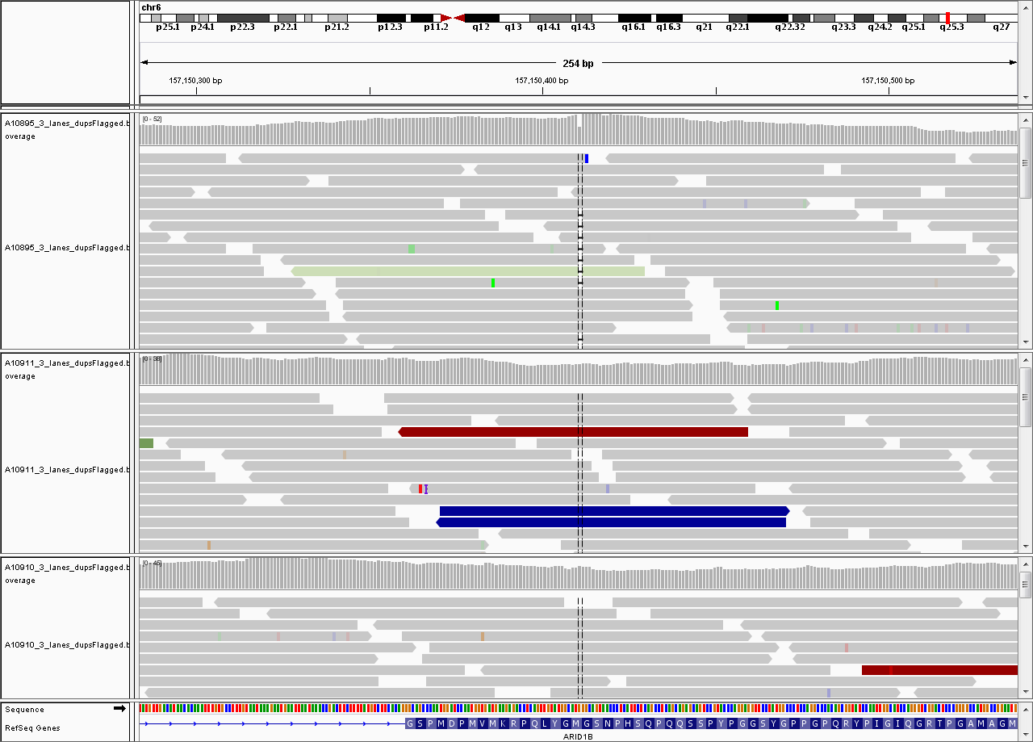
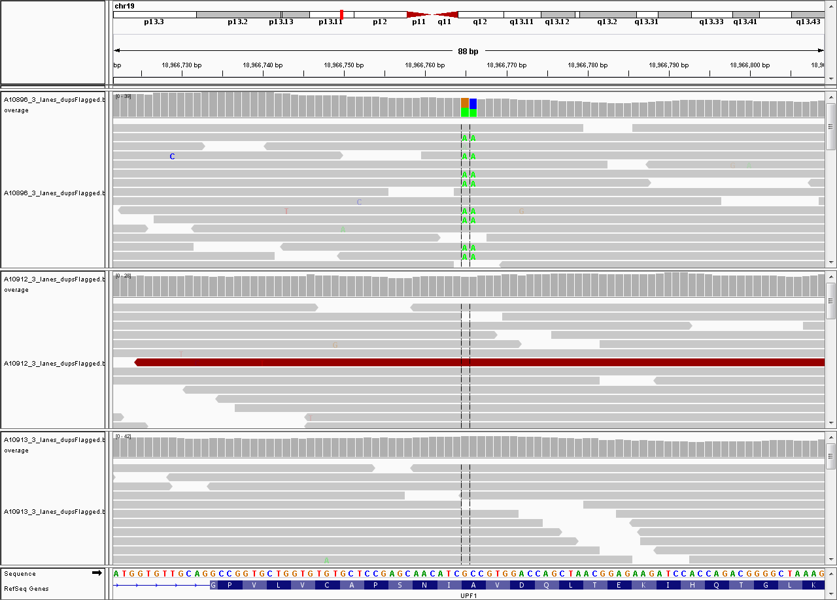
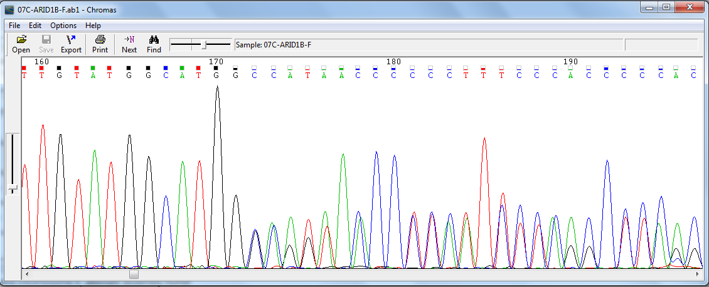
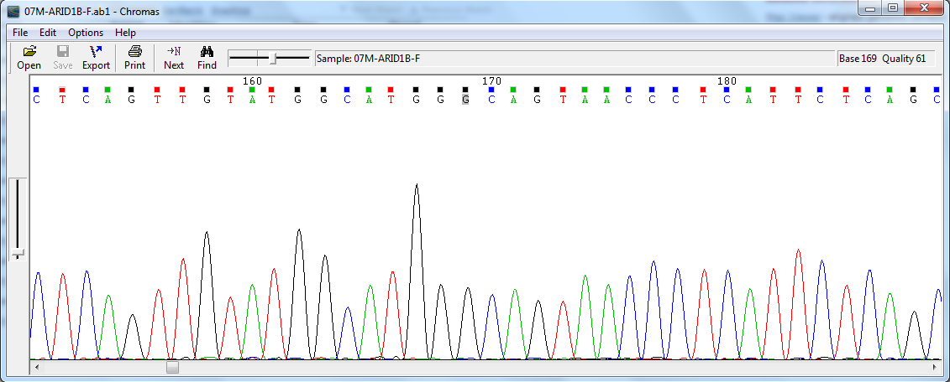
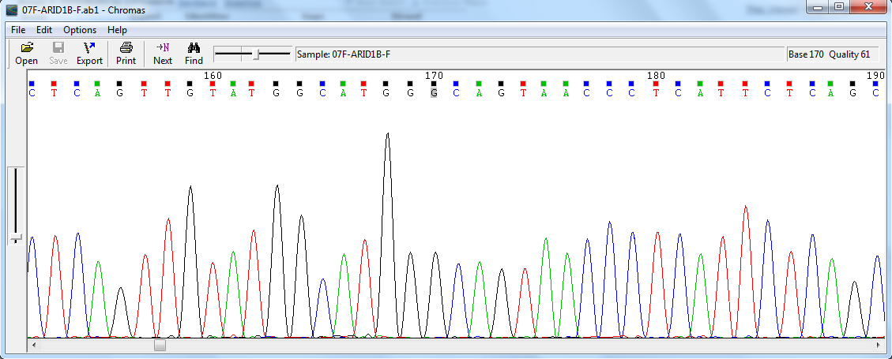
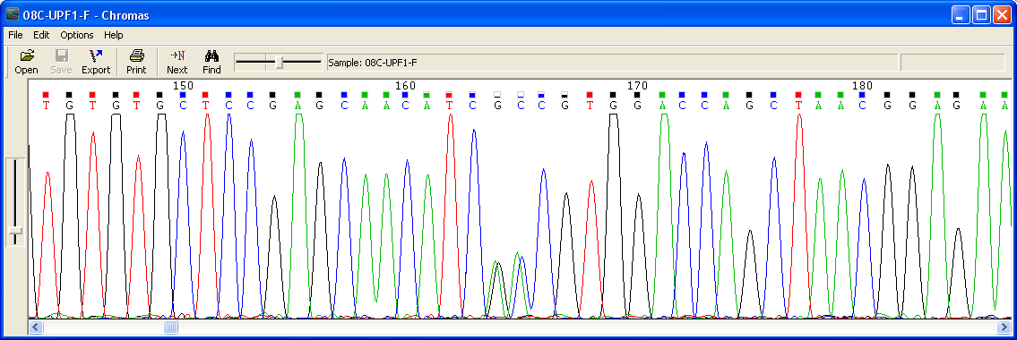
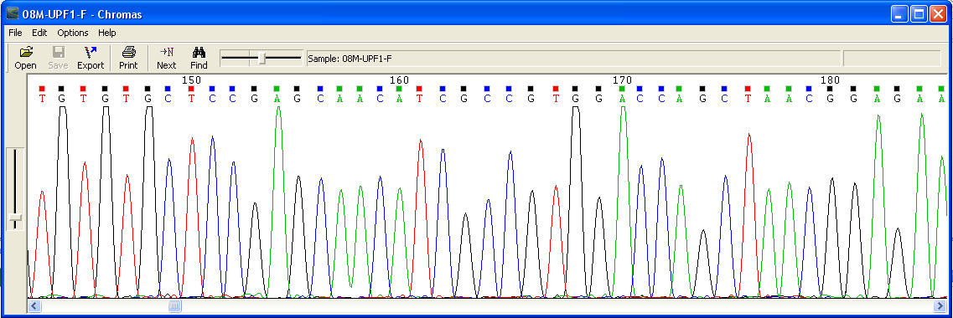
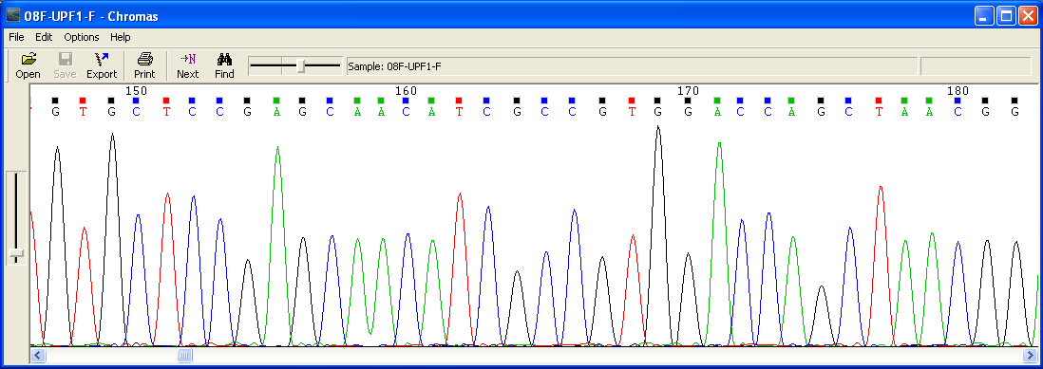
A
B
UPF1
ARID1B
Father
Mother
Child
Father
Father
Father
Mother
Mother
Mother
Child
Child
Child

Figure S1. IGV image and Sanger verification trace files for indel in ARID1B and missense variation in UPF1. IGV images shows panels for child’s, mother’s and father’s WGS data ordered from top to bottom. Sanger sequnce trace files are shown for child, mother and father ordered from top to bottom.

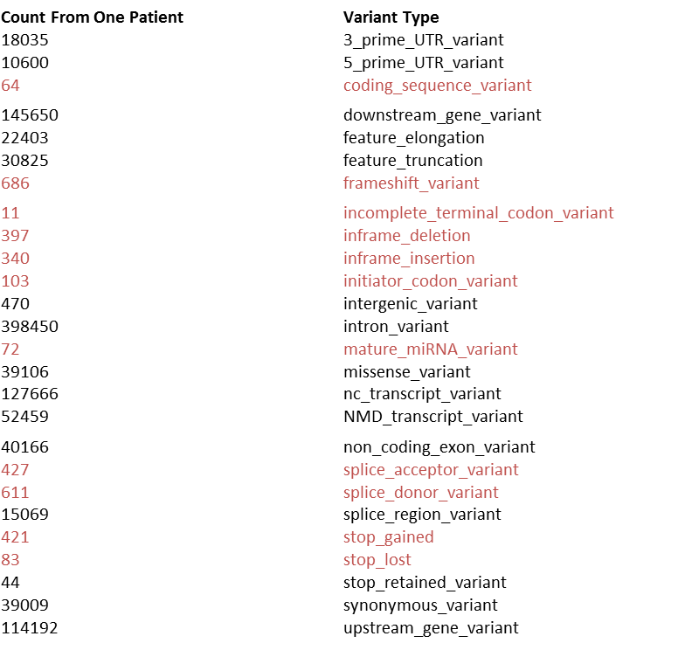
Figure S2. UK10K mutation load – counts as per variant annotation type on one patient. Annotations in red text were used for analyses
Min. 1st Qu. Median Mean 3rd Qu. Max.
18360 19200 19340 19490 19700 22040

Figure S3. Histogram of mutaiton burden per patient in the UK10K cohort

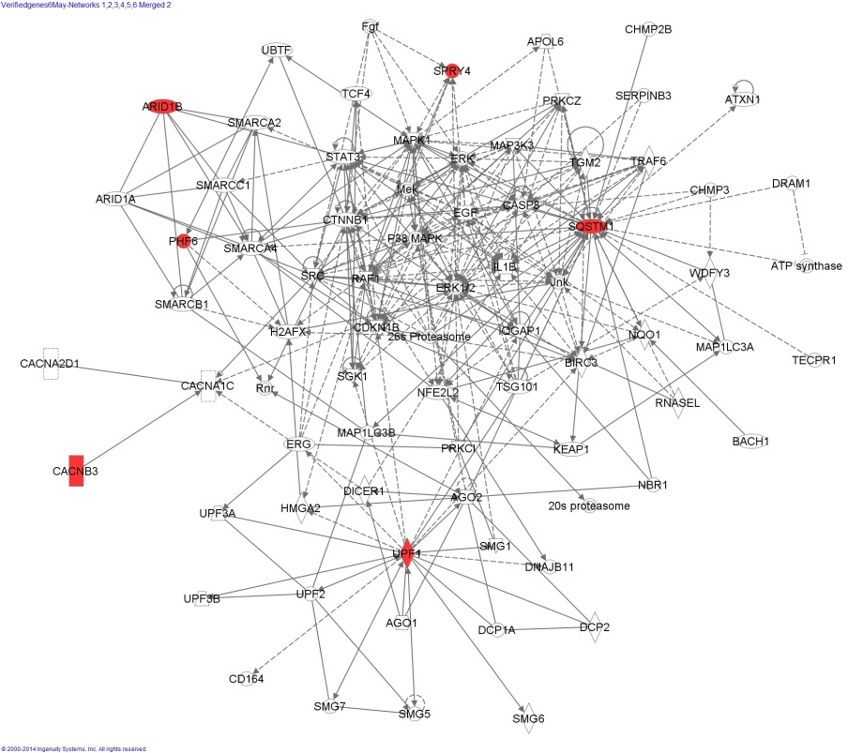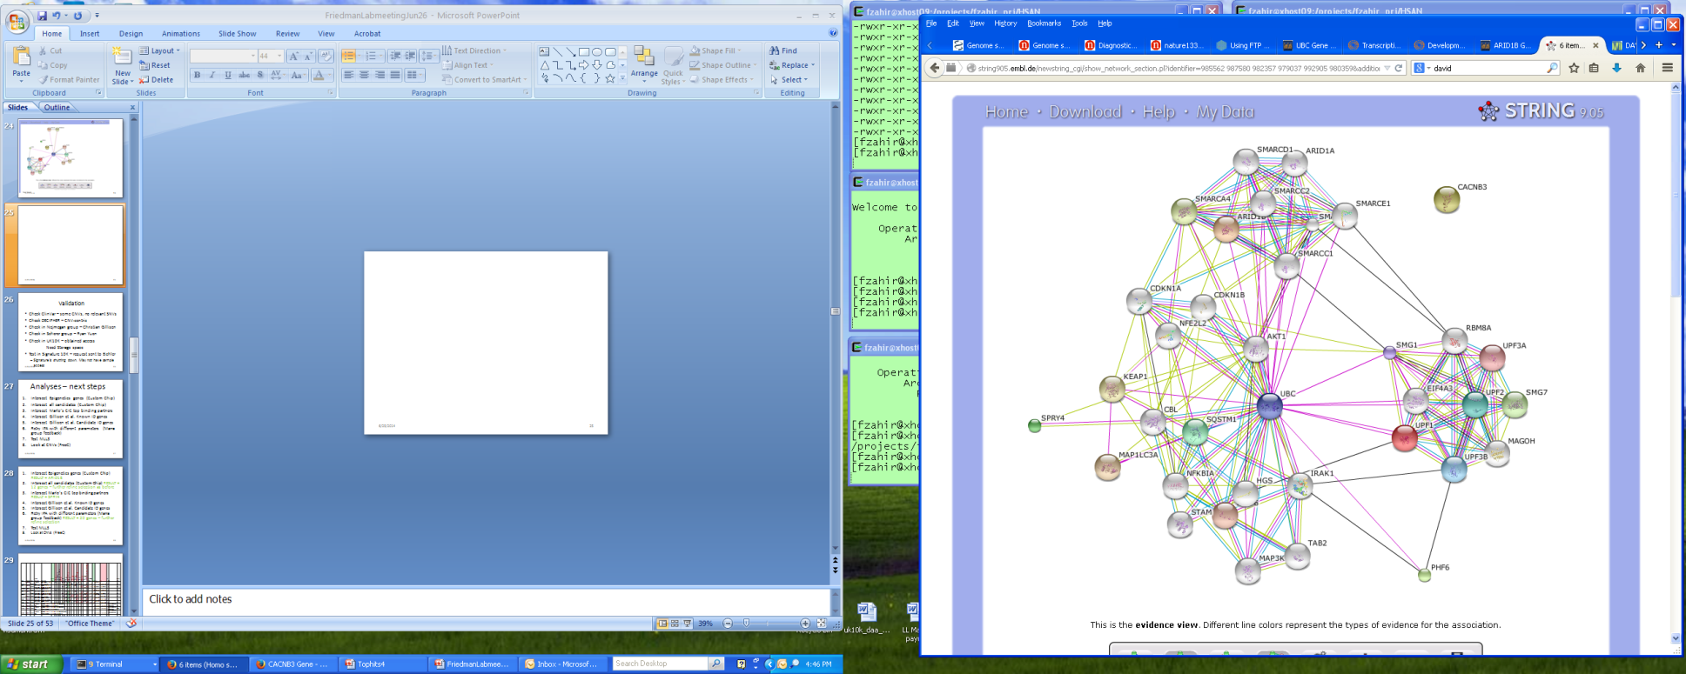

Figure S4. Pathway interactions of 6 candidate genes converge onto UPP pathway: A) IPA result B) STRING.db result

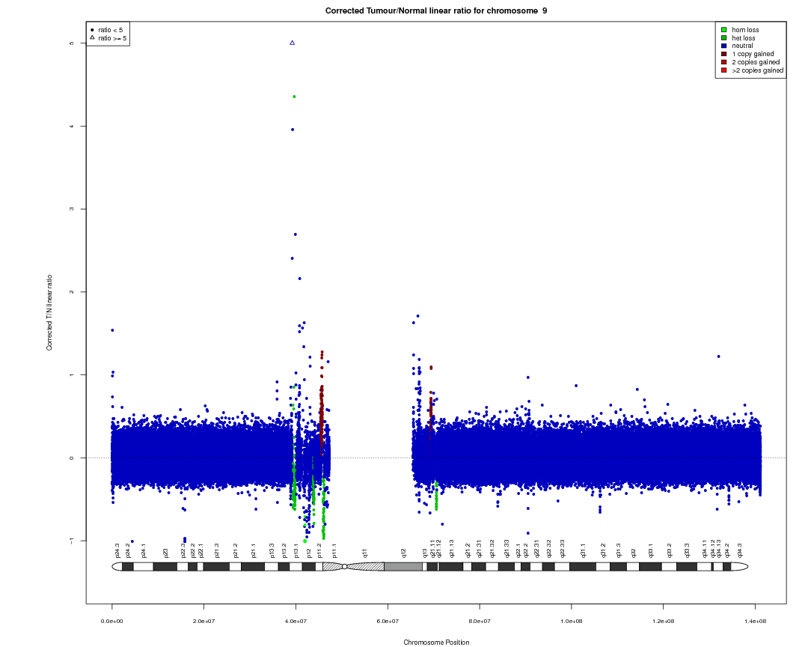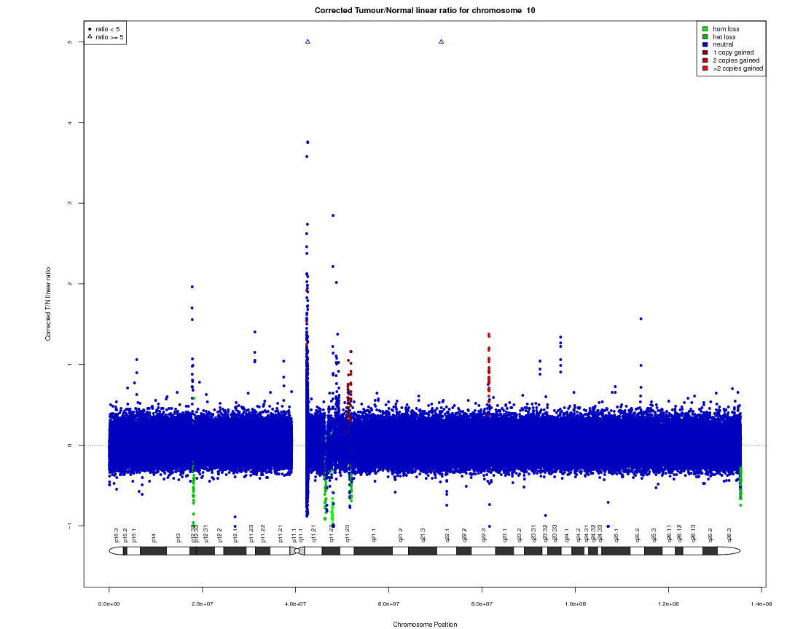
Figure S5. Plots for CNV distribution for two chromosomes as called by CNAseq. Note the preponderance of CNV calls at the centromere and telomere

