Supplementary Figure

Transcriptome-wide N⁶-methyladenosine methylome profiling of porcine muscle and adipose tissues reveals a potential mechanism for transcriptional regulation and differential methylation pattern
Xuelian Tao^{1,†}, Jianning Chen^{1,†}, Yanzhi Jiang^{1,†,}*,**, Yingying Wei¹, Yan Chen¹, Huaming Xu¹, Li Zhu², Guoqing Tang², Mingzhou Li², Anan Jiang², Surong Shuai², Lin Bai², Haifeng Liu², Jideng Ma², Long Jin², Anxiang Wen¹, Qin Wang¹, Guangxiang Zhu¹, Meng Xie¹, Jiayun Wu¹, Tao He¹, Chunyu Huang³, Xiang Gao³ and Xuewei Li^{2,}**

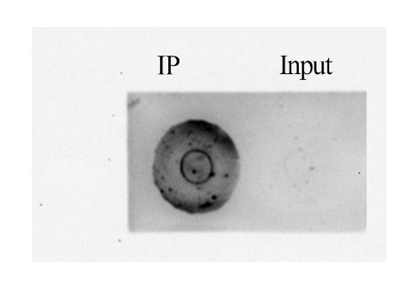Supplementary Figure S1. Dot blot analysis demonstrates antibody specificity for m⁶A. The membranes were spotted with 10 ng of m⁶A RNA and input RNA, respectively.

LM |  |  |  | LA
Motif | P-value | % of Targets | % of Background | Motif | P-value | % of Targets | % of Background
 | 1e-65 | 70.00 | 40.00 |  | 1e-59 | 39.60 | 15.07
 | 1e-28 | 24.50 | 10.33 |  | 1e-56 | 46.00 | 20.43
 | 1e-24 | 24.90 | 11.44 |  | 1e-23 | 10.50 | 2.56
Supplementary Figure S2. The motif sequence for m⁶A-containing peak regions. Analysis was performed by using Hypergeometric Optimization of Motif EnRichment software. LM and LA mean muscle and adipose tissue, respectively.
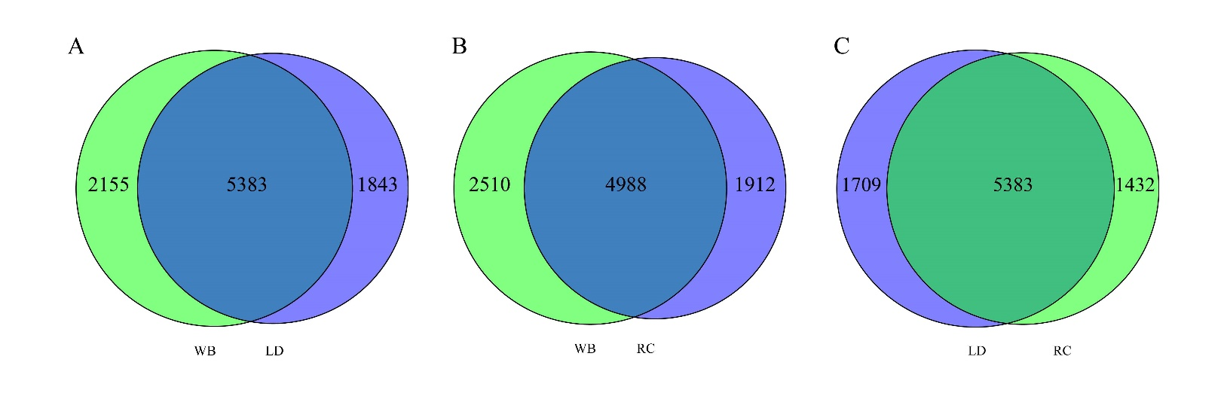
Supplementary Figure S3. Outline of the common and specific m⁶A peaks among three breeds. (A) Number of the common and specific m⁶A peaks between WB and LD. WB means the Wild boar and LD means the Landrace pig, and as follow same. (B) Number of the common and specific m⁶A peaks between WB and RC. WB means the Wild boar and RC means the Rongchang pig, and as follow same. (C) Number of the common and specific m⁶A peaks between LD and RC.

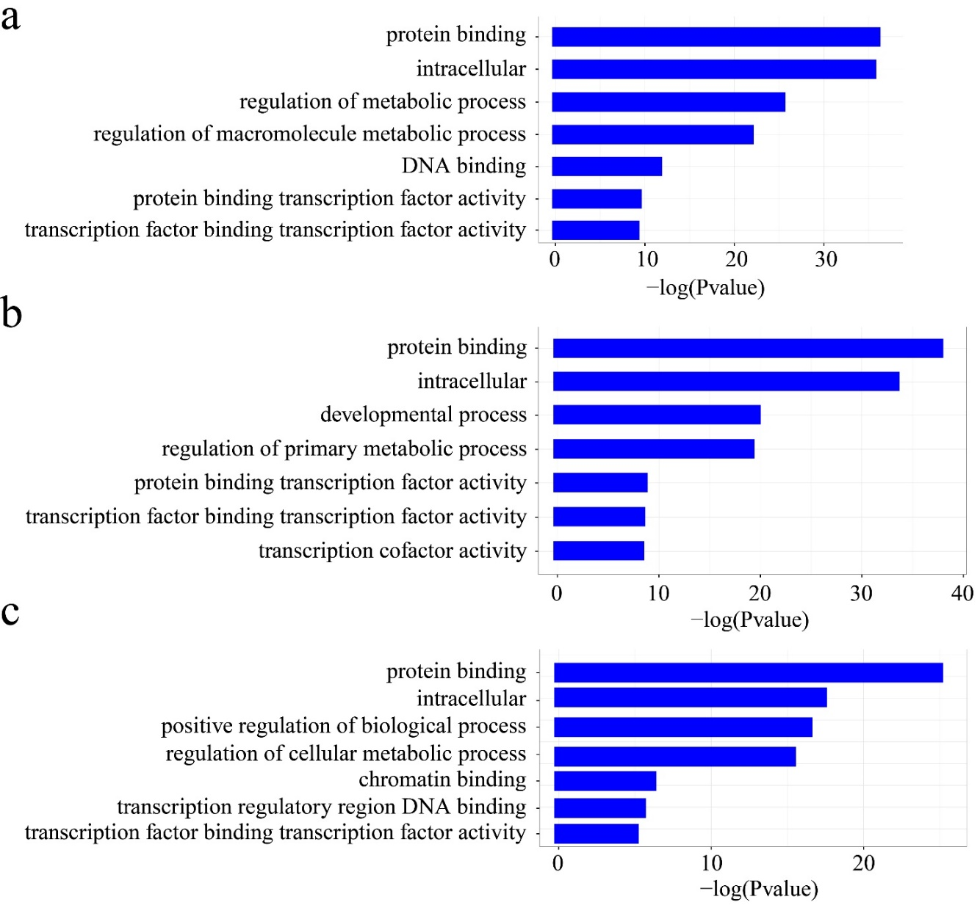
Supplementary Figure S4. Gene ontology analysis of the breed specifically methylated genes. (a) Gene ontology analysis of the breed specifically methylated genes between WB and LD. WB means the Wild boar and LD means the Landrace pig, and as follow same. (b) Gene ontology analysis of the breed specifically methylated genes between WB and RC. RC means the Rongchang pigs, and as follow same. (c) Gene ontology analysis of the breed specifically methylated genes between RC and LD.

