Transcription factor-associated combinatorial epigenetic pattern reveals higher transcriptional activity of TCF7L2-regulated intragenic enhancers
Qi Liu, Russell Bonneville, Tianbao Li, Victor X Jin

Figure S1: The log-likelihood of the 18-state HMM derived from the 25-state HMM at each training of second 100 iterations.

Figure S2: The transition (A) and initial (B) derived from the 25-state preliminary HMM.

A: The transitions are from the states on the y-axis to the x-axis.
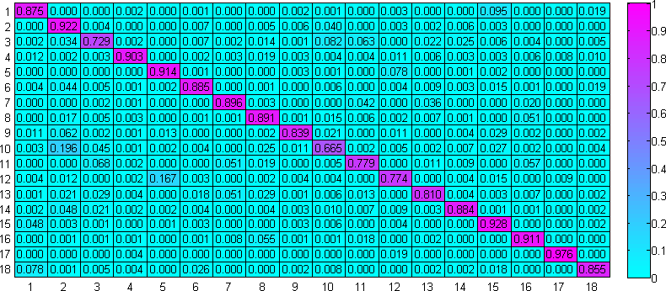

B: The initial probabilities of the 18-state HMM model.
State: | 1 | 2 | 3 | 4 | 5 | 6
Prob: | 5.50E-06 | 4.44E-06 | 4.42E-06 | 4.46E-06 | 4.42E-06 | 6.09E-06
7 | 8 | 9 | 10 | 11 | 12 | 13
0.039225 | 4.42E-06 | 4.52E-06 | 4.42E-06 | 4.45E-06 | 4.44E-06 | 1.60E-05
14 | 15 | 16 | 17 | 18
0.042431 | 0.918258 | 4.94E-06 | 4.79E-06 | 9.05E-06

Figure S3: The emission probabilities of each output of the final 18-state HMM.
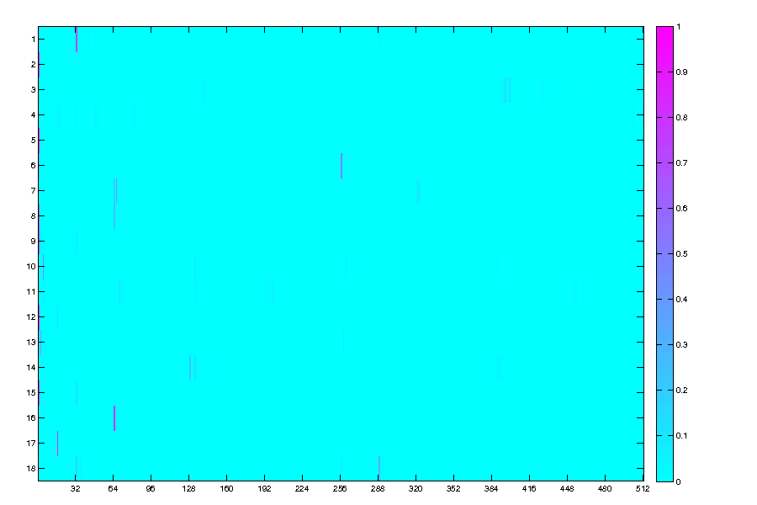

Figure S4: Plots of the output probabilities of each mark and the actual frequency of each mark in each cell line. The blue line is the expected line of best fit (perfect correlation, from (0, 0) to (1, 1)) and the red line is the actual line of best fit (calculated by least-squares regression).
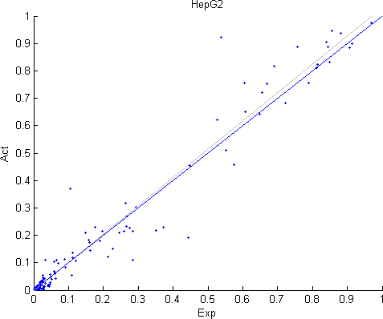
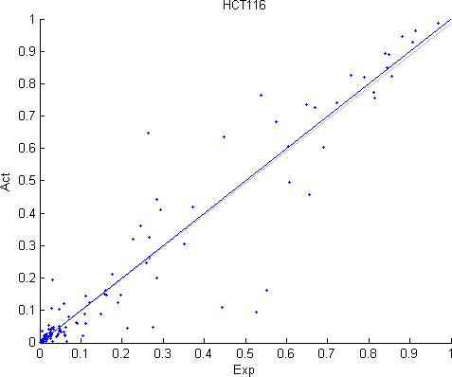

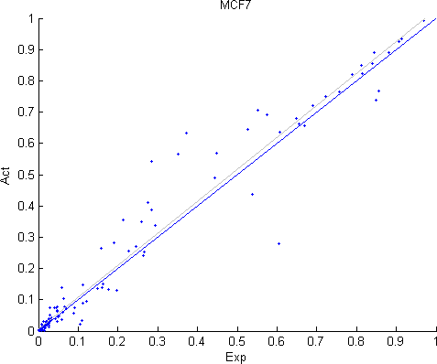
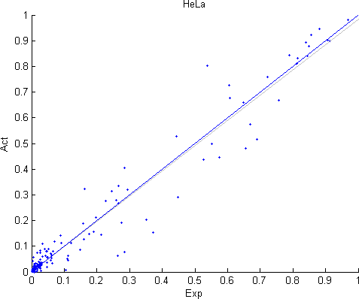

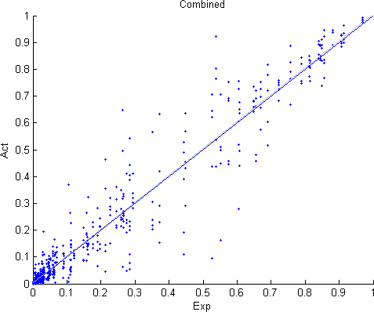
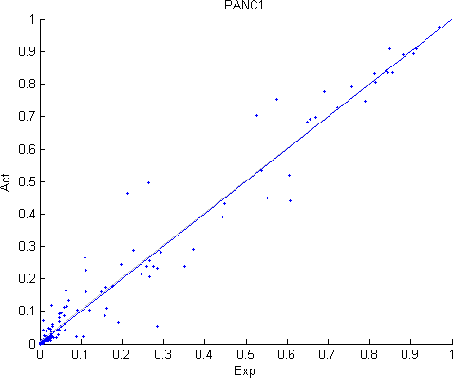
Figure S5: The mark frequencies in each cell line among bins in each state
HCT116 HepG2
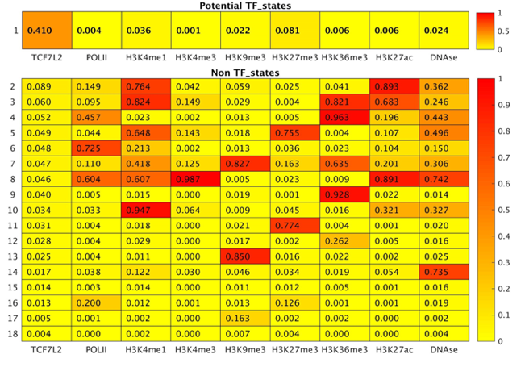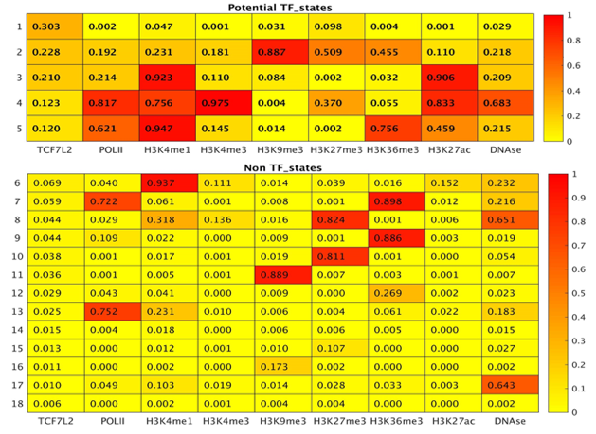
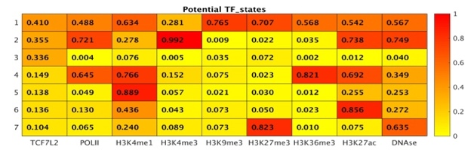
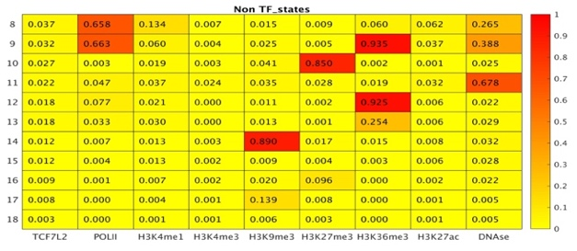
HeLa MCF7
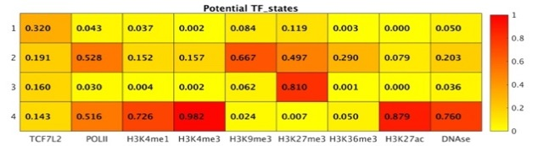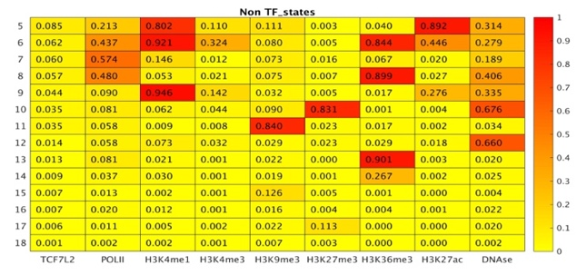
PANC1
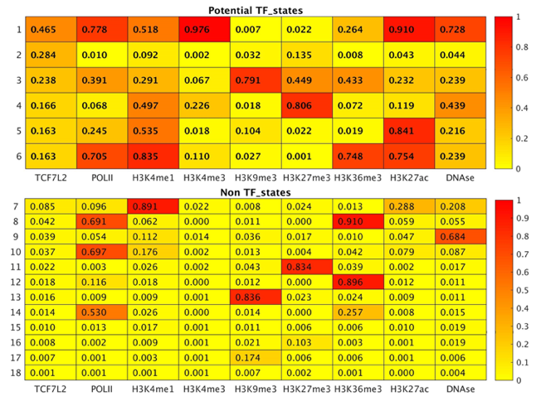

Figure S6: The correlations with other genomic information HMM states in all cells combined.

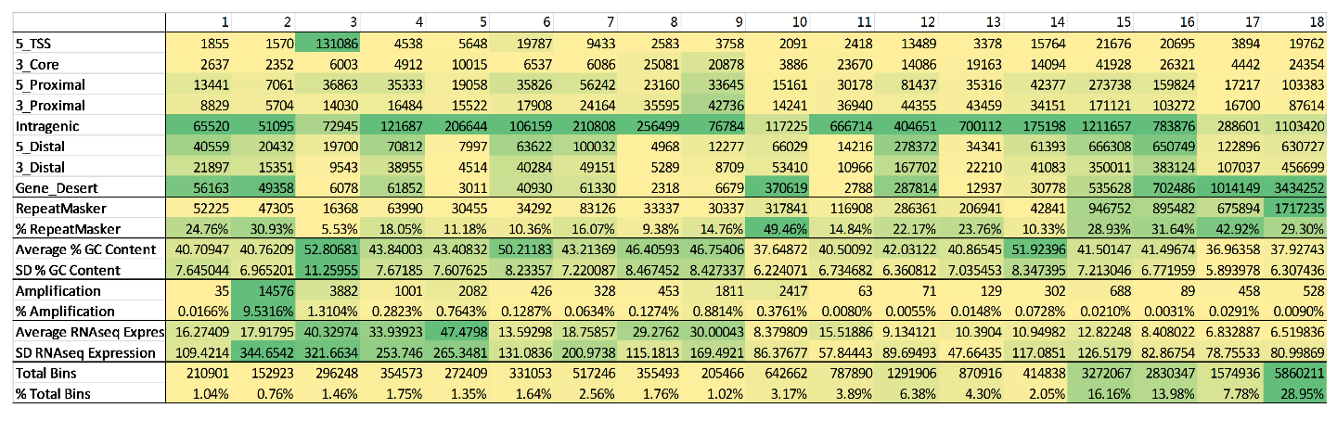

Figure S7: Plot of the distribution of states in all five cell types as described in Methods and Material. The body (5’ to 3’ with respect to the gene) and surrounding regions (+-90 kb) of each gene were divided into 120 bins spanning the region -90 kb to 5’ comprise the upstream surrounding region.

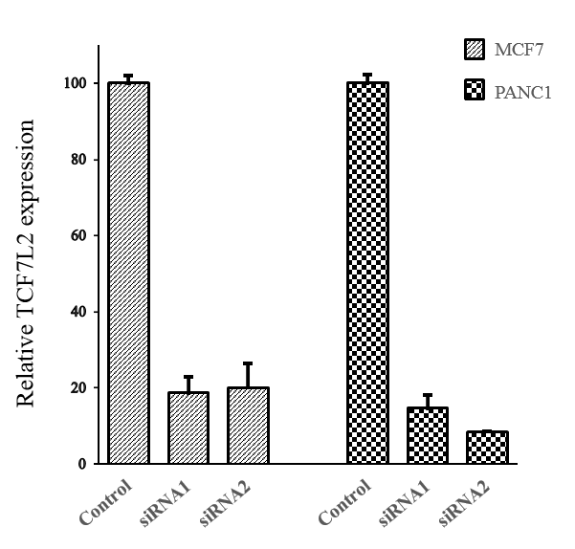
Figure S8: TCF7L2 knockdown efficiency in MCF7 and PANC1 cell lines.

Figure S9: The training of TCF7L2-omics data by ChromHMM with initial 18-state model (left) and 25-state model (right), respectively.
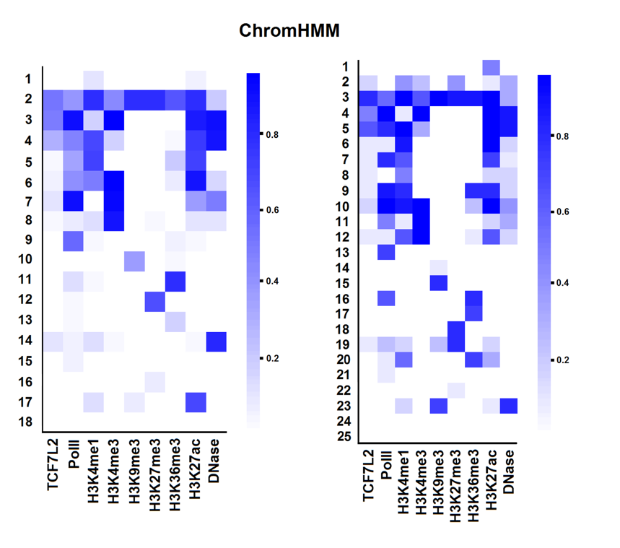
Some states can be assigned as a similar biological function in initial 25-state model. With an overall perspective, it showed that more ChromHMM states were annotated as undirected states in 25 states model. We did not find the clear difference of functional chromatin patterns between two models. It suggested an initial 18-state model is sufficient for ChromHMM in identifying the functional states.
Figure S10: For a broad test of T-cep, we applied T-cep on another data set, MYC-omics in four cell lines, HeLa, HepG2, K562 (not include in TCF7L2 data set) and MCF7.
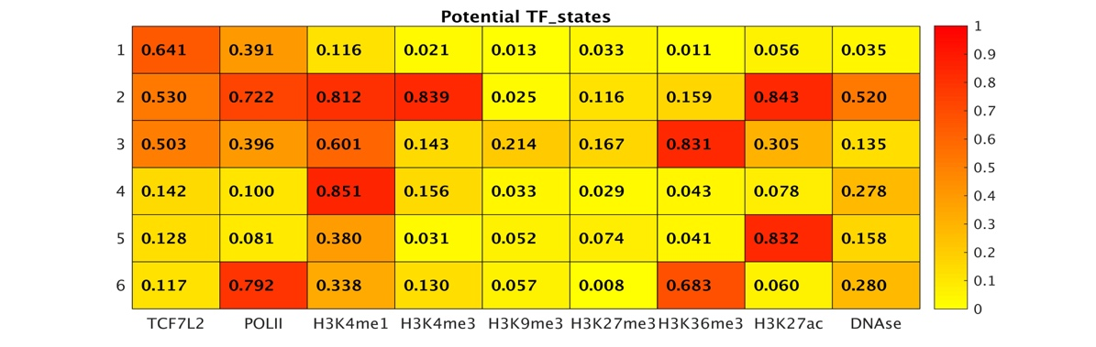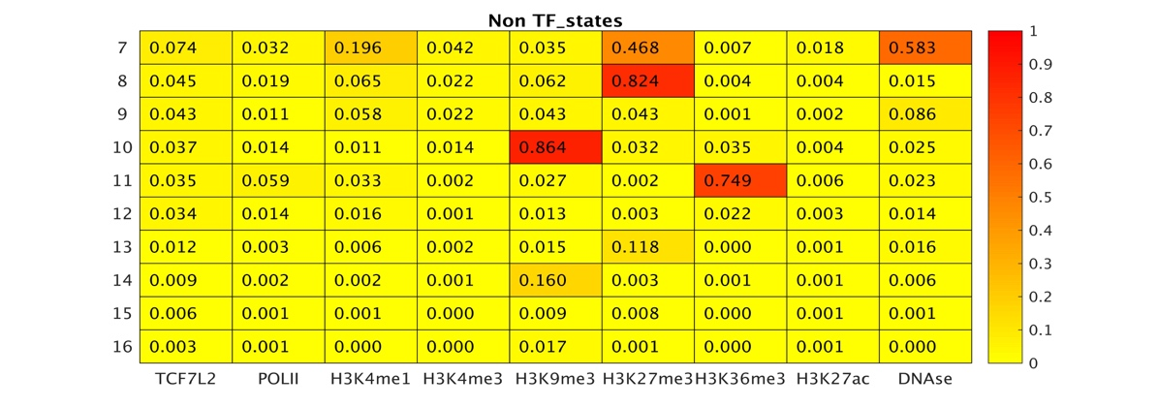
18-state HMM model was produced with BIC 3.68997*10⁷ after 300 iterations. With a cutoff of 0.1, we were able to classify five states associated with MYC, states 1-2, 4-6 as TF-states. For MYC-associated states, we can also identify the similar pattern as we did in TCF7L2 data set: TF-promoter (state 2), TF-intragenic enhancer (state 6), TF-distal enhancer (state 5) and TF-non-combinatorial state (state 1). One more TF-state found in MYC is state 4 as TF-inactivate enhancer.
State 2 was assigned as MYC-associated promoter because of its higher frequency in 5’-TSS regions and its high emission probabilities for PolII and H3K4me3. State 1 was classified as MYC binding, non-combinatorial TF-state, as its emission probability is only high for MYC and PolII. States 5 and 6 were classified as MYC-associated enhancer states due to their higher emission probabilities for the enhancer mark H3K27ac and H3K4me1. Location distribution showed most bins of state 6 were in gene body regions while the associated genes have a higher average gene expression and its high emission probabilities for enhancer marks H3K4me1, H3K27ac as well as gene body mark, H3K36me3. Thus, state 6 was classified as MYC-associated intragenic enhancer. State 5 was classified as a MYC-associated distal enhancer with H3K4me1 and H3K27ac. State 4 was assigned as inactivate enhancer due to absence of H3K27ac, which were not found in TCF7L2. State 3 was assigned as a mapping bias state.

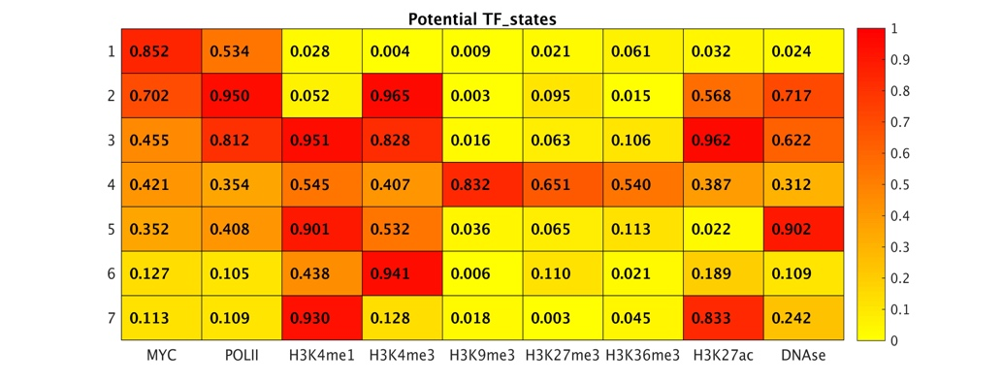
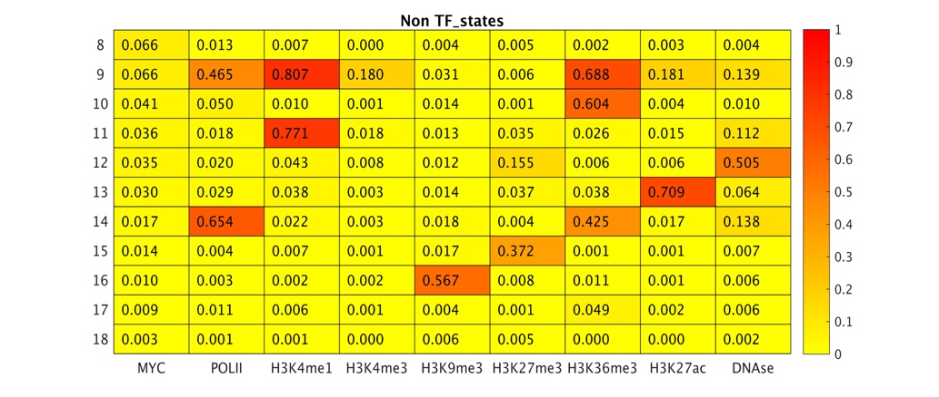
Figure S11: A comparison with ChromHMM for MYC omics-seq data.

Although we can find seven TF-states (states 1, 2, 3, 4, 5, 6, 7) in MYC datasets, four (states 2, 3, 5, 6) of them are more focused on different TF-promoter states. In addition, state 9 with a high probability of H3K4me3, H3K36me3 and PolII was thus assigned intragenic enhancer. However, State 5 was not associated with MYC. In MYC dataset, T-cep also showed an advantage of predicting more TF-states including TF-intragenic enhancer. Taken together, the results of MYC and TCF7L2 showed the similar TF-state patterns, demonstrating a broader application of T-cep in successfully training different TFs in multiple cell lines. Therefore, T-cep can provide a robust tool for studying TF regulated combinatorial epigenetic regulation.
Table S1: Data sets were used in T-cep training.
 | HeLa | HepG2 | MCF7 | HCT116 | PANC1
TCF7L2 | GSM816436 | GSM782122 | GSM816438 | GSM782123 | GSM816437
Pol-II | GSM733759 | GSM935603 | GSM822295 | GSM935426 | GSM1010788
DNase | GSM736564 | GSM736639 | GSM1024767 | GSM736600 | GSM736519
H3K4me1 | GSM798322 | GSM798321 | GSM946849 | GSM946853 | GSM818827
H3K4me3 | GSM733682 | GSM733737 | GSM945269 | GSM945304 | GSM945856
H3K27ac | GSM733684 | GSM733743 | GSM946850 | GSM946854 | GSM818826
H3K27me3 | GSM733696 | GSM733754 | GSM946851 | GSM1323588 | ENCFF002AAI
 |  |  |  |  | ENCFF002AAJ
H3K9me3 | GSM1003480 | GSM1003519 | GSM946852 | ENCFF002AAK | ENCFF002AAG
 |  |  |  | ENCFF002AAM | ENCFF002AAH
H3K36me3 | GSM733711 | GSM733685 | GSM970217 | ENCFF002AAO | ENCFF002AAE
 |  |  |  | ENCFF002AAN | ENCFF002AAF
RNA-seq | GSM765402 | GSM758575 | GSM765388 | GSM958749 | GSM923421

Table S2: Number of unique mapped reads in each ChIP-seq experiment. Total reads: 2020399637.
 | HCT116 | HepG2 | HeLa | MCF7 | PANC1
TCF7L2 | 13045108 | 20840620 | 23283663 | 45532010 | 29674416
Pol-II | 11327095 | 22126177 | 61911244 | 42889537 | 37457222
H3K4me1 | 51343131 | 52320612 | 38435440 | 53456130 | 45010948
H3K4me3 | 49150304 | 18620773 | 35897578 | 54134097 | 47338963
H3K9me3 | 48699522 | 93907278 | 49032372 | 39213124 | 49944883
H3K27me3 | 10526223 | 35259983 | 56820865 | 65774031 | 59766516
H3K36me3 | 51066551 | 19355666 | 60030600 | 54120953 | 41487070
H3K27ac | 35516872 | 14008928 | 39672909 | 59598739 | 54379908
DNase | 80919605 | 50838536 | 54267867 | 89113893 | 53281675
Total | 351594411 | 327278573 | 419352538 | 503832514 | 418341601

Table S3: BIC scores of all five preliminary 25-state HMMs. The highlighted HMM was selected due to its lowest BIC score.

HMM: | s25_a | s25_b | s25_c | s25_d | s25_e
log likelihood: | 2.16E+07 | 2.19E+07 | 2.18E+07 | 2.15E+07 | 2.15E+07
BIC: | 4.36E+07 | 4.40E+07 | 4.38E+07 | 4.32E+07 | 4.33E+07

Table S4: Number of bins in all cell lines in which each state in the preliminary 25-state HMM was called by the Viterbi algorithm. Highlighted states were manually removed, and transition probabilities to them uniformly redistributed to other states. This produced the initial 18-state HMM.
State | 1 | 2 | 3 | 4 | 5 | 6 | 7 | 8 | 9
Bins | 0 | 1307133 | 7195109 | 0 | 0 | 0 | 297068 | 156692 | 2921997
State | 10 | 11 | 12 | 13 | 14 | 15 | 16 | 17 | 18
Bins | 406525 | 0 | 330792 | 903017 | 188330 | 525948 | 279996 | 79 | 612185
State | 19 | 20 | 21 | 22 | 23 | 24 | 25
Bins | 222051 | 356377 | 3070989 | 827262 | 1 | 329340 | 311194

Table S5: Pearson correlation coefficients between the emission probabilities of the final 18-state HMM and the actual frequency of each mark in each cell line.
Cell line | r²
HCT116 | 0.9545
HepG2 | 0.9784
HeLa | 0.9755
MCF7 | 0.9787
PANC1 | 0.9795
Combined | 0.9730

Table S6: The definition of genomic regions based on an annotated RefSeq gene.
Position Annotation | Relative distance annotated gene
5_TSS | 1000 (to 5’ end)
Intragenic | within gene
5_Distal | 1000000 (to 5’ end)
3_Distal | 1000000 (to 3’ end)
3_Core | 2000 (to either end)
Gene_Desert | >1000000
5_Proximal | 10000 (to 5’ end)
3_Proximal | 10000 (to 3’ end)

Table S7: The primers for RT-qPCR.
Knockdown efficiency
TCF7L2 forward | CATATGGTCCCACCACATCA
TCF7L2 reverse | CACTCTGGGACGATTCCTGT
Selected loci in MCF7 | Primer F/R | Selected loci in PANC1 | Primer F/R
CHD2 | F: CGAAAGCAGGCATTGGATCACT | CALM2 | F: TGCAGCATGGTTAGCTTTGT
 | R: GATGACAACTGTGTCCGCTGAA |  | R: TCAGTCAGTTGGTCAGCCTT
KRT8 | F: GATCTCTGAGATGAACCGGAACA | CD44 | F: TCCCTGCTACCACTTTGATG
 | R: GCTCGGCATCTGCAATGG |  | R: AACCAATCCCAGGTTTCTTG
MPRIP | F: CACACTCTGGCAGGAAGAAA | ERRFI1 | F: AAGACAGGCCTCCCAAAGTA
 | R: TTTGCTCTCTAGCCCAGGTT |  | R: TTGAGGTAAGACGGAAGGCT
PTK2 | F: GAAGGCCAATTTGGAGATGT | FHL2 | F: CCGTAGTGGAACGAAGGATT
 | R: CACGCTGTCCGAAGTACAGT |  | R: GGTCACTTCTCAGGAGGCAT
CSNK1D | F: CCGGTCTAGGATCGAAATGT | PARD6B | F: CGGCAAACCAGAGGAATAAT
 | R: AGCTCTTGGAGTCTGTCCGT |  | R: TTCAATCTGCTGTGGGTAGC
FAM102A | F: CAGAGCCAGGATTTCACAGA | SMAD3 | F: GTCCATCCTGCCTTTCACTC
 | R: TCACAACTGGCTCGTAGACC |  | R: CTTCTCGCACCATTTCTCCT
SNX27 | F: GAGCAGGCGAGAAGGAATTG | TNS3 | F: GGACCCACAAGACAGGAAGT
 | R: GCTTAGAACACAGCTGCCTC |  | R: GTCATGCTCTGCAAACAGGT
TMEM64 | F: TACCAATCTGTGGCTGTGGT | ZNF217 | F: CTACCCTCTGTGAACCAGCA
 | R: ATGACAATGCTTTGCACGAT |  | R: ATGTCTGCCCACATACCTCA
ZHX2 | F: AGCAGGTGGCTGACTTCTTT
 | R: GCCATTCACCTCTGTACCCT

Table S8: Selected TF-enhancer loci for Luciferase experimental validation.
Seleted TF-enhancer loci | Genomic region
KRT8 internal TFE | chr12:53295000,53295750
KRT8 distal TFE | chr12:53314500,53315250
PTK2 internal TFE | chr8:141744000,141744750
PTK2 distal TFE | chr8:142051500,142052250
ERRFI1 internal TFE | chr1:8073750,8075250
ERRFI1 distal TFE | chr1:8180250,8181750
ZNF217 internal TFE | chr20:52186500,52188000
ZNF217 distal TFE | chr20:52237500,52239000

Table S9: The primer for TFE cloning.
Gene loci | Primer sequence
KRT8_inter_F1 | GGAGACTCCCTCACCTTCTTG
KRT8_inter_R1 | ATCAACAACCTTAGGCGGCA
KRT8_dis_f1 | ACCGTCACATCCACAGCATT
KRT8_dis_r1 | GGGGTGGAGGTTTAGTGTGG
PTK2_inter_F1 | TGCCAGTCATGAAATAGCGT
PTK2_inter_R1 | TCTGTCAAGTACCAGCCACG
PTK2_dis_f1 | CGCTTCGTCCCTCTTAGTCC
PTK2_dis_r1 | ACCCTTTGAGGCATTTGCTTA
ERRFI1_inter_F1 | AGGTATGGGAACTCTGGGGG
ERRFI1_inter_R1 | GGCTGTGATTGCTCTTCGCT
ERRFI1_dis_f1 | GGACAAACTGCCACAAACCC
ERRFI1_dis_r1 | AAAGACCAGTGCTGTAGCCG
ZNF217_inter_F1 | TGTGAGCTGGTCCAGAGGAT
ZNF217_inter_R1 | CTGGATTGGCTGAGTGCGG
ZNF217_dis_f1 | CAGGAAGCCTCAAGGAGGAAG
ZNF217_dis_r1 | ATCCGGTTTGTAAGGGGCAA

