Additional File 1. Revised gene models for TA20855 and TA19820 validated by RNA-seq reads, and alternate prediction of TM helices of TA20855 using different software.

A
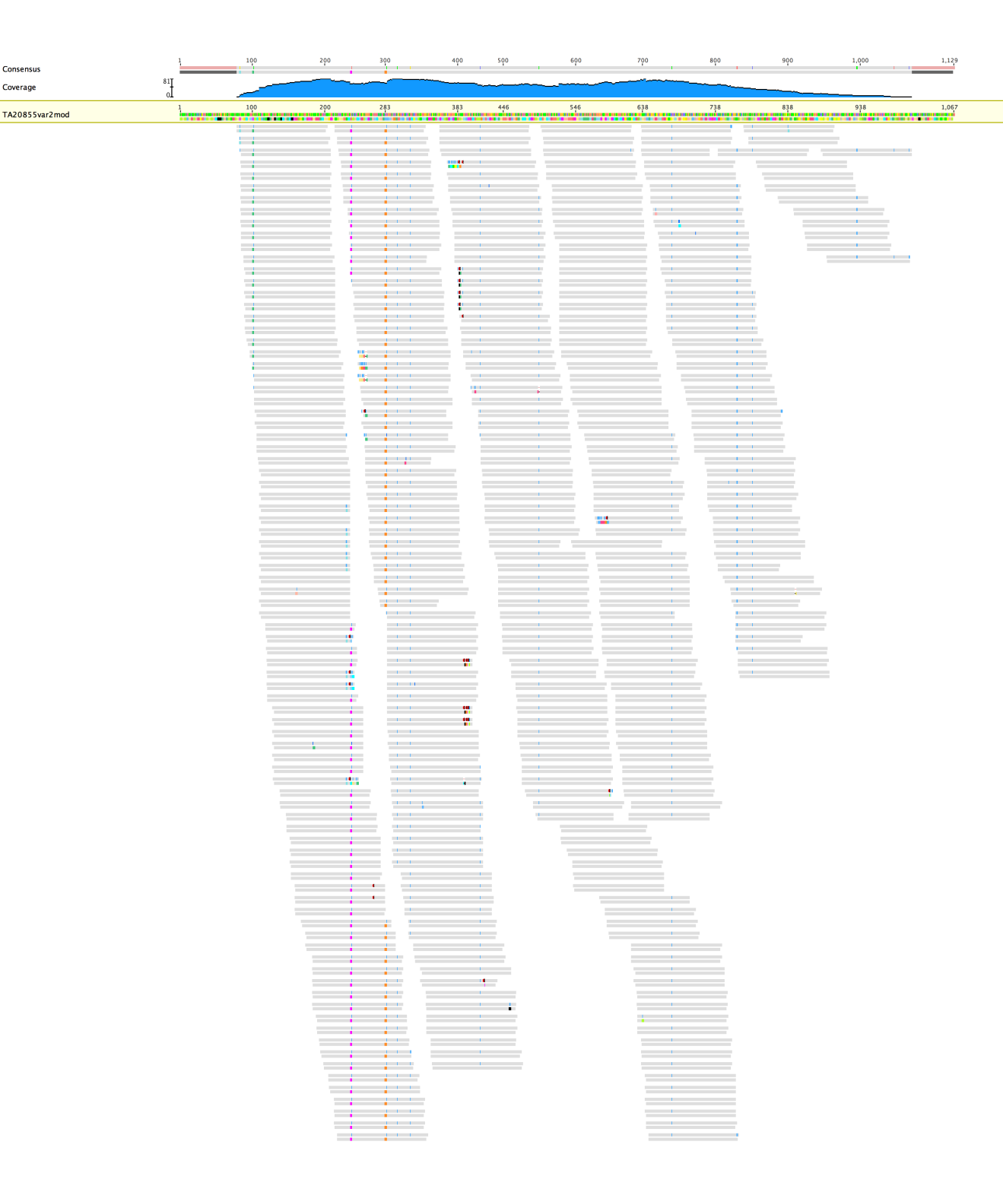
B
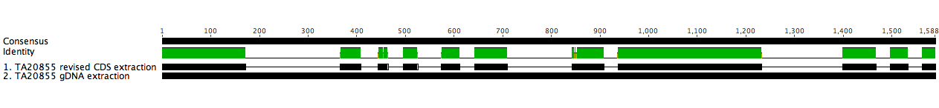

C
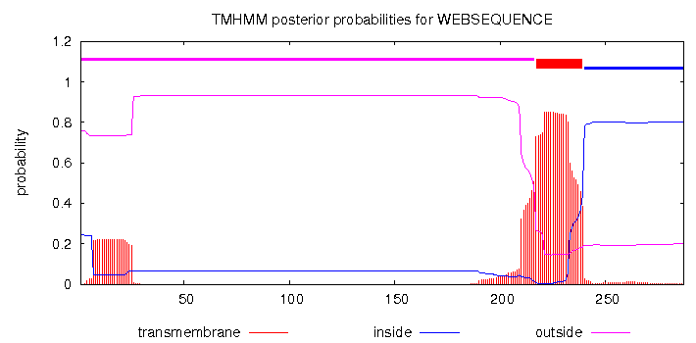
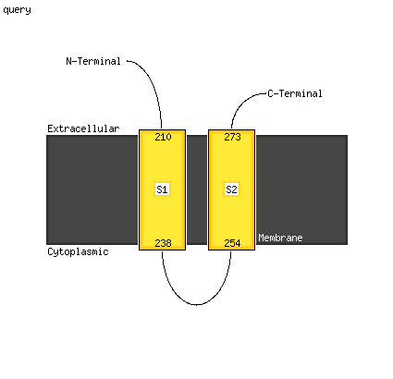

D
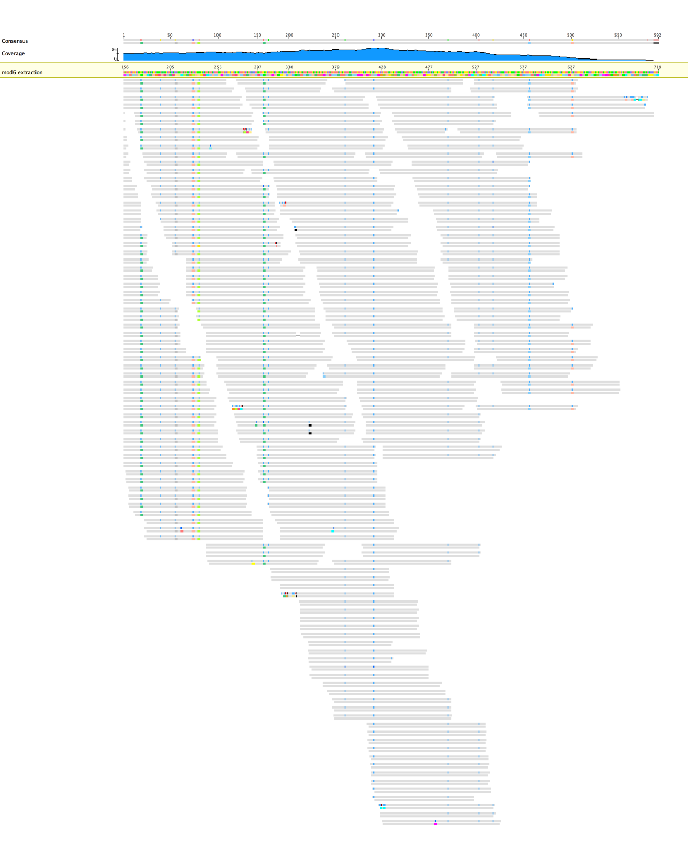
E

A) RNA-seq reads mapped against the revised CDS of TA20855 (including UTRs) demonstrating complete coverage or predicted amino acid sequence: analysis of RNA-seq reads indicated a number of variant transcripts where intron 3 was not spliced out resulting in a stop codon, and termination of the protein after amino acid residue 78 (R). Such premature termination caused by splicing events has been proposed as a mechanism for control of gene expression in plants (Filichkin et al. 2010). B) Revised TA20855 gene model aligned against gDNA sequence in GeneDB, highlighting the position of 11 exons. C) Prediction of one TM helix for TA20855 by TMHMM Server v2.0 and two helices by Memsat_SVM in Phyre² (Kelly et al., 2015), the overall topology (majority of protein to the extracellular side of the membrane) is predicted to be similar by both algorithms. D) RNA-seq reads mapped against the revised CDS of TA19820 (excluding UTRs) demonstrating complete coverage or predicted amino acid sequence. E) Revised TA19820 gene model aligned against gDNA sequence in GeneDB, highlighting the position of 10 exons.

