Additional File 3. Transcriptome data mined from EuPathDB for Plasmodium and Toxoplasma homologues of gene TA20855.

A
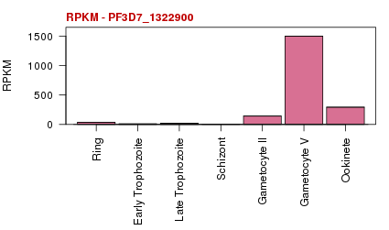
B
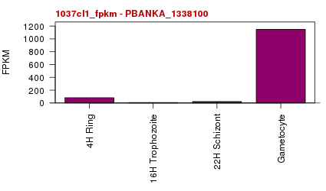

C
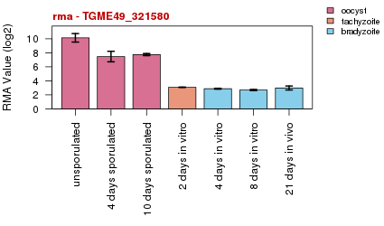

A) Expression profile of PF3D7_1322900 generated from Illumina-based sequencing of P.falciparum 3D7 mRNA representing two gametocyte stages (II and V), the ookinete, and four time points of erythrocytic stages - ring, early trophozoite, late trophozoite, and schizont (http://plasmodb.org/plasmo/app/record/gene/PF3D7_1322900): x-axis, life cycle stages cycle: y-axis, reads per kilobase of exon model per million mapped reads (RPKM). B) Expression profile of PBANKA_1338100 generated from Illumina-based sequencing of RNA from five different stages of P. berghei ANKA development (4h Ring, 16h Trophozoite, 22h Schizont, Gametocytes (http://plasmodb.org/plasmo/app/record/gene/PBANKA_1338100): x-axis, stages of P.berghei ANKA development; y-axis, reads per kilobase of exon model per million mapped reads (RPKM). C) Transcriptome analysis for TGME49_321580 of oocyst, tachyzoite and bradyzoite development in the type II strain M4 of T. gondii (http://toxodb.org/toxo/app/record/gene/TGME49_321580): X-axis, 1. time post infection or sporulation (i.e. 4d vs 8d bradyzoites and 4d vs 10d sporulated oocyst), 2. developmental form (oocyst, tachyzoite, bradyzoite), 3. bradyzoite samples - obtained in vitro vs. in vivo: Y-axis, RMA Normalized Values (log base 2).

