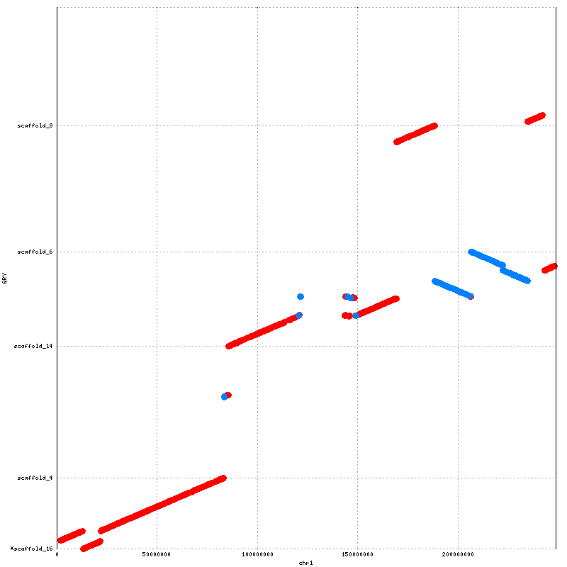
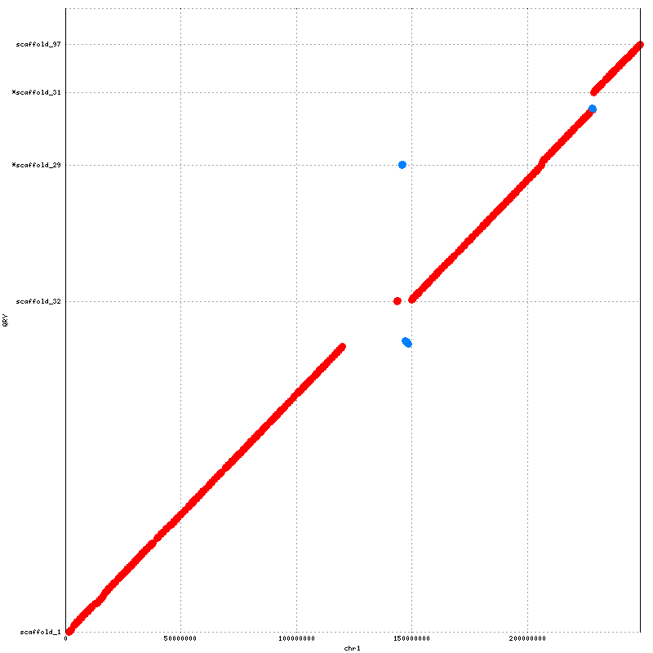
\\\\\\\\\\\||\E
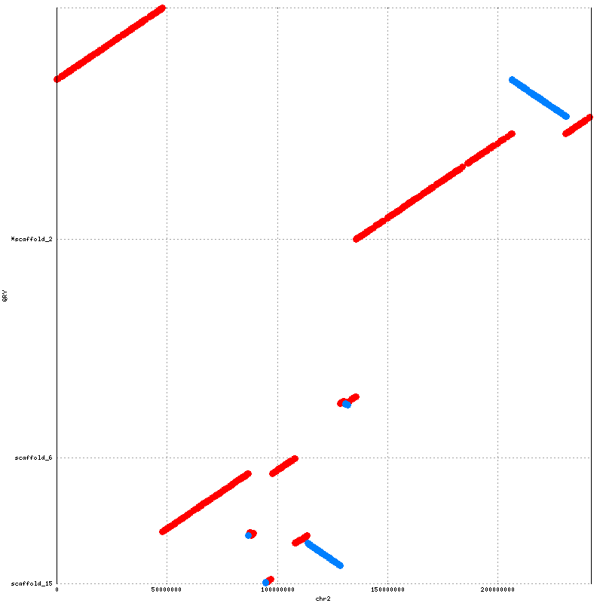
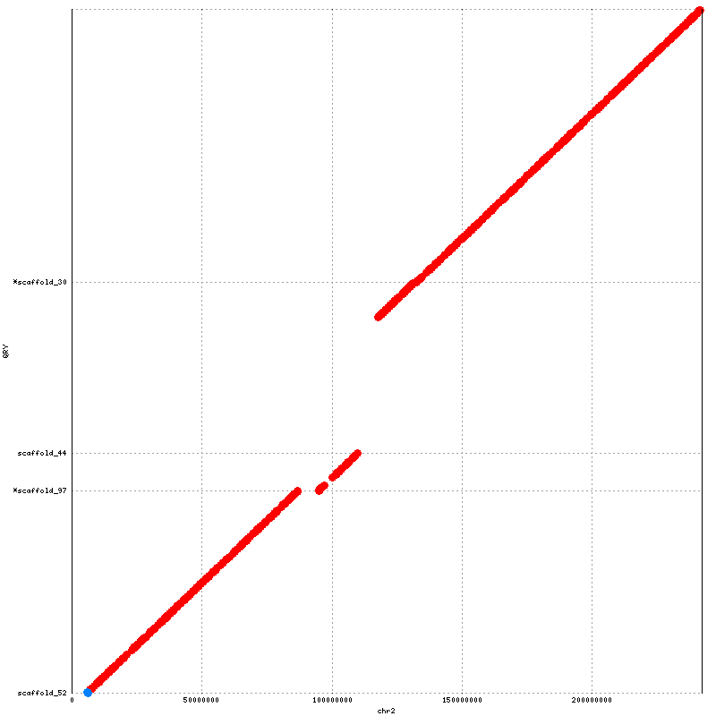
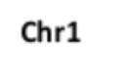
Supplementary Figure S1: Orientation and ordering results for SALSA (on the left) with Lachesis (on the right) for NA12878. These plots are in detailed view for each chromosome in Figure 3
Chr2
Chr2
Chr1
Chr1
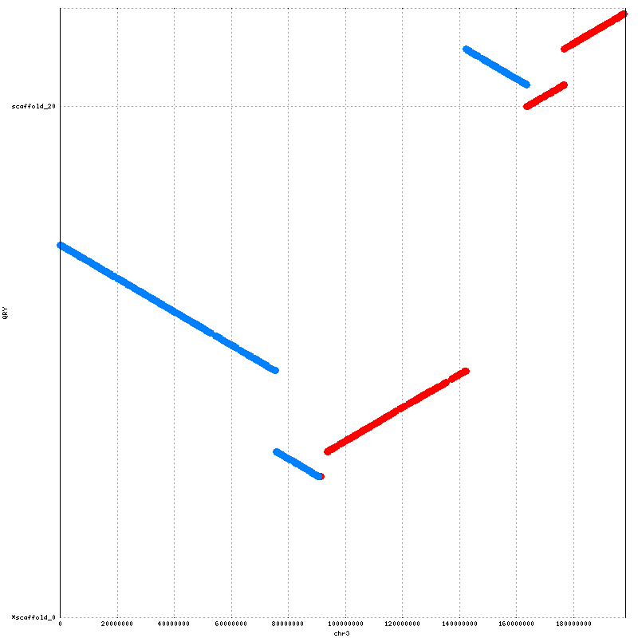
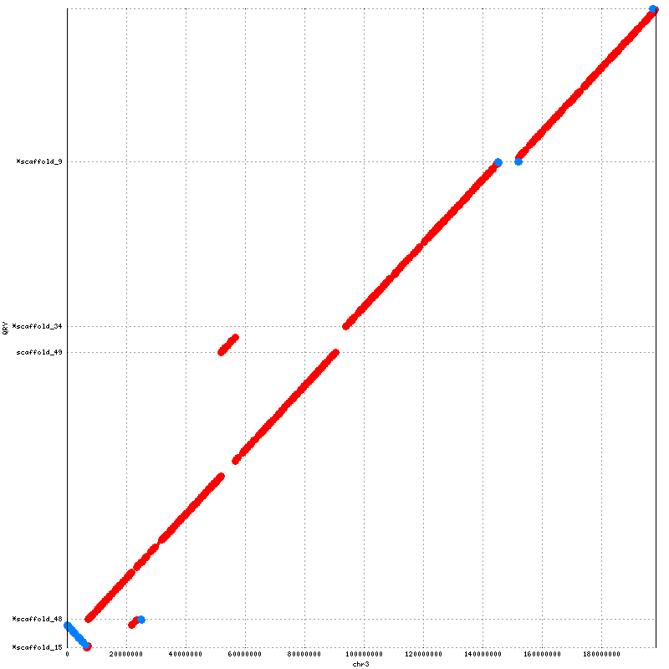

Chr3
Chr3

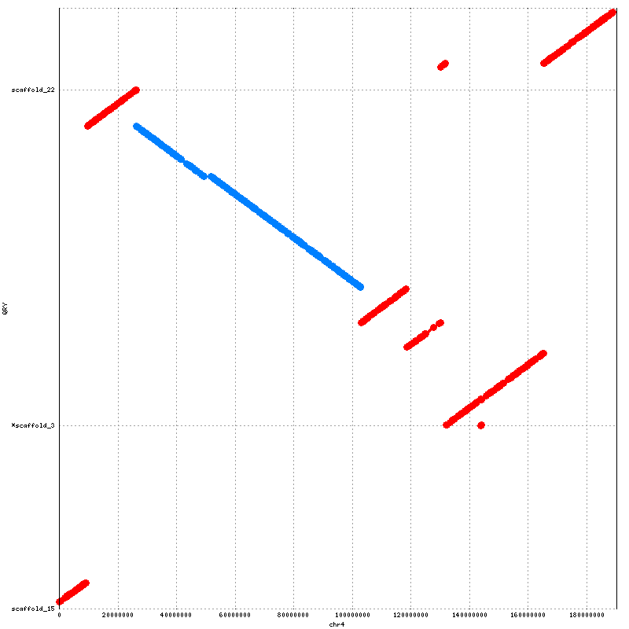
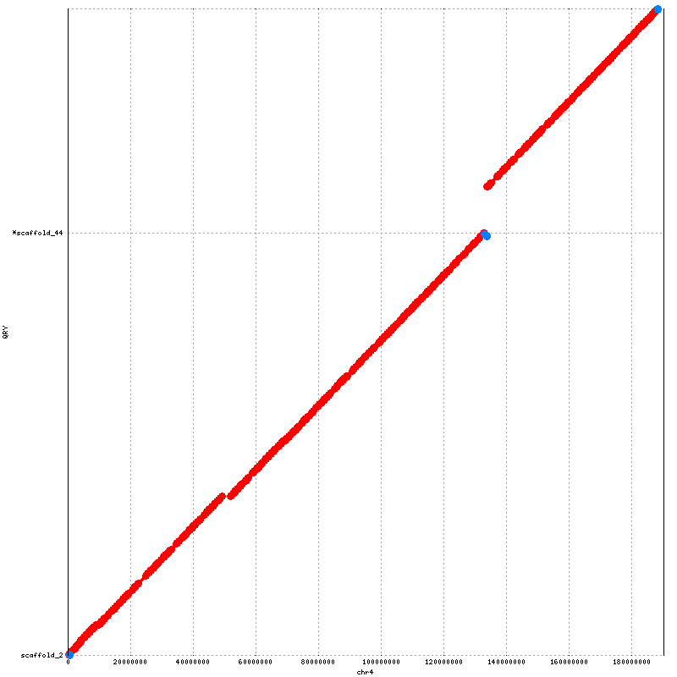

Chr4
Chr4

Supplementary Figure S1: Orientation and ordering results for SALSA (on the left) with Lachesis (on the right) for NA12878. These plots are in detailed view for each chromosome in Figure 3
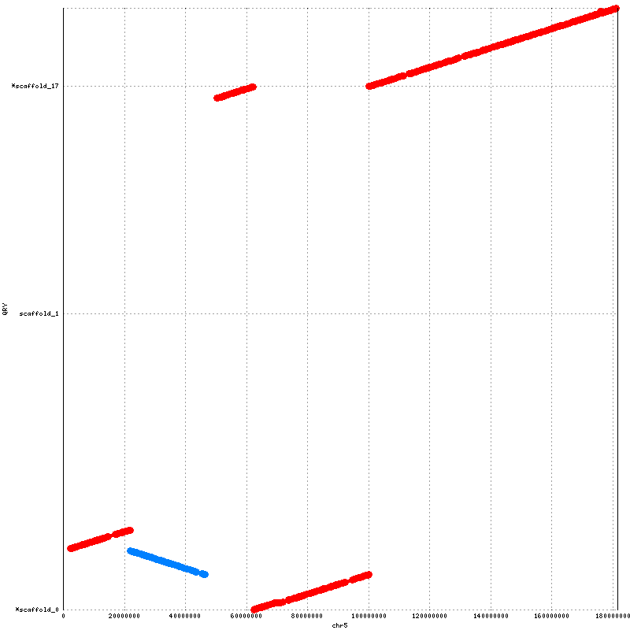
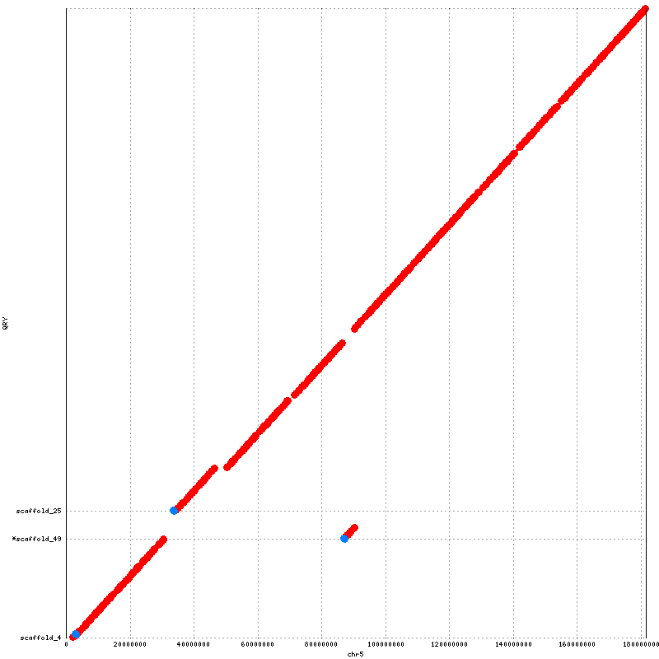

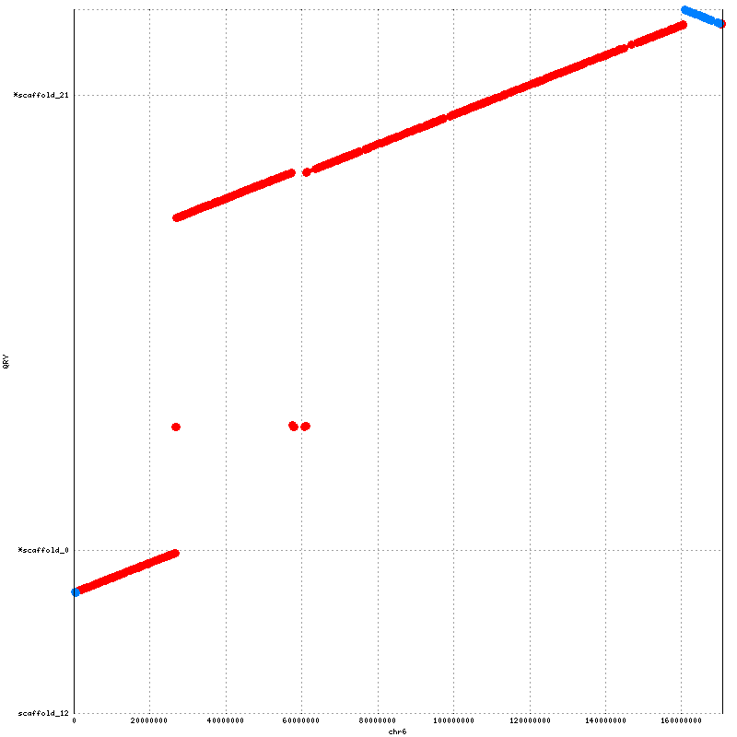
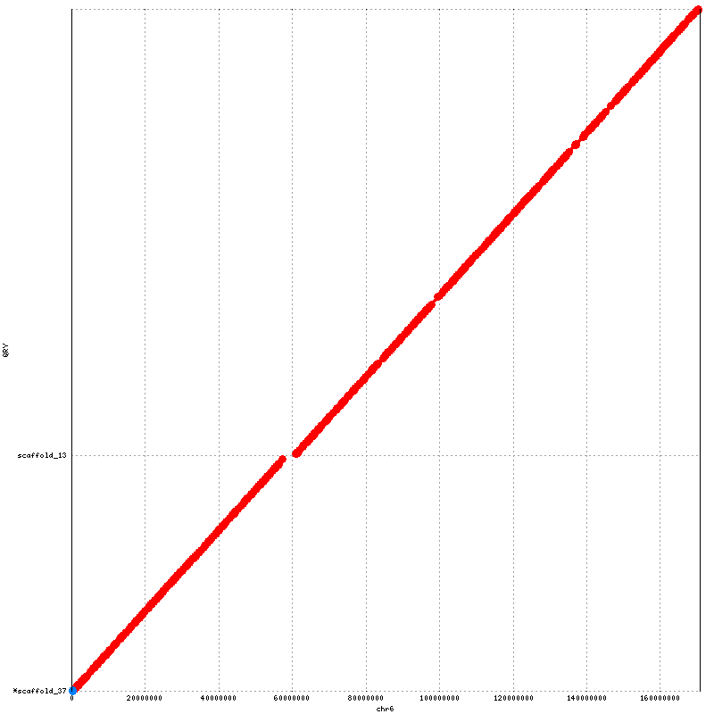
Supplementary Figure S1: Orientation and ordering results for SALSA (on the left) with Lachesis (on the right) for NA12878. These plots are in detailed view for each chromosome in Figure 3
Chr6
Chr6
Chr5
Chr5
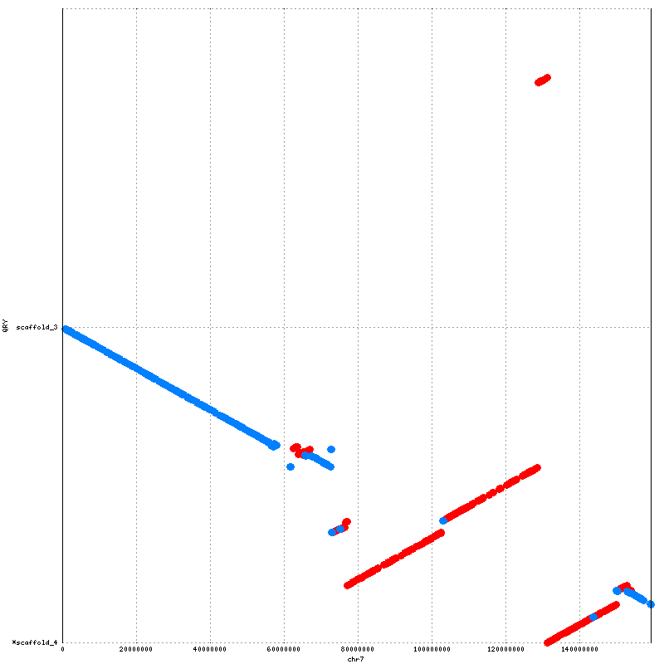
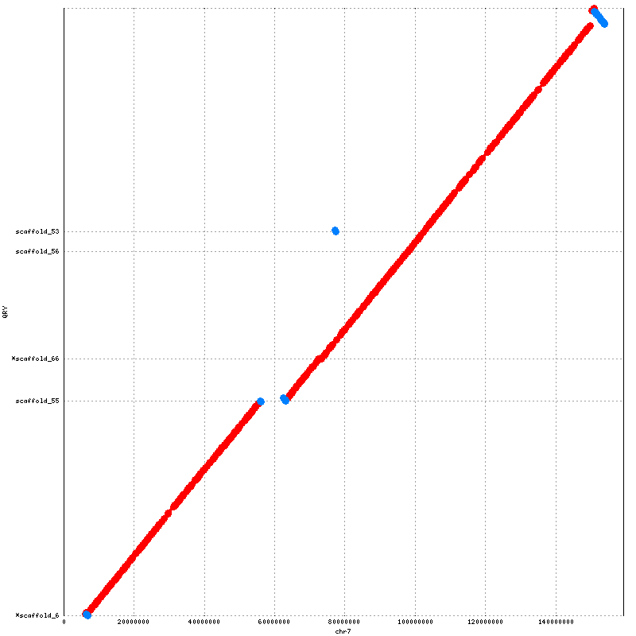

Chr7
Chr7

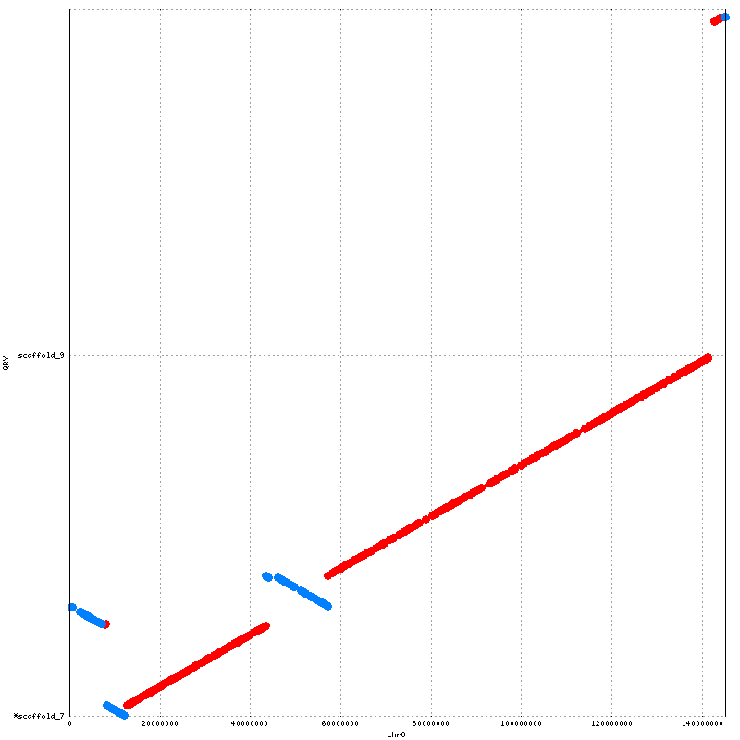
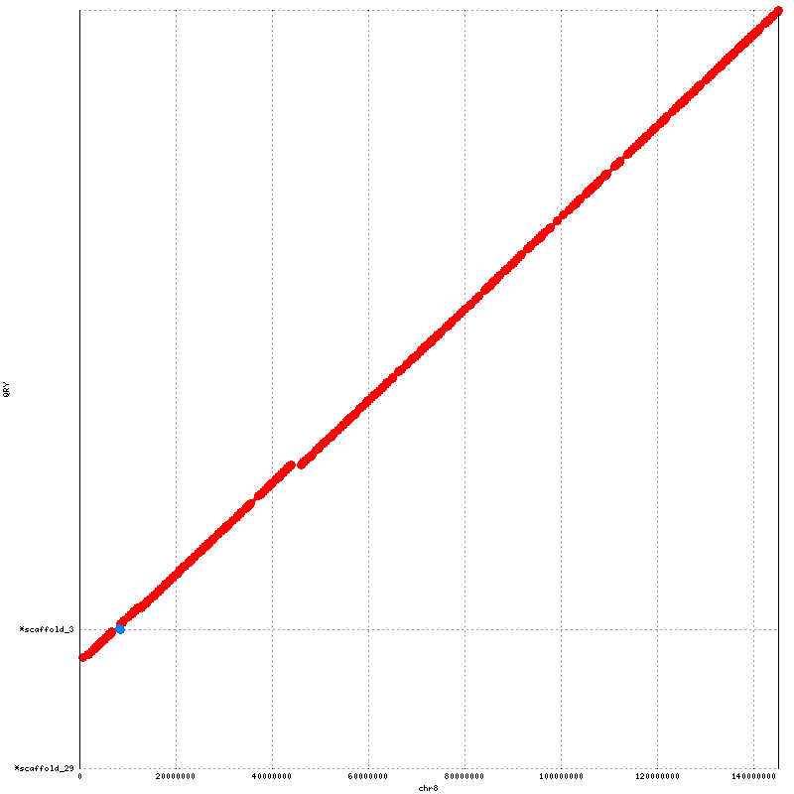

Chr8
Chr8

Supplementary Figure S1: Orientation and ordering results for SALSA (on the left) with Lachesis (on the right) for NA12878. These plots are in detailed view for each chromosome in Figure 3

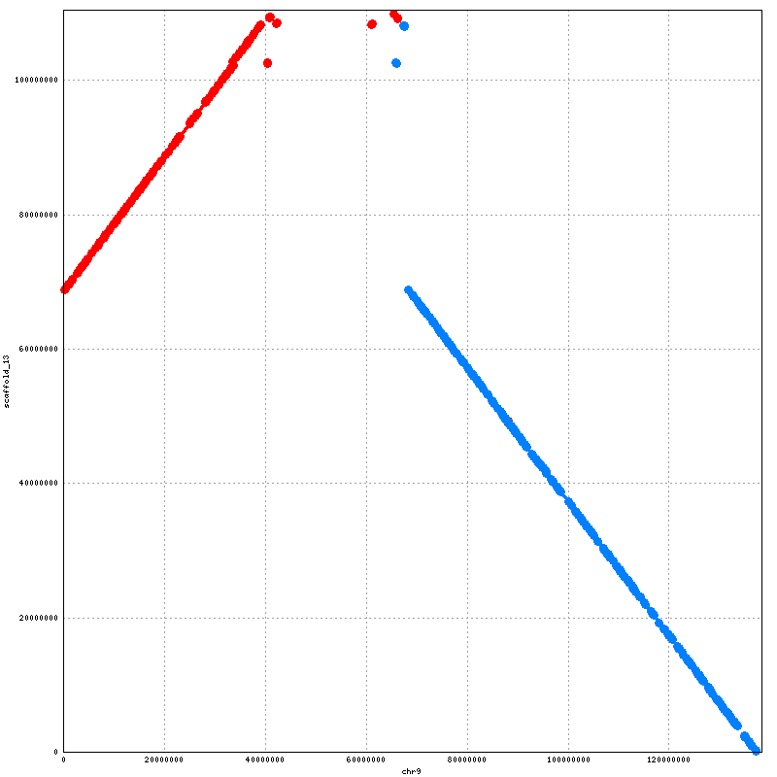
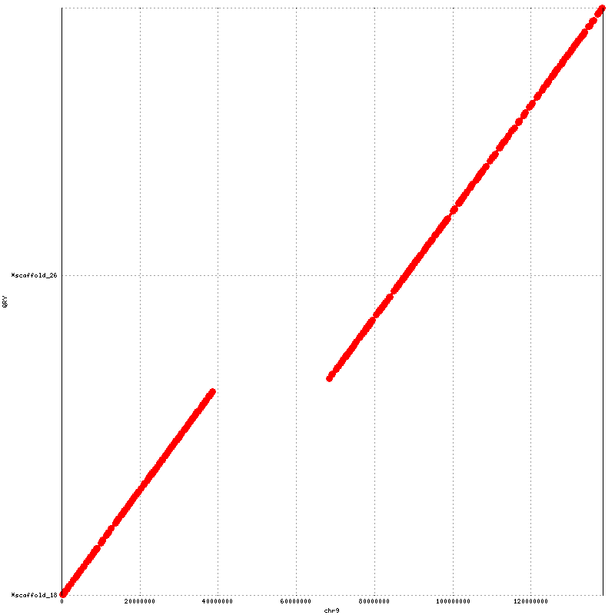

Chr9
Chr9

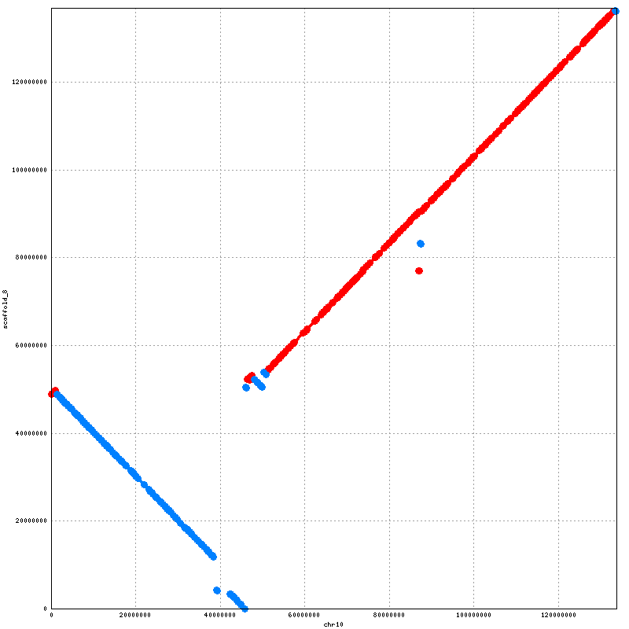
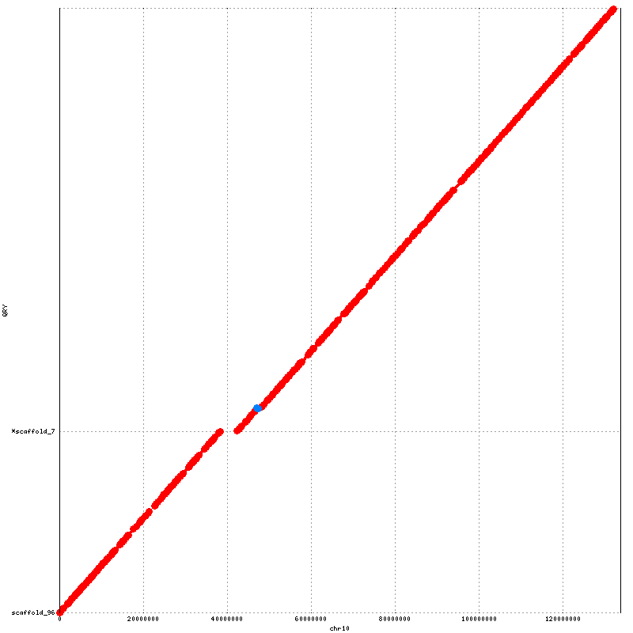

Supplementary Figure S1: Orientation and ordering results for SALSA (on the left) with Lachesis (on the right) for NA12878. These plots are in detailed view for each chromosome in Figure 3
Chr10
Chr10
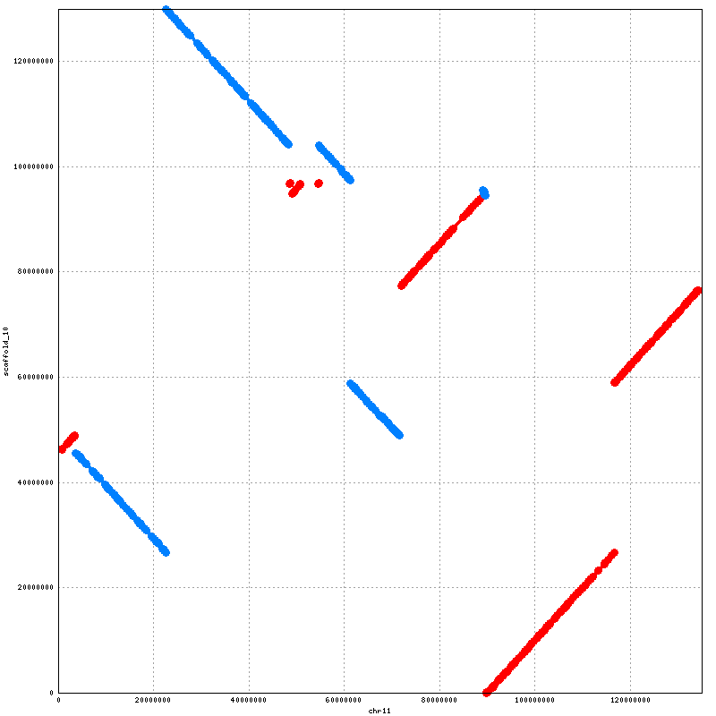
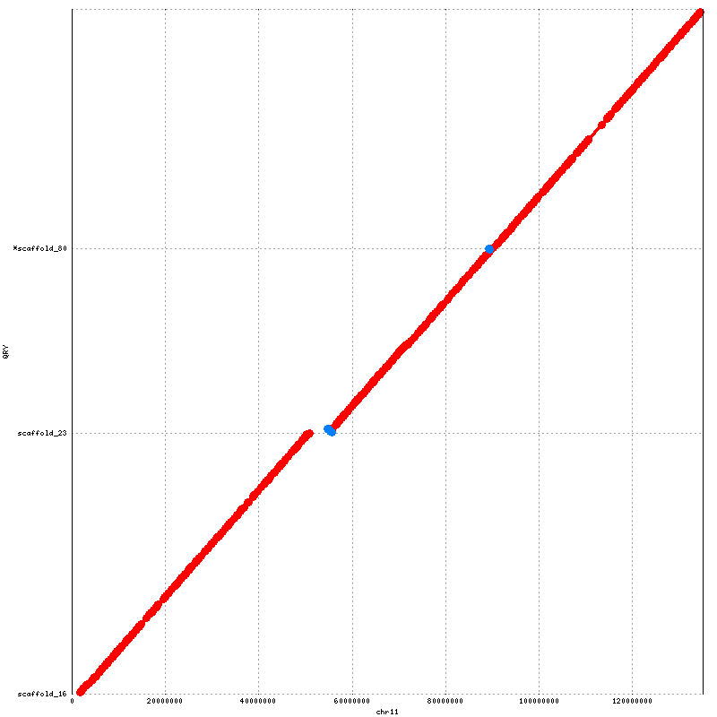

Chr11

Chr11

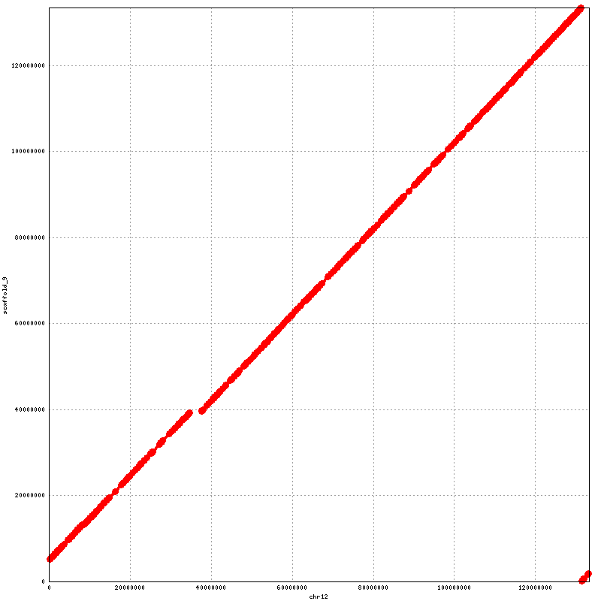
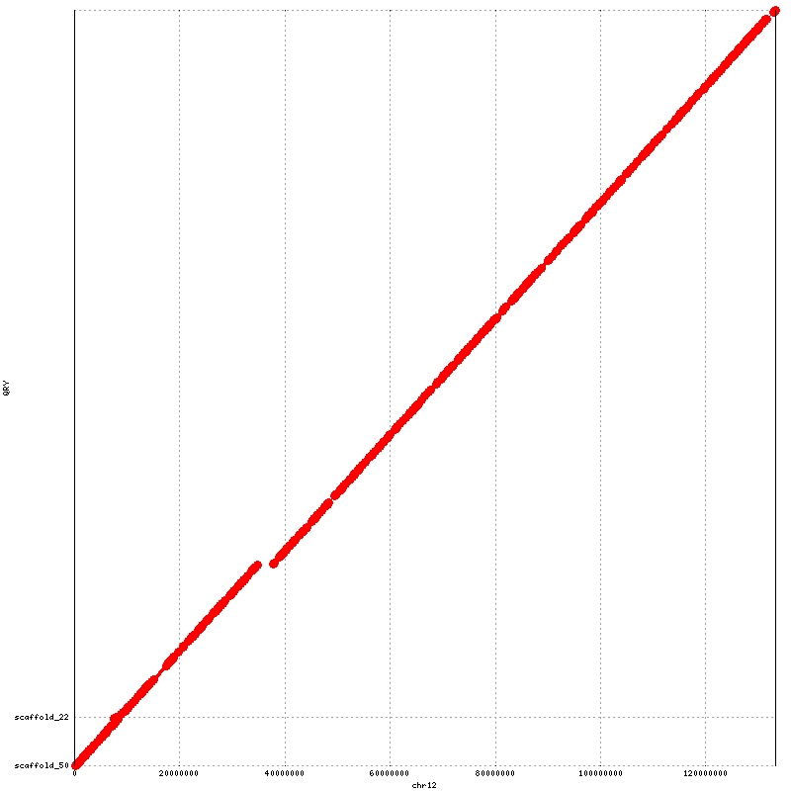

Chr12
Chr12

Supplementary Figure S1: Orientation and ordering results for SALSA (on the left) with Lachesis (on the right) for NA12878 . These plots are in detailed view for each chromosome in Figure 3
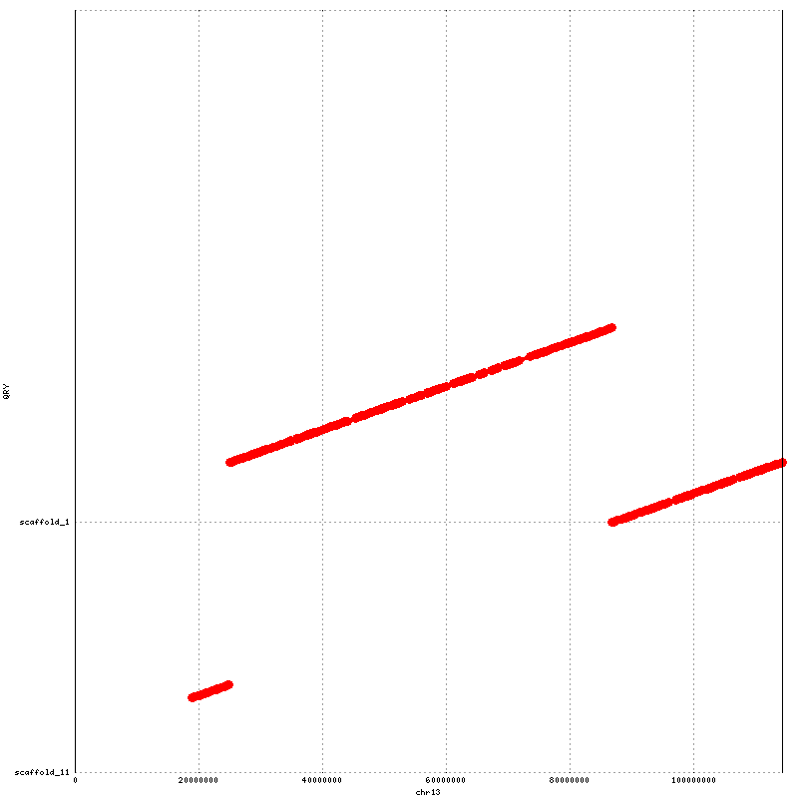
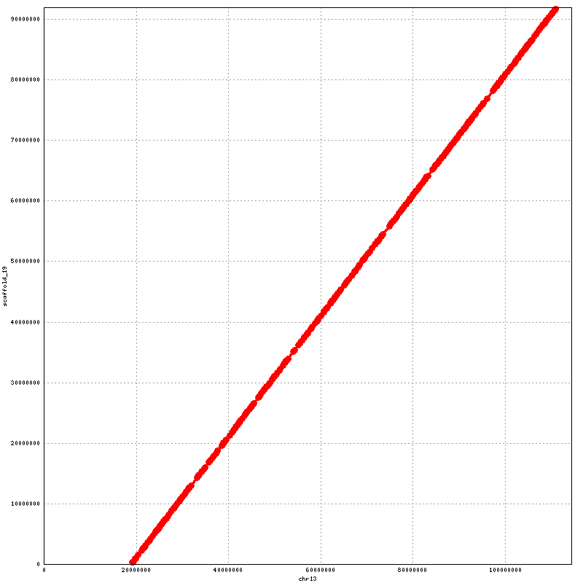

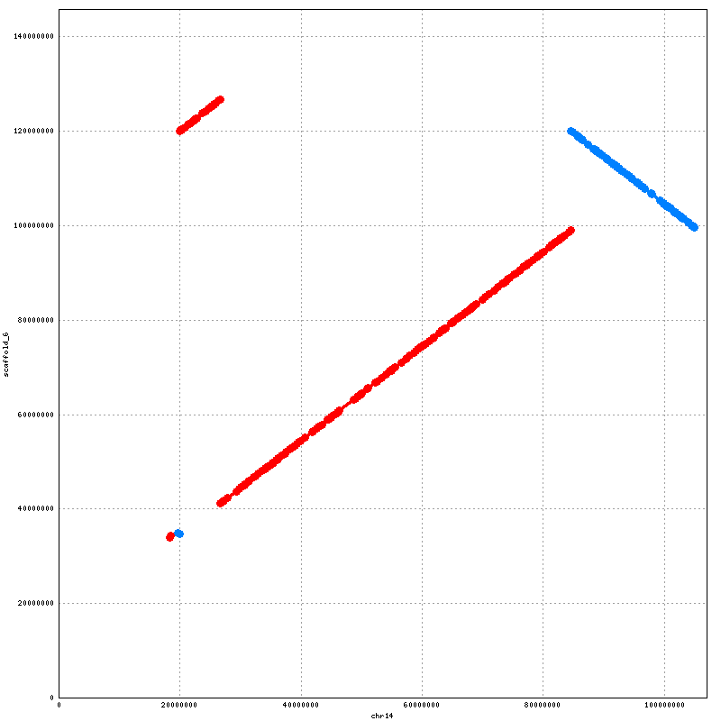
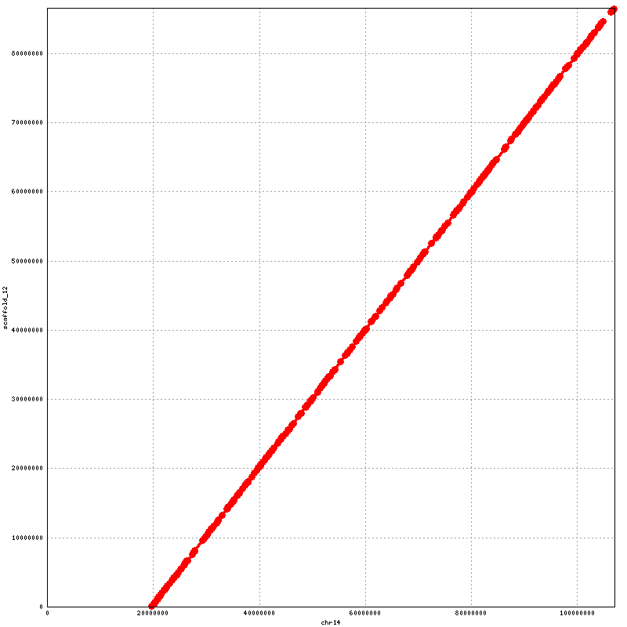
Supplementary Figure S1: Orientation and ordering results for SALSA (on the left) with Lachesis (on the right) for NA12878. These plots are in detailed view for each chromosome in Figure 3
Chr14
Chr14
Chr13
Chr13
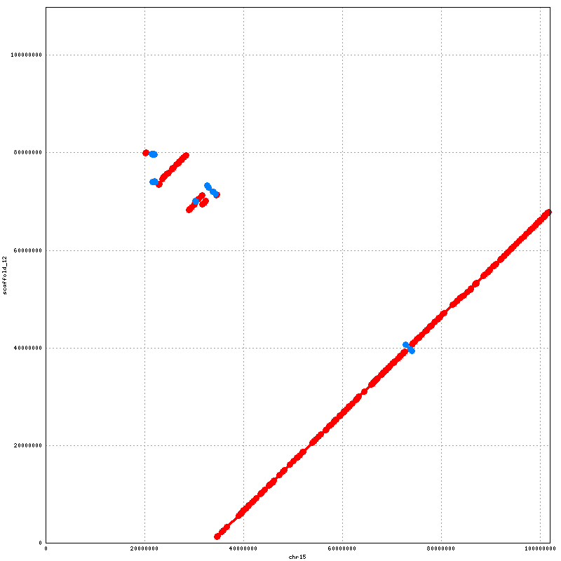
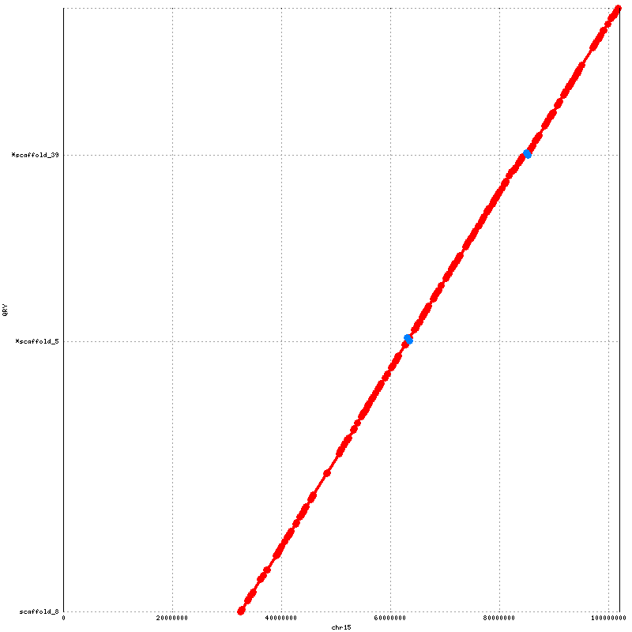
ß
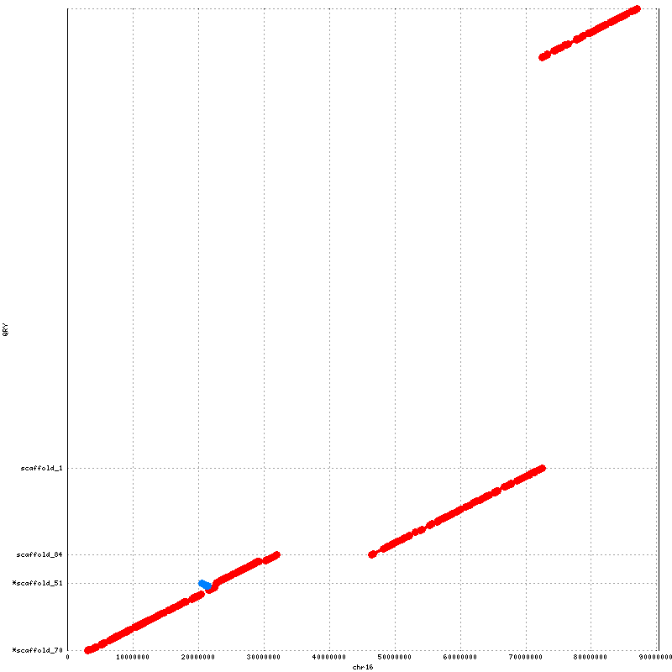
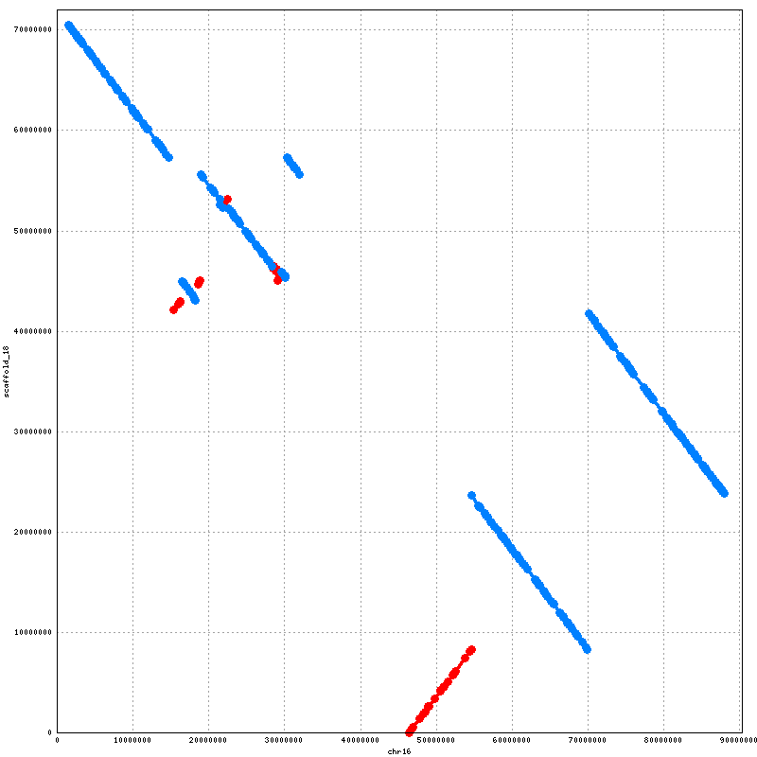
Supplementary Figure 1: Orientation and ordering results for SALSA (on the left) with Lachesis (on the right) for NA12878. These plots are in detailed view for each chromosome in Figure 3
Chr16
Chr16
Chr15
Chr15
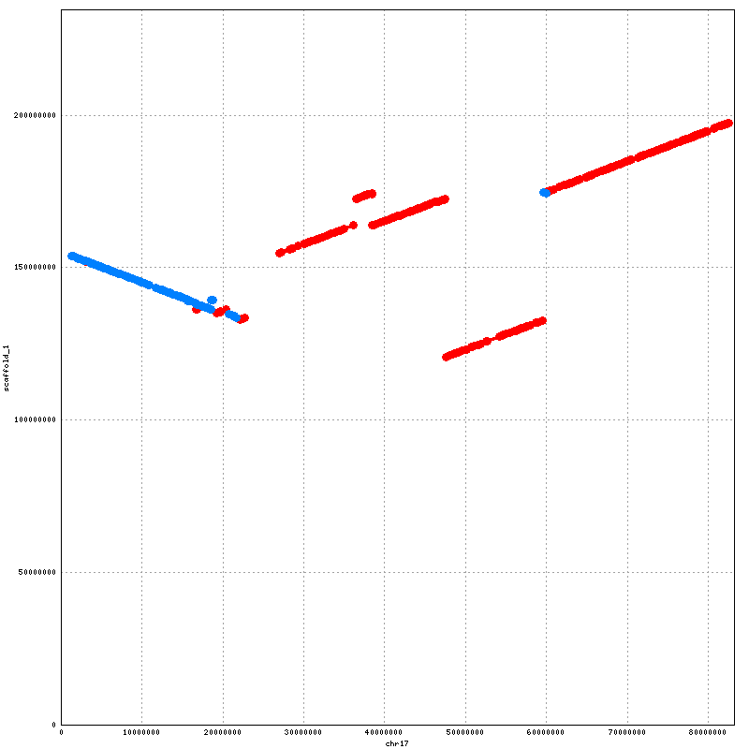
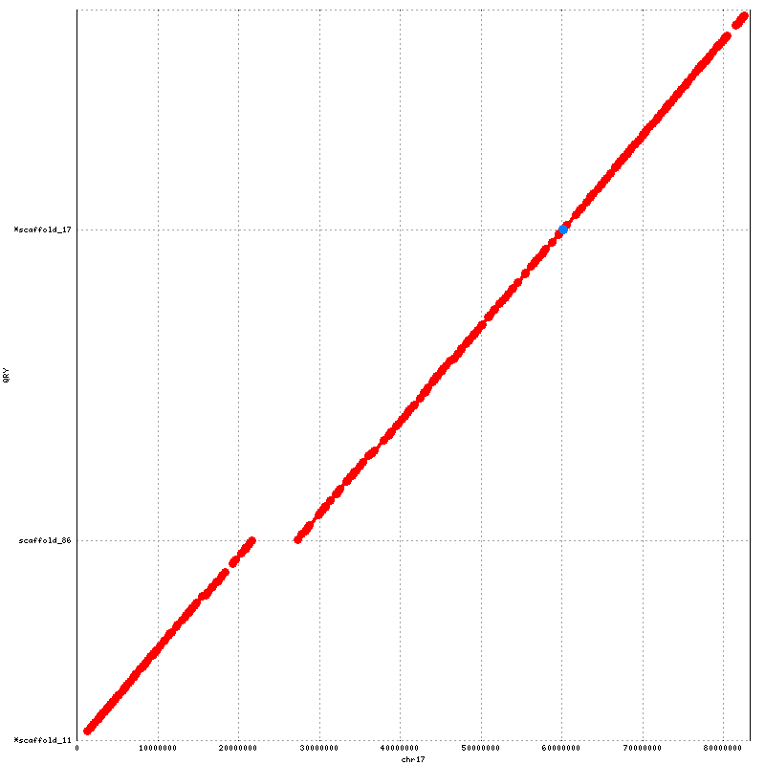

Chr17
Chr17

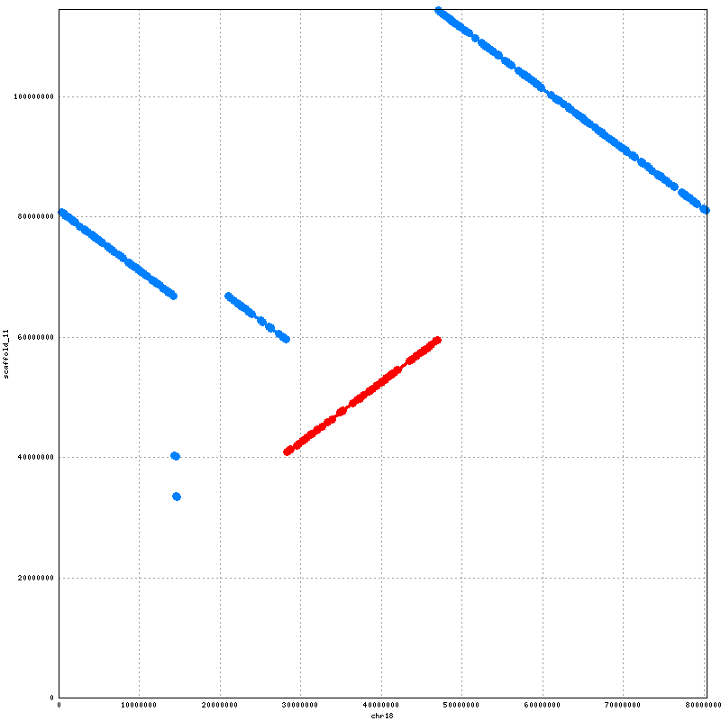
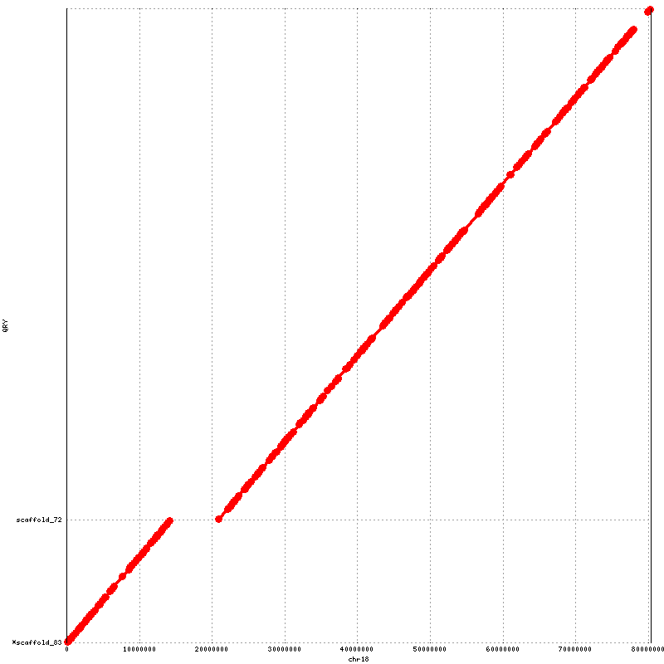

Chr18
Chr18

Supplementary Figure S1: Orientation and ordering results for SALSA (on the left) with Lachesis (on the right) for NA12878. These plots are in detailed view for each chromosome in Figure 3
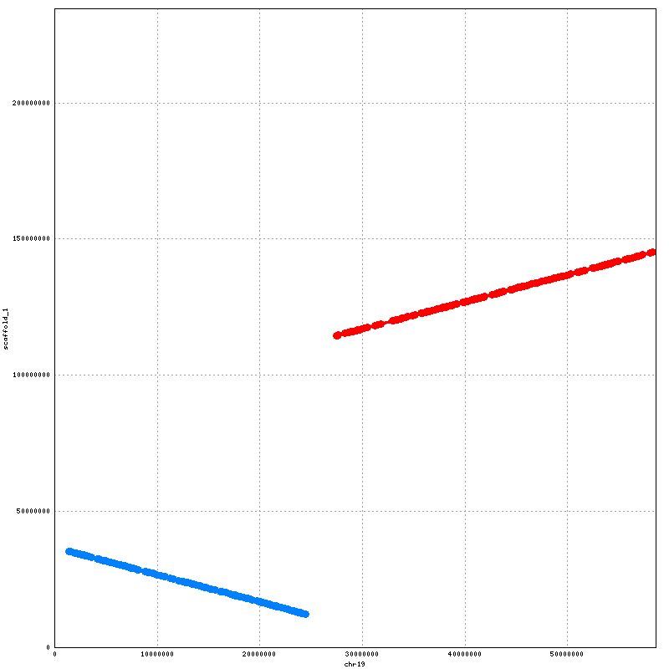
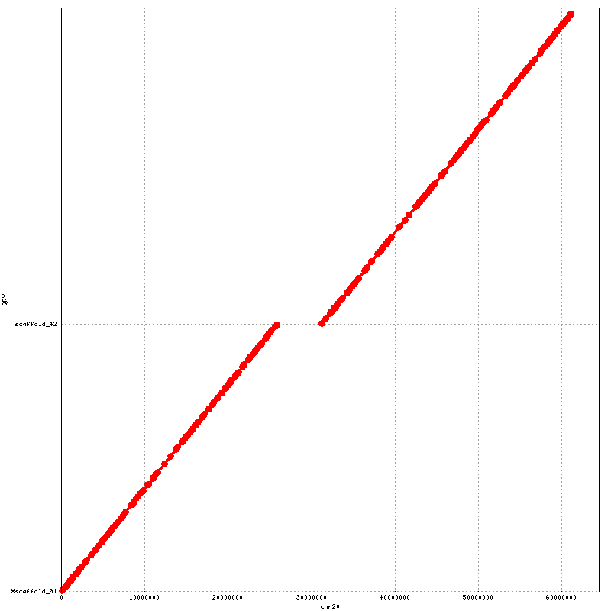
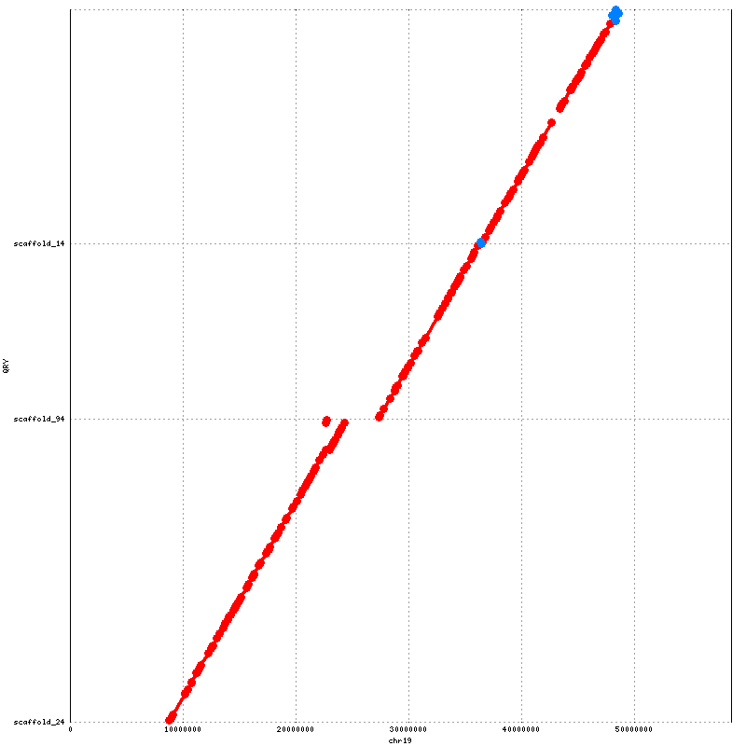

Chr19
Chr19

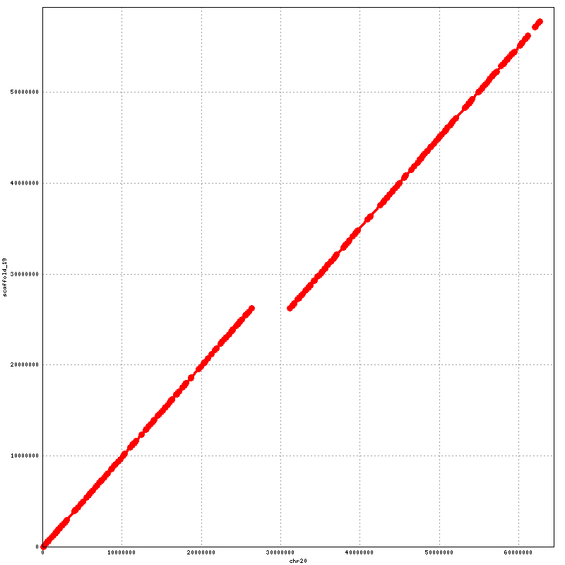

Chr20
Chr20

Supplementary Figure S1: Orientation and ordering results for SALSA (on the left) with Lachesis (on the right) for NA12878. These plots are in detailed view for each chromosome in Figure 3
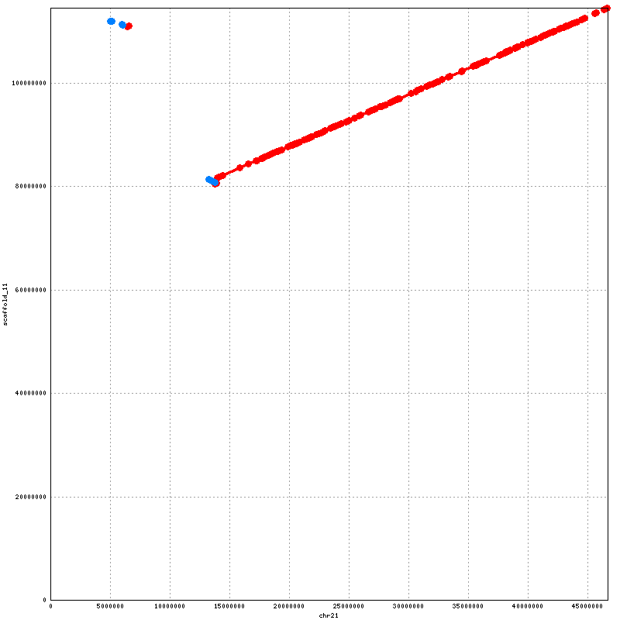
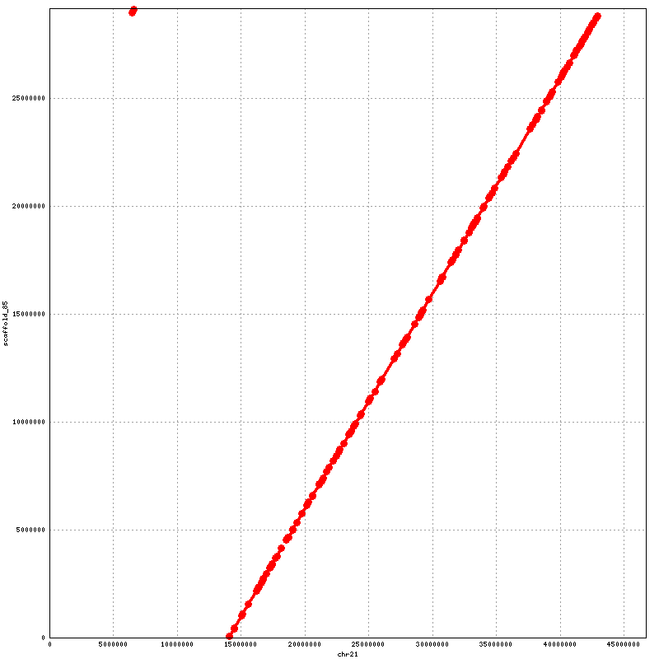

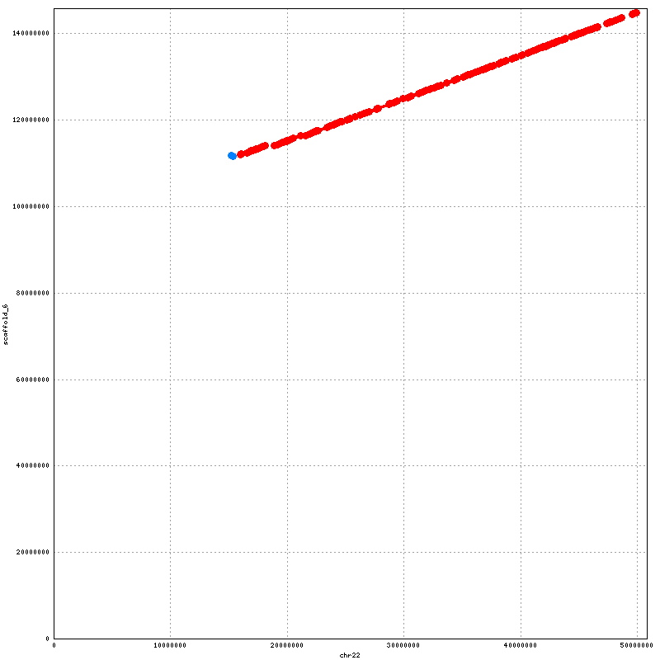
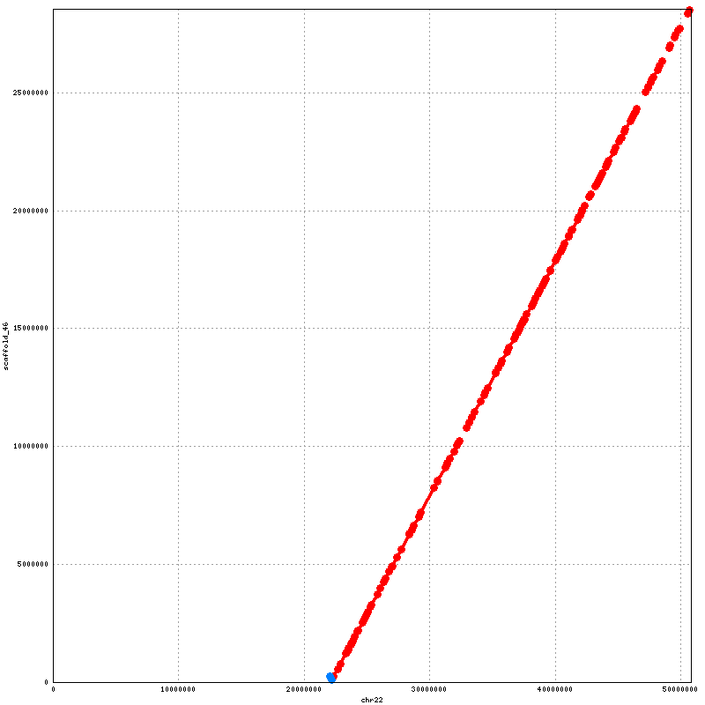
Supplementary Figure S1: Orientation and ordering results for SALSA (on the left) with Lachesis (on the right) for NA12878. These plots are in detailed view for each chromosome in Figure 3
Chr22
Chr22
Chr21
Chr21

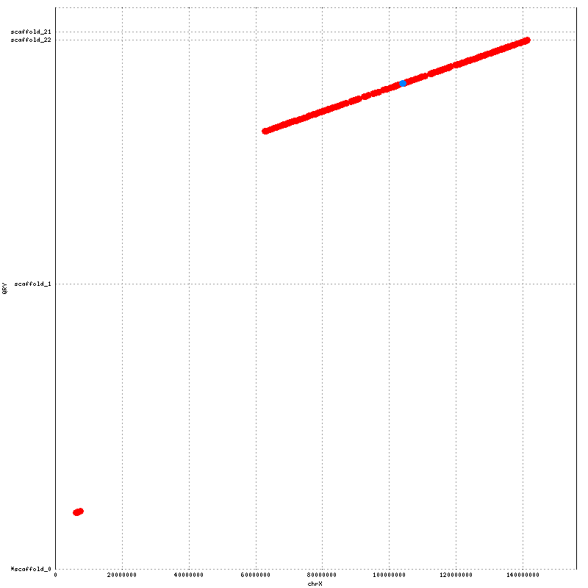
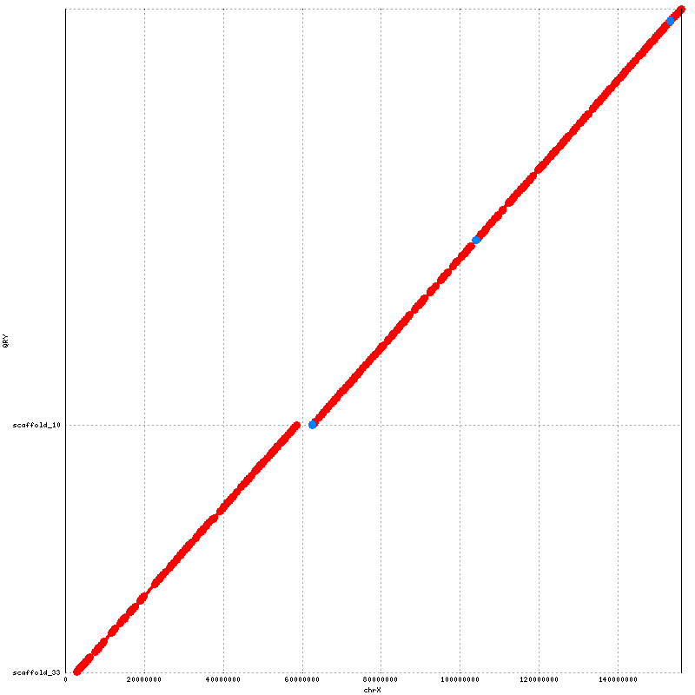
ChrX

ChrX

Supplementary Figure S1: Orientation and ordering results for SALSA (on the left) with Lachesis (on the right) for NA12878. These plots are in detailed view for each chromosome in Figure 3

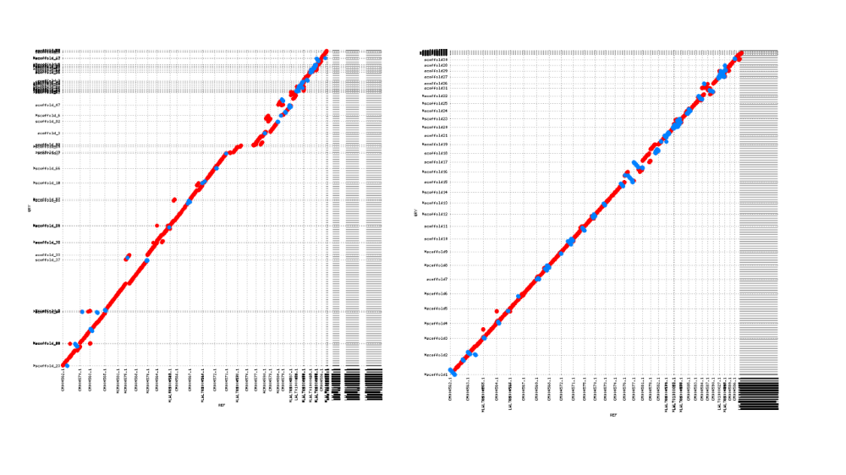
Supplementary Figure S2: Alignment dot plots for scaffolds generated using bionano scaffolds by SALSA (on the left) and LACHESIS (on the right)

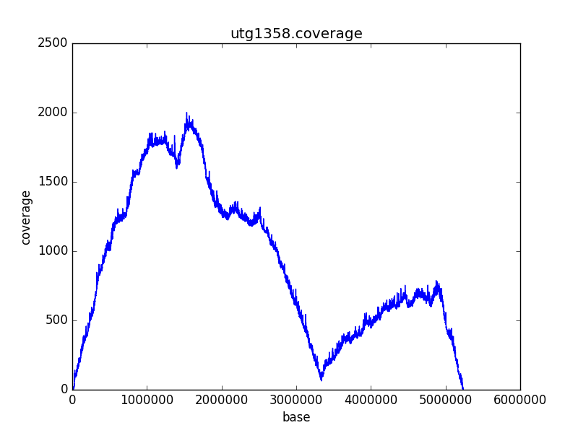
Supplementary Figure S3: Detection of Misassemblies using physical coverage. It can be seen that there is a significant dip in the coverage at about 3.4Mb which indicates a potential misjoin to generate a contig during assembly. This indicates contigs those map to two different chromosomes. Our misassembly detection algorithm finds such dips in the physical coverages and breaks contigs at that position to avoid propagation of errors in the scaffolding process.

