- Linkage disequilibrium pattern on chromosome 2

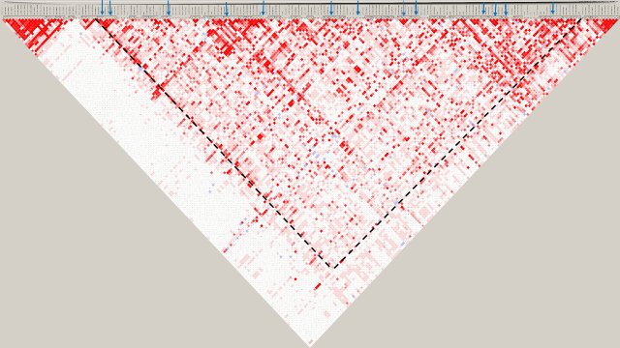
- Linkage disequilibrium pattern on chromosome 3

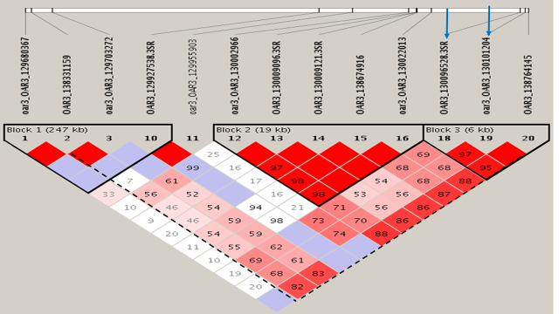
- Linkage disequilibrium pattern on chromosome 5
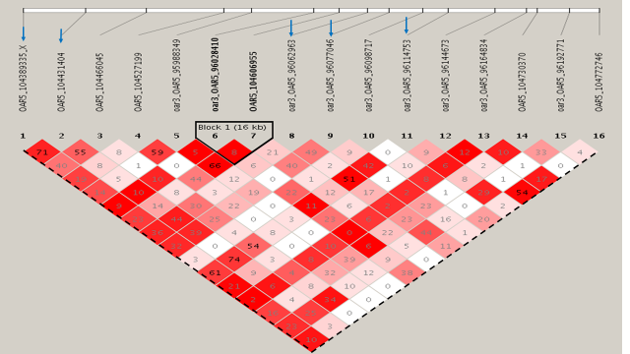
- Linkage disequilibrium pattern on chromosome 16

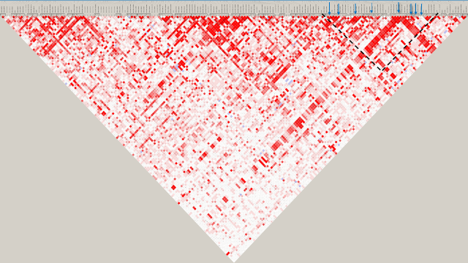

- Linkage disequilibrium pattern on chromosome 19

