Fig. S7: STRUCTURE* analysis assuming 7 clusters (K=7), organized according to table 2.
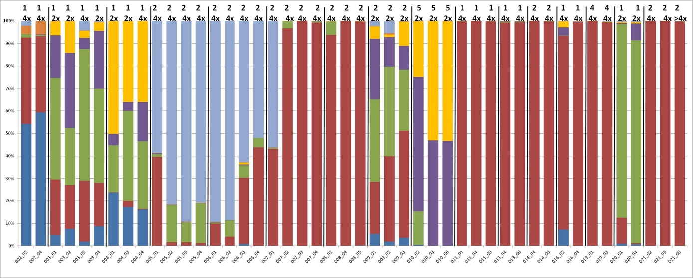
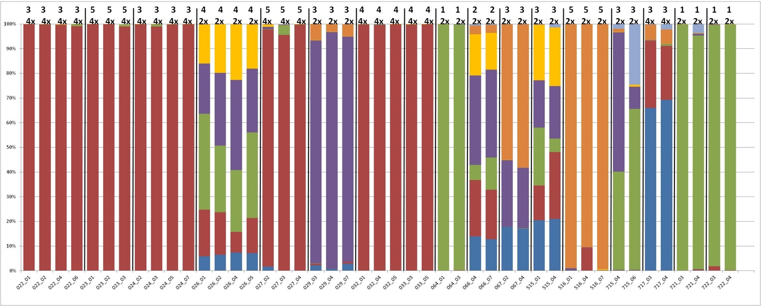
* The genotypes are represented by the vertical bars and the different origins are separated by vertical black lines, whereas the different colours indicate the seven genetic clusters (Table S1). The top row indicates the geographical origin (upper) and ploidy (lower) for each sample according to Table 1.

