Fig. S8: PCoA analysis of the 91 samples M. recutita coloured according to (a) ploidy, (b) geographic origin, (c) flowering time
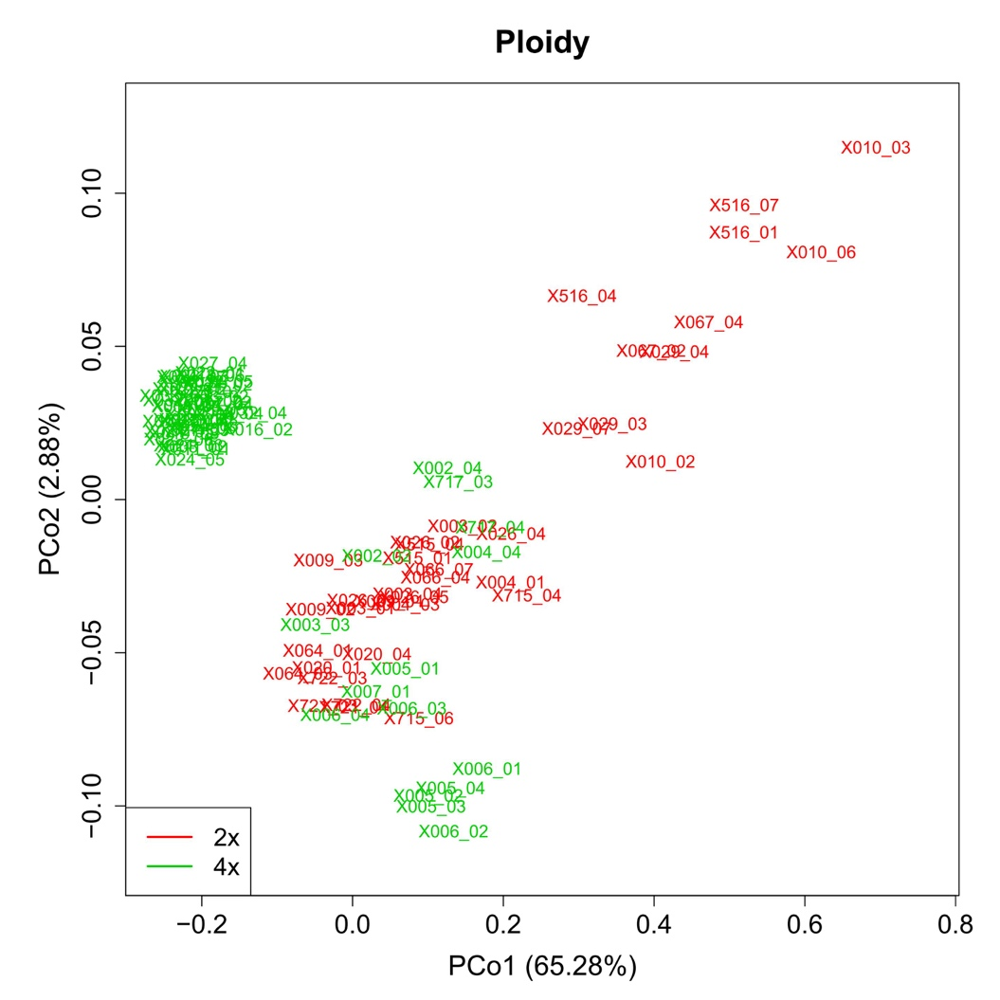
(a) ploidy

(b) geographic origin
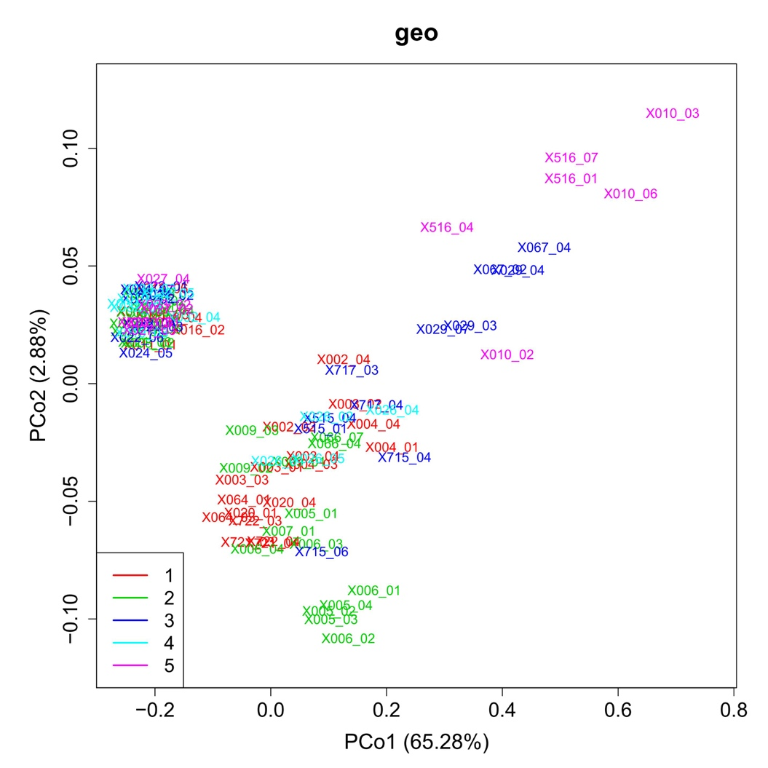

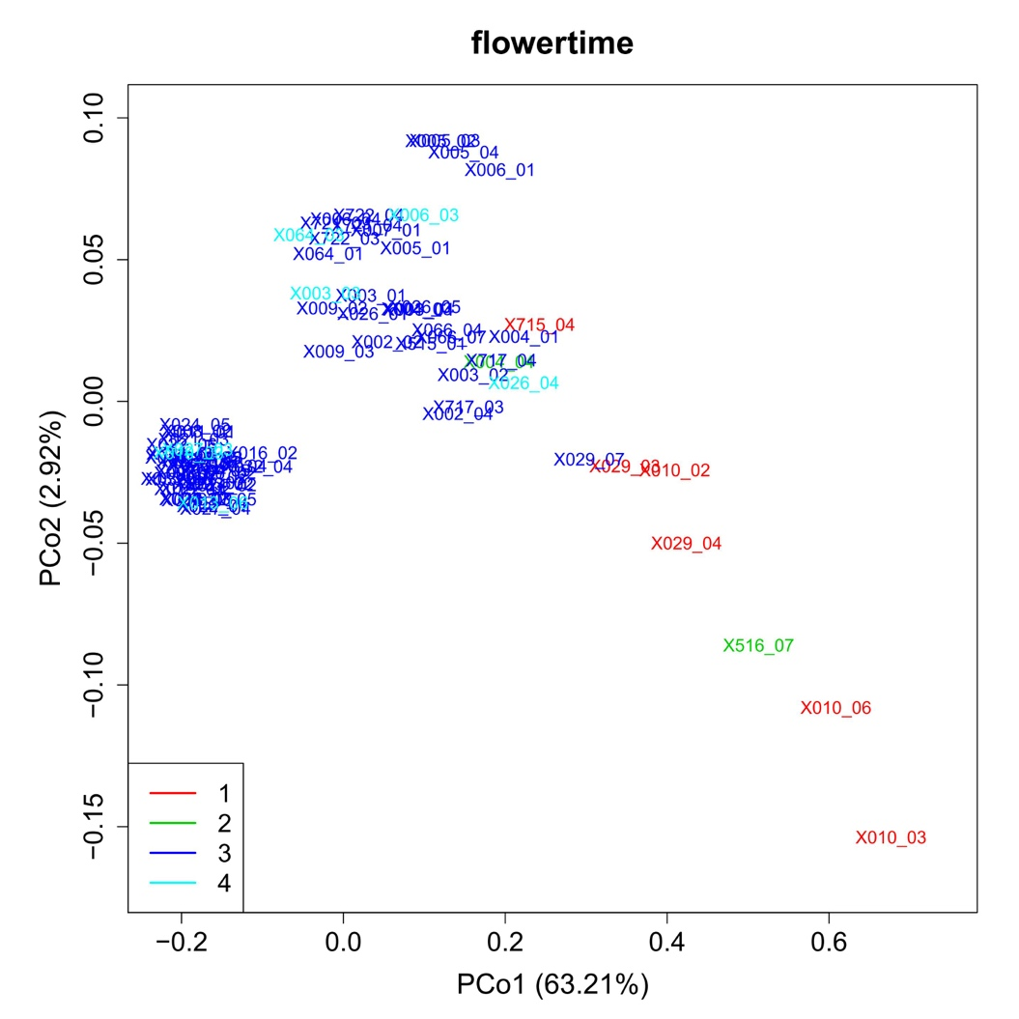
(c) flowering time

PCoA performed as described in Fig. S1
(a): red: diploid, green: tetraploid (b) code for geographic origin see Table 1 (c) start flowering from days after sowing (DAS): 1 (78 DAS - 107 DAS), 2 (108 DAS - 200 DAS), 3 (201 DAS - 260 DAS), 4 (261 DAS - 298 DAS), 1-2: short day conditions; 3-4: long day conditions

