Additional File 1:

The Maf-S-cnc-Keap1 pathway in Anopheles gambiae

A single ortholog of the Drosophila Maf-S (CG9954) is present in the genome of An. gambiae on chromosome arm 3L. Anopheles gambiae Maf-S has two splice variants: AGAP010405-RA contains two coding exons and encodes a putative protein of 146 amino acids; AGAP010405-RB encodes a putative protein of 136 amino acids encoded by a single exon (Figure S1). Both splice variants contain the bZip-Maf domain which is a basic leucine zipper motif, allowing dimerization and DNA binding [1].

Keap1 is present in An. gambiae in a two-to-one homology relationship with D. melanogaster; both paralogs (AGAP003645 (1014 amino acids) and AGAP012550 (256 amino acids)) are annotated as Kelch-like proteins showing relatively low query coverage (<40%) but high identity when compared to D. melanogaster Keap1 (CG3962) of 73% and 75%, indicative of shared functional domains. The two homologs of Keap1 present in Anopheles were manually examined using VectorBase for the presence of both a BTB/POZ domain and the 6 kelch repeats necessary for binding to cnc [2]. Only AGAP003645 contained all these features with AGAP012550 representing a truncated version of AGAP003645, lacking the kelch repeats (Figure S1). Thus, AGAP003645 is therefore the probable functional ortholog of Keap1.

The single ortholog of Drosophila cnc found in An. gambiae (AGAP005300) is predicted to have three isoforms: cncA, cncB and cncC, all splice variants contain the bZIP motif necessary for binding Maf-S; however, only cncA and cncB contain an ETGE motif thought necessary to bind Keap1 [3] (Figure S1).

Figure S1: Schematic of Maf-S cnc and Keap1 in An gambiae. The two splice variants of Maf-S (AGAP010405) are shown with the leucine-zipper motif represented in green. Splice sites are shown by dashed black lines. The two Keap1 homologs (AGAP003645 and AGAP012550) are shown with the BTB/POZ and Kelch domains represented in red and blue respectively. The presence of both these domains are necessary for cnc binding [4]. The three cnc (AGAP005300) splice variants cncA, cncB and cncC are illustrated with the b-zip domain and the ETGE motif in yellow and black respectively. Again, the presence of both are necessary for Maf-S binding [5].

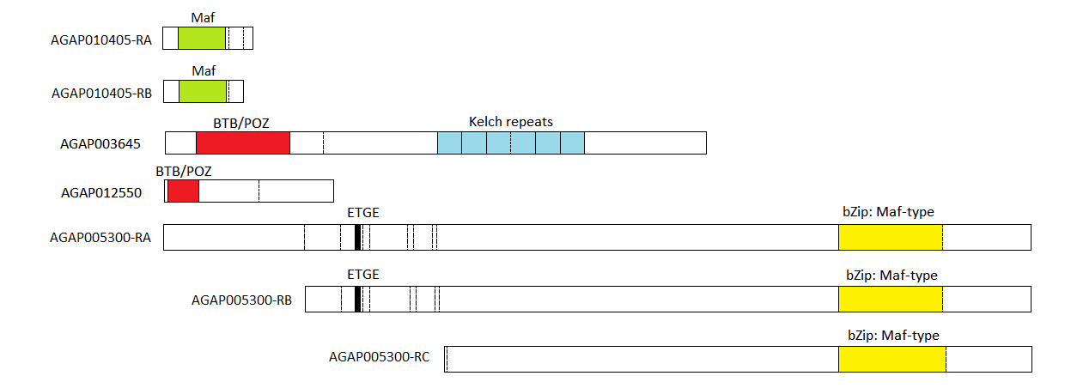

References
1. Katsuoka F, Yamamoto M. Small Maf proteins (MafF, MafG, MafK): History, structure and function. Gene. 2016;586:197–205.
2. Sykiotis GP, Bohmann D. Keap1/Nrf2 signaling regulates oxidative stress tolerance and lifespan in Drosophila. Dev. Cell. Elsevier; 2008;14:76–85.
3. Kobayashi M, Itoh K, Suzuki T, Osanai H, Nishikawa K, Katoh Y, et al. Identification of the interactive interface and phylogenic conservation of the Nrf2‐Keap1 system. Genes to Cells. Wiley Online Library; 2002;7:807–20.
4. Zipper LM, Mulcahy RT. The Keap1 BTB/POZ dimerization function is required to sequester Nrf2 in cytoplasm. J. Biol. Chem. ASBMB; 2002;277:36544–52.
5. Tong KI, Katoh Y, Kusunoki H, Itoh K, Tanaka T, Yamamoto M. Keap1 recruits Neh2 through binding to ETGE and DLG motifs: characterization of the two-site molecular recognition model. Mol. Cell. Biol. Am Soc Microbiol; 2006;26:2887–900.

