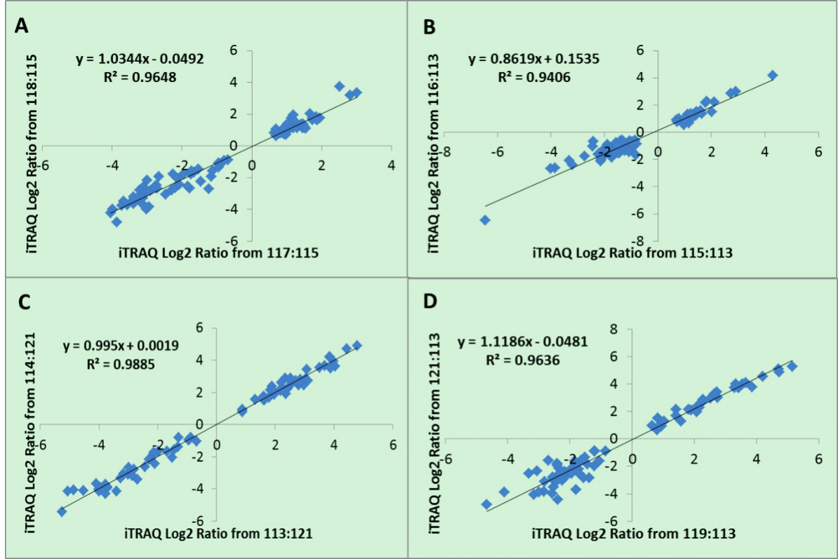

Figure S1. Correlation of iTRAQ Log2 Ratio of differential abundant proteins between two biological replicates in BJY: 117 and 118 for ED 12 (A, n = 92); 115 and 116 for ED 17 (B, n = 99); 113 and 114 for D 1 (C, n = 77); 119 and 121 for D 14 (D, n = 77).

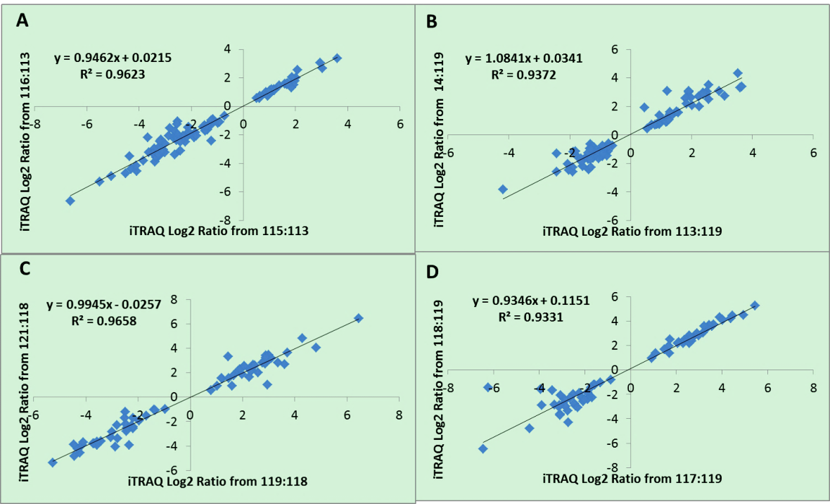
Figure S2. Correlation of iTRAQ Log2 Ratio of differential abundant proteins between two biological replicates in Cobb: 115 and 116 for ED 12 (A, n = 95); 113 and 114 for ED 17 (B, n = 92); 119 and 121 for D 1 (C, n = 68); 117 and 118 for D 14 (D, n = 68).

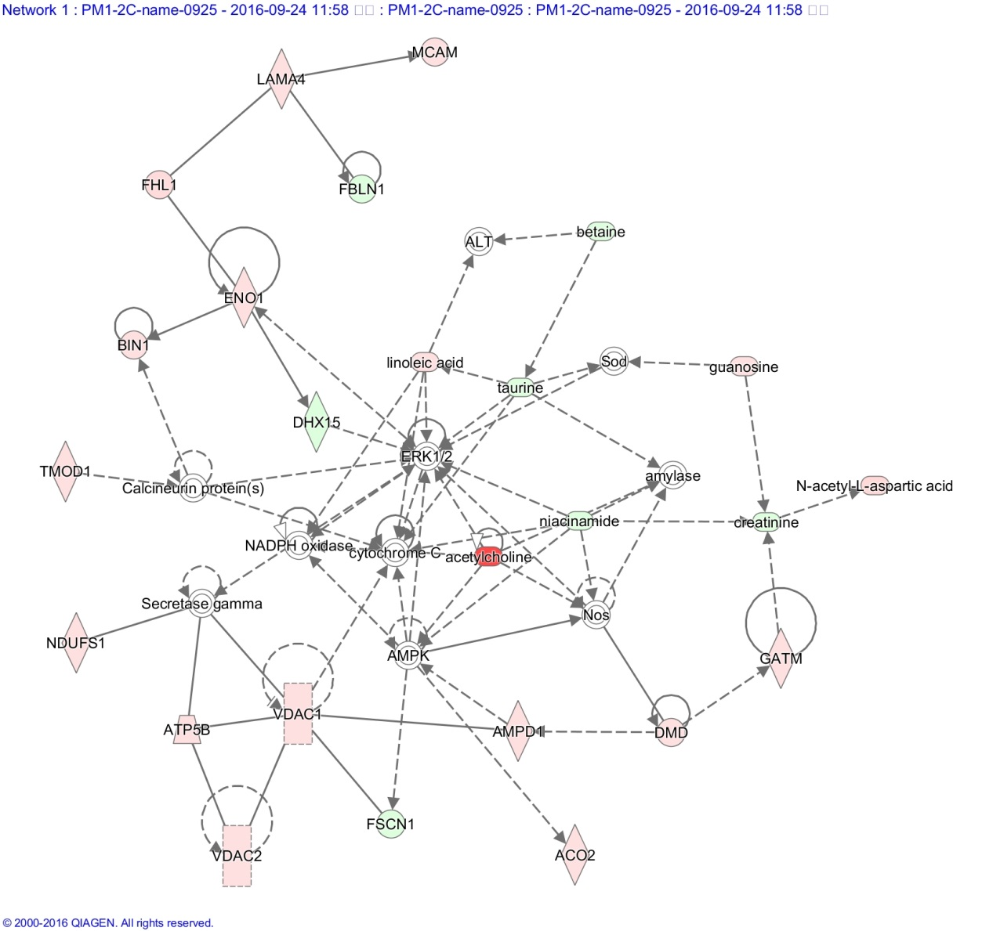
Figure S3. Top 1 significant network enriched by DA proteins and metabolites (from ED 12 – ED 17) related to Skeletal and Muscular Development in Cobb chickens. Red and green symbols show the up-regulated and down-regulated molecules found in the current study while white symbols indicate genes that are functionally associated.

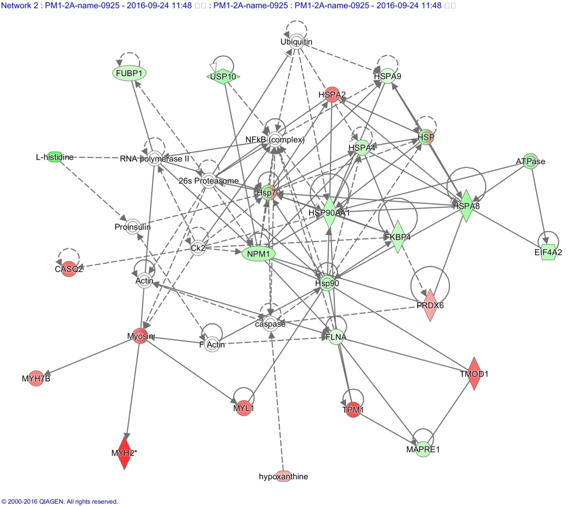

Figure S4. Top significant network enriched by DA proteins and metabolites (from ED 12 – ED 17) related to Protein Folding and Cell Morphology in BJY chickens. Red and green symbols show the up-regulated and down-regulated molecules found in the current study while white symbols indicate genes that are functionally associated.

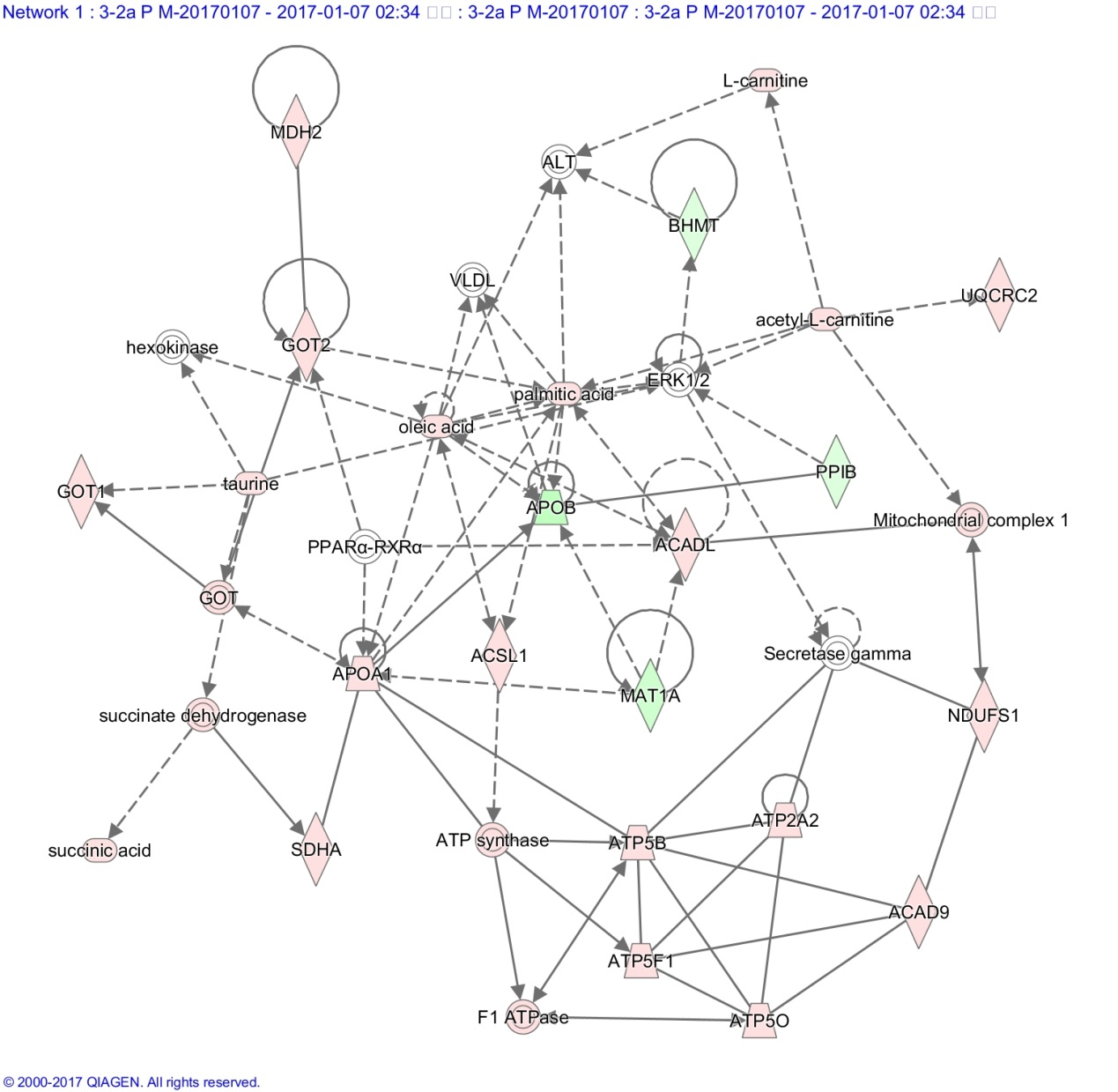

Figure S5. Top 1 Significant network (Top 1) enriched by DA proteins and metabolites (from ED 17 – D 1) related to Lipid Metabolism in BJY chickens. Red and green symbols show the up-regulated and down-regulated molecules found in the current study while white symbols indicate genes that are functionally associated.

