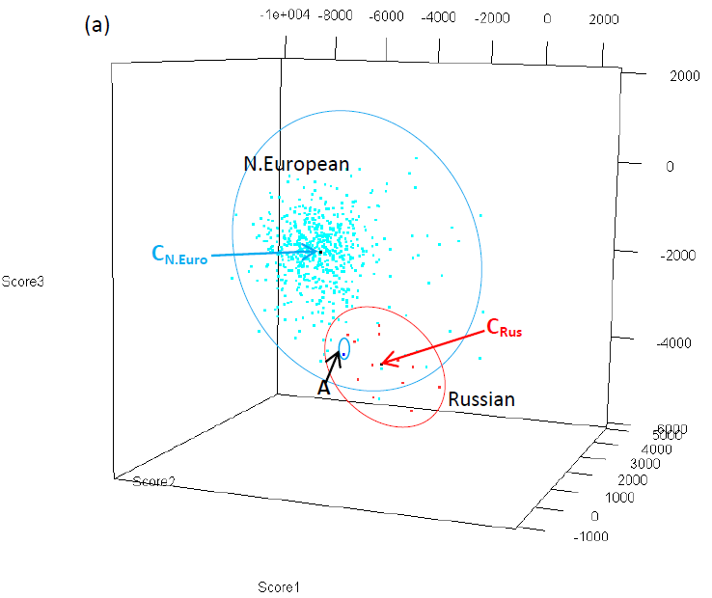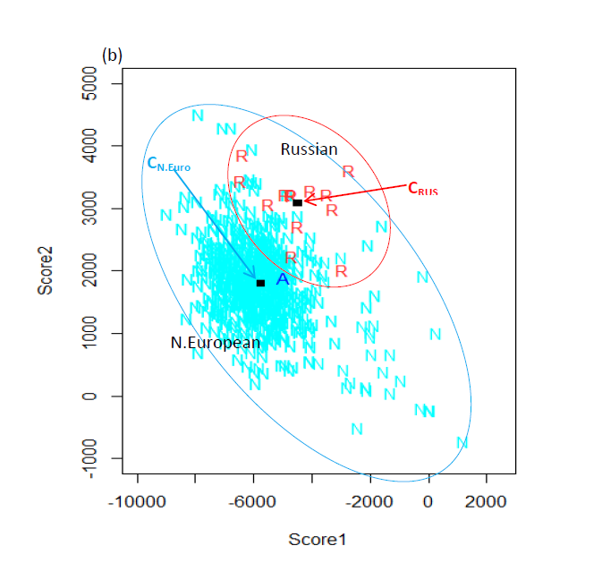
Supplementary Figure 1 C_{N.Euro} and C_{Rus} present centroid of known ancestry samples from Northern Europeans and Russians, respectively. (a) With the first three scores from PCA, individual A seems to be closer to Russian group on the proportion of total variance explained by eigenvalues. (b) In the two dimensional plot with the top two principal component scores, individual A seems to be closer to N. European.

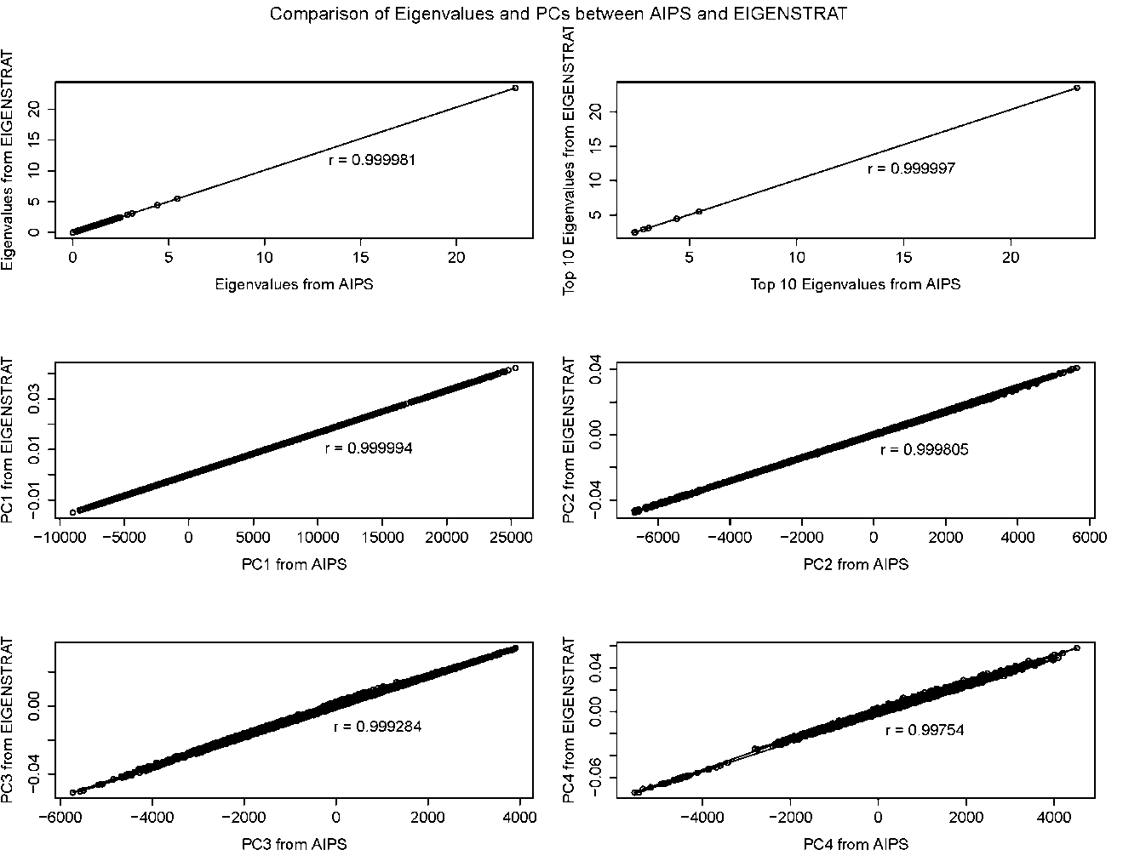
Supplementary Figure 2 Comparison of eigenvalues and top 3 principal components from AIPS and EIGENSTRAT. The options that were set in EIGENSTRAT were numoutlieriter=0;outliermode=2(no outlier removal) and in AIPS the option was method=eigen.

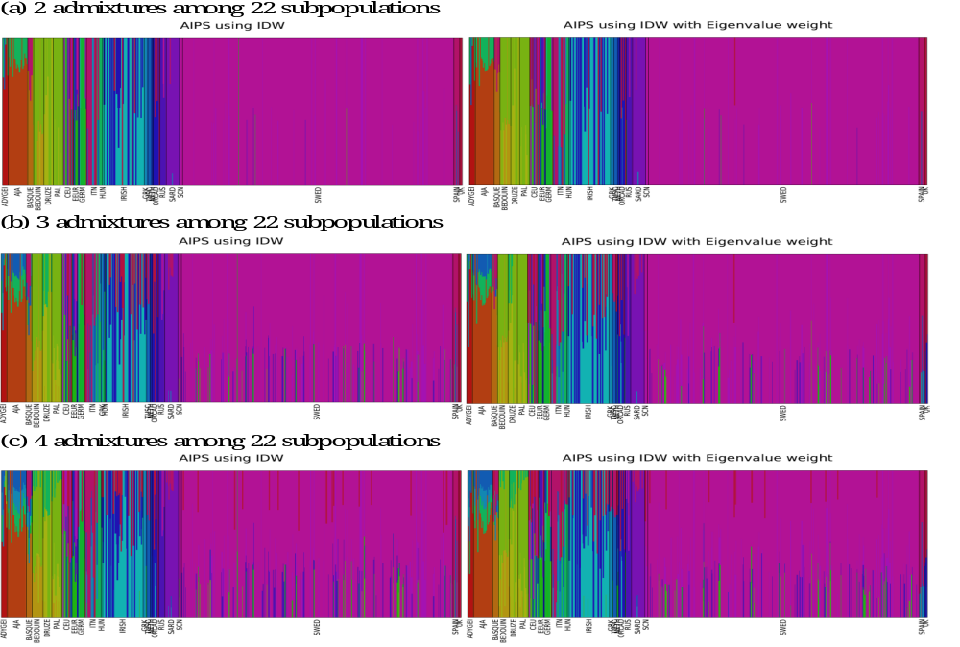
Supplementary Figure 3 Graphical Comparison of Population Structure using AIPS among 22 European subpopulations. Only 952 known ancestry individuals were used in 22 subpopulations within Europe. The scores from PCA were first calculated then Inverse-Distance Weighted Interpolation without and with eigenvalue weight were applied to infer the ancestry membership. The number of admixture indicated the definition of admixture in AIPS.

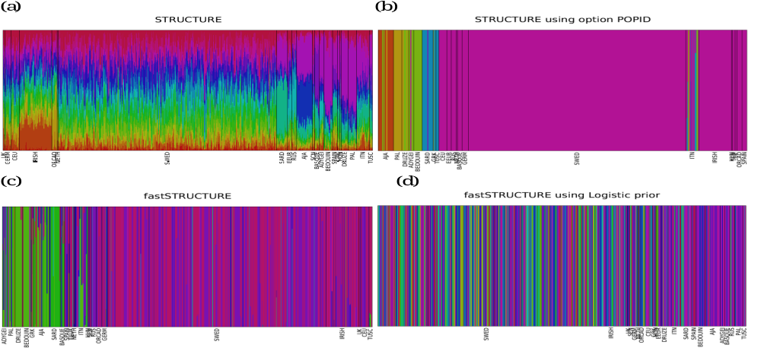
Supplementary Figure 4 Graphical Comparison of Population Structure using STRUCTURE and fastSTRUCTURE among 22 European subpopulations. The inferences of ancestry membership for 952 individuals were calculated by STRUCTURE and fastSTRUCTURE. (a) The prior population information was not given to compute inference of population membership using STRUCTURE. (b) To infer the population membership within 22 Europe countries, the prior population information was assigned in STRUCTURE. (c) fastSTRUCTURE was applied to infer 22 European subpopulations with simple model. (d) fastSTRUCTURE was used with logistic prior model.

Supplementary Table 1 Distance-based clustering among 952 known and 3,426 unknown ancestry Europeans on 25,732 AIMs
Population in 22 clusters | Population in 7 clusters | Sample Size | Centroid
Population in 22 clusters | Population in 7 clusters | Sample Size | Score1 | Score2 | Score3 | Score4 | Score5
Adygei | S. European | 12 | 11591.92 | -2212.24 | -2367.38 | 3223.757 | 3178.474
Ashkenazi Jewish American | Jews | 40 | 20169.72 | 3620.954 | 869.7979 | -161.391 | 60.11818
Basque | Basque | 12 | 1263.031 | -2406.59 | 1362.048 | -1732.34 | -2806.74
Bedouin | Arab | 22 | 22771.81 | -5744.59 | -2981.06 | 1286.952 | 4680.254
CEPH Euro American | Great Britain | 21 | -4322.12 | 535.2313 | -215.943 | -528.366 | 128.0176
Druze | Arab | 19 | 19996.68 | -5063.35 | -2398.69 | 851.0351 | 2978.709
Dutch American | N. European | 3 | -3075.48 | 298.3933 | -380.633 | -869.586 | 236.0964
Eastern Euro American | N. European | 11 | -2848.29 | 1565.323 | -3503.47 | 2265.713 | -1424.3
German American | N. European | 16 | -2300.78 | 471.317 | -995.442 | -102.679 | -525.496
Greek American | S. European | 7 | 12257.82 | -3692.28 | -1954.23 | 185.8735 | -361.976
Hungarian American | N. European | 3 | -283.938 | -75.1753 | -2410.01 | 1138.751 | -745.296
Irish | Great Britain | 84 | -4797.17 | -265.801 | 2563.482 | 1491.641 | 206.8548
Italian American | S. European | 33 | 9261.946 | -3387.1 | -806.009 | -511.316 | -517.197
Orcadian | Great Britain | 14 | -3996.66 | 203.2738 | 1032.663 | 190.5672 | 519.0328
Palestinian | Arab | 21 | 21550.08 | -5498.04 | -2865.19 | 994.4572 | 3831.989
Russian | Russian | 13 | -4478.12 | 3083.255 | -4533.56 | 3246.187 | -621.77
Sardinian | S. European | 28 | 10934.98 | -5847.51 | 342.1359 | -4488.94 | -4881.06
Scandinavian American | N. European | 6 | -5628.36 | 1615.751 | -1185.1 | -1006.6 | 892.1619
Spanish | S. European | 12 | 5432.036 | -2537 | 148.0293 | -841.74 | -1186.6
Swedish | N. European | 562 | -5946.41 | 1858.517 | -1849.93 | -843.028 | 788.9773
Tuscan | S. European | 8 | 8677.799 | -2981.94 | -820.659 | -474.701 | -605.715
United Kingdom American | Great Britain | 5 | -4176.13 | 241.1639 | 873.1527 | -124.392 | 401.243
Unknown* | Unknown* | 3,424 | . | . | . | . | .
*Note these samples from the New York Cancer Project and the Children’s Hospital of Philadelphia were self-identified as European.

Supplementary Table 2 Rank-based on Closeness among 22 European subpopulations
POP | R1 | R2 | R3 | R4 | R5 | R6 | R7 | R8 | R9 | R10 | R11 | R12 | R13 | R14 | R15 | R16 | R17 | R18 | R19 | R20 | R21 | R22
ADYGEI | ADYGEI | GRK | ITN | TUSC | SPAIN | DRUZE | PAL | AJA | BEDOUIN | SARD | HUN | BASQUE | GERM | UK | EEUR | NETH | ORCAD | CEU | RUS | IRISH | SCN | SWED
AJA | AJA | DRUZE | PAL | GRK | BEDOUIN | ADYGEI | ITN | TUSC | SARD | SPAIN | BASQUE | HUN | GERM | UK | NETH | EEUR | ORCAD | CEU | IRISH | RUS | SCN | SWED
BASQUE | BASQUE | SPAIN | UK | GERM | HUN | NETH | ORCAD | CEU | IRISH | TUSC | EEUR | ITN | SCN | SWED | SARD | RUS | GRK | ADYGEI | AJA | DRUZE | PAL | BEDOUIN
BEDOUIN | BEDOUIN | PAL | DRUZE | AJA | GRK | ADYGEI | ITN | TUSC | SARD | SPAIN | BASQUE | HUN | GERM | UK | NETH | EEUR | ORCAD | CEU | IRISH | RUS | SCN | SWED
DRUZE | DRUZE | PAL | BEDOUIN | GRK | ADYGEI | AJA | ITN | TUSC | SARD | SPAIN | BASQUE | HUN | GERM | UK | NETH | EEUR | ORCAD | CEU | IRISH | RUS | SCN | SWED
PAL | PAL | BEDOUIN | DRUZE | GRK | AJA | ADYGEI | ITN | TUSC | SARD | SPAIN | BASQUE | HUN | GERM | UK | NETH | EEUR | ORCAD | CEU | IRISH | RUS | SCN | SWED
CEU | CEU | NETH | ORCAD | UK | SCN | GERM | SWED | IRISH | EEUR | HUN | RUS | BASQUE | SPAIN | TUSC | ITN | ADYGEI | GRK | SARD | AJA | DRUZE | PAL | BEDOUIN
EEUR | EEUR | RUS | HUN | GERM | NETH | CEU | SWED | SCN | UK | ORCAD | IRISH | BASQUE | SPAIN | TUSC | ITN | ADYGEI | GRK | SARD | AJA | DRUZE | PAL | BEDOUIN
GERM | GERM | NETH | UK | CEU | HUN | ORCAD | EEUR | SCN | SWED | IRISH | BASQUE | RUS | SPAIN | TUSC | ITN | ADYGEI | GRK | SARD | AJA | DRUZE | PAL | BEDOUIN
GRK | GRK | ITN | TUSC | ADYGEI | SPAIN | SARD | DRUZE | PAL | AJA | BEDOUIN | BASQUE | HUN | GERM | UK | NETH | EEUR | ORCAD | CEU | IRISH | RUS | SCN | SWED
HUN | HUN | GERM | EEUR | NETH | UK | CEU | ORCAD | BASQUE | RUS | SCN | SWED | IRISH | SPAIN | TUSC | ITN | ADYGEI | GRK | SARD | AJA | DRUZE | PAL | BEDOUIN
IRISH | IRISH | ORCAD | UK | CEU | NETH | GERM | SCN | SWED | HUN | EEUR | BASQUE | RUS | SPAIN | TUSC | ITN | ADYGEI | GRK | SARD | AJA | DRUZE | PAL | BEDOUIN
ITN | ITN | TUSC | GRK | SPAIN | ADYGEI | SARD | BASQUE | HUN | DRUZE | GERM | UK | NETH | AJA | PAL | EEUR | ORCAD | CEU | BEDOUIN | IRISH | SCN | RUS | SWED
TUSC | TUSC | ITN | SPAIN | GRK | ADYGEI | SARD | BASQUE | HUN | GERM | UK | DRUZE | NETH | EEUR | ORCAD | AJA | CEU | PAL | IRISH | SCN | RUS | SWED | BEDOUIN
NETH | NETH | CEU | UK | GERM | ORCAD | SCN | SWED | HUN | IRISH | EEUR | BASQUE | RUS | SPAIN | TUSC | ITN | ADYGEI | GRK | SARD | AJA | DRUZE | PAL | BEDOUIN
ORCAD | ORCAD | UK | CEU | NETH | IRISH | GERM | SCN | SWED | HUN | EEUR | BASQUE | RUS | SPAIN | TUSC | ITN | ADYGEI | GRK | SARD | AJA | DRUZE | PAL | BEDOUIN
RUS | RUS | EEUR | SWED | SCN | GERM | HUN | CEU | NETH | ORCAD | UK | IRISH | BASQUE | SPAIN | TUSC | ITN | ADYGEI | GRK | SARD | AJA | DRUZE | PAL | BEDOUIN
SARD | SARD | ITN | TUSC | GRK | SPAIN | BASQUE | ADYGEI | DRUZE | HUN | AJA | PAL | GERM | UK | NETH | BEDOUIN | ORCAD | CEU | EEUR | IRISH | SCN | SWED | RUS
SCN | SCN | SWED | CEU | NETH | ORCAD | GERM | UK | IRISH | EEUR | RUS | HUN | BASQUE | SPAIN | TUSC | ITN | ADYGEI | GRK | SARD | AJA | DRUZE | PAL | BEDOUIN
SWED | SWED | SCN | CEU | NETH | ORCAD | GERM | UK | EEUR | RUS | IRISH | HUN | BASQUE | SPAIN | TUSC | ITN | ADYGEI | GRK | SARD | AJA | DRUZE | PAL | BEDOUIN
SPAIN | SPAIN | TUSC | ITN | BASQUE | HUN | GRK | SARD | GERM | UK | ADYGEI | NETH | ORCAD | CEU | EEUR | IRISH | SCN | SWED | RUS | DRUZE | AJA | PAL | BEDOUIN
UK | UK | ORCAD | NETH | CEU | GERM | IRISH | SCN | HUN | SWED | EEUR | BASQUE | RUS | SPAIN | TUSC | ITN | ADYGEI | GRK | SARD | AJA | DRUZE | PAL | BEDOUIN

Supplementary Table 3 Distance between two centroids among 22 European subpopulations
POP | ADYGEI | AJA | BASQUE | BEDOUIN | DRUZE | PAL | CEU | EEUR | GERM | GRK | HUN | IRISH | ITN | TUSC | NETH | ORCAD | RUS | SARD | SCN | SWED | SPAIN | UK
ADYGEI | 0.00 | 11800.87 | 13454.07 | 11993.97 | 9189.10 | 10752.09 | 16994.28 | 15689.89 | 15062.14 | 4956.20 | 12858.37 | 17564.90 | 6070.21 | 6282.39 | 15836.22 | 16633.08 | 17476.26 | 12058.67 | 18322.68 | 18619.12 | 8868.44 | 15556.99
AJA | 11800.87 | 0.00 | 20117.85 | 11522.03 | 9781.58 | 10703.65 | 24712.12 | 23691.21 | 22774.33 | 11151.41 | 21097.63 | 25378.63 | 13090.32 | 13381.39 | 23526.04 | 24414.25 | 25477.04 | 14776.80 | 25984.54 | 26335.36 | 15951.87 | 23279.15
BASQUE | 13454.07 | 20117.85 | 0.00 | 23617.98 | 20305.55 | 22147.06 | 7239.01 | 8616.91 | 5865.34 | 11966.30 | 5878.26 | 7888.68 | 8739.60 | 8154.88 | 6259.62 | 7024.77 | 11287.89 | 10877.80 | 9184.89 | 9706.03 | 4819.19 | 5741.88
BEDOUIN | 11993.97 | 11522.03 | 23617.98 | 0.00 | 3403.87 | 1540.47 | 28375.61 | 27355.38 | 26462.18 | 11935.22 | 24361.65 | 28997.60 | 14934.84 | 15555.87 | 27124.90 | 28045.49 | 29237.89 | 16611.27 | 29725.43 | 30058.26 | 18865.51 | 26847.97
DRUZE | 9189.10 | 9781.58 | 20305.55 | 3403.87 | 0.00 | 1888.19 | 25249.68 | 24257.90 | 23301.89 | 8577.81 | 21216.54 | 25893.55 | 11604.52 | 12229.21 | 23992.39 | 24933.54 | 26242.15 | 13436.66 | 26656.24 | 26998.68 | 15555.41 | 23707.84
PAL | 10752.09 | 10703.65 | 22147.06 | 1540.47 | 1888.19 | 0.00 | 26996.55 | 25977.14 | 25063.45 | 10424.80 | 22963.01 | 27647.86 | 13448.71 | 14073.04 | 25740.70 | 26682.24 | 27906.84 | 15134.50 | 28368.18 | 28702.48 | 17396.06 | 25468.21
CEU | 16994.28 | 24712.12 | 7239.01 | 28375.61 | 25249.68 | 26996.55 | 0.00 | 4925.19 | 2303.38 | 17220.16 | 5003.50 | 3560.84 | 14165.98 | 13500.86 | 1328.64 | 1563.65 | 6321.80 | 17737.13 | 2150.41 | 2755.92 | 10443.93 | 1984.02
EEUR | 15689.89 | 23691.21 | 8616.91 | 27355.38 | 24257.90 | 25977.14 | 4925.19 | 0.00 | 3768.87 | 16238.48 | 3491.97 | 6871.64 | 13674.60 | 12996.33 | 4898.59 | 5642.14 | 2761.46 | 17812.67 | 5401.91 | 5194.38 | 10497.20 | 5553.94
GERM | 15062.14 | 22774.33 | 5865.34 | 26462.18 | 23301.89 | 25063.45 | 2303.38 | 3768.87 | 0.00 | 15176.18 | 2820.89 | 4745.47 | 12197.85 | 11516.49 | 1475.25 | 2870.26 | 5941.71 | 15972.17 | 3904.39 | 4268.64 | 8547.77 | 2115.48
GRK | 4956.20 | 11151.41 | 11966.30 | 11935.22 | 8577.81 | 10424.80 | 17220.16 | 16238.48 | 15176.18 | 0.00 | 13101.13 | 18029.10 | 3300.92 | 3886.04 | 15968.14 | 17002.28 | 18495.50 | 7344.32 | 18753.18 | 19094.45 | 7238.55 | 15711.33
HUN | 12858.37 | 21097.63 | 5878.26 | 24361.65 | 21216.54 | 22963.01 | 5003.50 | 3491.97 | 2820.89 | 13101.13 | 0.00 | 6795.07 | 10365.34 | 9690.74 | 4128.86 | 5311.45 | 6044.12 | 14681.09 | 6340.95 | 6511.36 | 7118.64 | 4422.25
IRISH | 17564.90 | 25378.63 | 7888.68 | 28997.60 | 25893.55 | 27647.86 | 3560.84 | 6871.64 | 4745.47 | 18029.10 | 6795.07 | 0.00 | 14942.91 | 14315.39 | 4186.46 | 2234.95 | 8090.14 | 18580.75 | 4999.26 | 5576.87 | 11207.97 | 3226.06
ITN | 6070.21 | 13090.32 | 8739.60 | 14934.84 | 11604.52 | 13448.71 | 14165.98 | 13674.60 | 12197.85 | 3300.92 | 10365.34 | 14942.91 | 0.00 | 717.52 | 12910.15 | 13915.03 | 16083.47 | 6710.80 | 15783.80 | 16177.65 | 3995.36 | 12595.41
TUSC | 6282.39 | 13381.39 | 8154.88 | 15555.87 | 12229.21 | 14073.04 | 13500.86 | 12996.33 | 11516.49 | 3886.04 | 9690.74 | 14315.39 | 717.52 | 0.00 | 12245.73 | 13263.81 | 15410.84 | 7003.53 | 15115.11 | 15506.04 | 3374.18 | 11943.76
NETH | 15836.22 | 23526.04 | 6259.62 | 27124.90 | 23992.39 | 25740.70 | 1328.64 | 4898.59 | 1475.25 | 15968.14 | 4128.86 | 4186.46 | 12910.15 | 12245.73 | 0.00 | 2014.63 | 6681.52 | 16549.11 | 3057.47 | 3625.11 | 9218.57 | 1415.30
ORCAD | 16633.08 | 24414.25 | 7024.77 | 28045.49 | 24933.54 | 26682.24 | 1563.65 | 5642.14 | 2870.26 | 17002.28 | 5311.45 | 2234.95 | 13915.03 | 13263.81 | 2014.63 | 0.00 | 7081.34 | 17638.12 | 3338.79 | 3998.93 | 10181.19 | 1412.14
RUS | 17476.26 | 25477.04 | 11287.89 | 29237.89 | 26242.15 | 27906.84 | 6321.80 | 2761.46 | 5941.71 | 18495.50 | 6044.12 | 8090.14 | 16083.47 | 15410.84 | 6681.52 | 7081.34 | 0.00 | 20470.96 | 5921.78 | 5437.59 | 13073.49 | 7430.14
SARD | 12058.67 | 14776.80 | 10877.80 | 16611.27 | 13436.66 | 15134.50 | 17737.13 | 17812.67 | 15972.17 | 7344.32 | 14681.09 | 18580.75 | 6710.80 | 7003.53 | 16549.11 | 17638.12 | 20470.96 | 0.00 | 19437.66 | 19864.80 | 8165.72 | 16256.93
SCN | 18322.68 | 25984.54 | 9184.89 | 29725.43 | 26656.24 | 28368.18 | 2150.41 | 5401.91 | 3904.39 | 18753.18 | 6340.95 | 4999.26 | 15783.80 | 15115.11 | 3057.47 | 3338.79 | 5921.78 | 19437.66 | 0.00 | 799.83 | 12192.59 | 4015.94
SWED | 18619.12 | 26335.36 | 9706.03 | 30058.26 | 26998.68 | 28702.48 | 2755.92 | 5194.38 | 4268.64 | 19094.45 | 6511.36 | 5576.87 | 16177.65 | 15506.04 | 3625.11 | 3998.93 | 5437.59 | 19864.80 | 799.83 | 0.00 | 12636.41 | 4658.84
SPAIN | 8868.44 | 15951.87 | 4819.19 | 18865.51 | 15555.41 | 17396.06 | 10443.93 | 10497.20 | 8547.77 | 7238.55 | 7118.64 | 11207.97 | 3995.36 | 3374.18 | 9218.57 | 10181.19 | 13073.49 | 8165.72 | 12192.59 | 12636.41 | 0.00 | 8833.55
UK | 15556.99 | 23279.15 | 5741.88 | 26847.97 | 23707.84 | 25468.21 | 1984.02 | 5553.94 | 2115.48 | 15711.33 | 4422.25 | 3226.06 | 12595.41 | 11943.76 | 1415.30 | 1412.14 | 7430.14 | 16256.93 | 4015.94 | 4658.84 | 8833.55 | 0.00

Supplementary Table 4 The Average Percent of Correctly Inferred Proportions from AIPS and ADMIXTURE without Population Information
AIPS | ADYGEI | AJA_NS | BASQUE | BEDOUIN | DRUZE | PAL | CEU | EEUR | GERM | GRK | HUN | IRISH | ITN | TUSC | NETH | ORCAD | RUS | SARD | SCN | SWED | SPAIN | UK
ADYGEI | 0.81 | 0.00 | 0.00 | 0.00 | 0.00 | 0.00 | 0.00 | 0.00 | 0.00 | 0.10 | 0.00 | 0.00 | 0.05 | 0.03 | 0.00 | 0.00 | 0.00 | 0.00 | 0.00 | 0.00 | 0.00 | 0.00
AJA_NS | 0.00 | 0.89 | 0.00 | 0.00 | 0.04 | 0.02 | 0.00 | 0.00 | 0.00 | 0.05 | 0.00 | 0.00 | 0.00 | 0.00 | 0.00 | 0.00 | 0.00 | 0.00 | 0.00 | 0.00 | 0.00 | 0.00
BASQUE | 0.00 | 0.00 | 0.82 | 0.00 | 0.00 | 0.00 | 0.00 | 0.00 | 0.03 | 0.00 | 0.04 | 0.00 | 0.00 | 0.00 | 0.00 | 0.00 | 0.00 | 0.00 | 0.00 | 0.00 | 0.11 | 0.00
BEDOUIN | 0.00 | 0.00 | 0.00 | 0.76 | 0.09 | 0.14 | 0.00 | 0.00 | 0.00 | 0.00 | 0.00 | 0.00 | 0.00 | 0.00 | 0.00 | 0.00 | 0.00 | 0.00 | 0.00 | 0.00 | 0.00 | 0.00
DRUZE | 0.00 | 0.00 | 0.00 | 0.04 | 0.78 | 0.17 | 0.00 | 0.00 | 0.00 | 0.02 | 0.00 | 0.00 | 0.00 | 0.00 | 0.00 | 0.00 | 0.00 | 0.00 | 0.00 | 0.00 | 0.00 | 0.00
PAL | 0.00 | 0.00 | 0.00 | 0.14 | 0.14 | 0.72 | 0.00 | 0.00 | 0.00 | 0.00 | 0.00 | 0.00 | 0.00 | 0.00 | 0.00 | 0.00 | 0.00 | 0.00 | 0.00 | 0.00 | 0.00 | 0.00
CEU | 0.00 | 0.00 | 0.00 | 0.00 | 0.00 | 0.00 | 0.34 | 0.00 | 0.10 | 0.00 | 0.00 | 0.00 | 0.00 | 0.00 | 0.17 | 0.02 | 0.00 | 0.00 | 0.11 | 0.09 | 0.00 | 0.19
EEUR | 0.00 | 0.00 | 0.00 | 0.00 | 0.00 | 0.00 | 0.02 | 0.58 | 0.03 | 0.00 | 0.17 | 0.00 | 0.00 | 0.00 | 0.00 | 0.00 | 0.18 | 0.00 | 0.00 | 0.02 | 0.00 | 0.00
GERM | 0.00 | 0.00 | 0.03 | 0.00 | 0.00 | 0.00 | 0.15 | 0.05 | 0.51 | 0.00 | 0.12 | 0.00 | 0.00 | 0.00 | 0.11 | 0.00 | 0.00 | 0.00 | 0.00 | 0.00 | 0.00 | 0.02
GRK | 0.00 | 0.00 | 0.00 | 0.00 | 0.19 | 0.00 | 0.00 | 0.00 | 0.00 | 0.43 | 0.00 | 0.00 | 0.20 | 0.18 | 0.00 | 0.00 | 0.00 | 0.00 | 0.00 | 0.00 | 0.00 | 0.00
HUN | 0.00 | 0.00 | 0.00 | 0.00 | 0.00 | 0.00 | 0.00 | 0.16 | 0.10 | 0.00 | 0.66 | 0.00 | 0.00 | 0.00 | 0.08 | 0.00 | 0.00 | 0.00 | 0.00 | 0.00 | 0.00 | 0.00
IRISH | 0.00 | 0.00 | 0.00 | 0.00 | 0.00 | 0.00 | 0.00 | 0.00 | 0.00 | 0.00 | 0.00 | 0.83 | 0.00 | 0.00 | 0.00 | 0.08 | 0.00 | 0.00 | 0.00 | 0.00 | 0.00 | 0.09
ITN | 0.00 | 0.00 | 0.01 | 0.00 | 0.02 | 0.00 | 0.00 | 0.00 | 0.00 | 0.33 | 0.00 | 0.00 | 0.18 | 0.20 | 0.00 | 0.03 | 0.00 | 0.00 | 0.00 | 0.00 | 0.24 | 0.00
TUSC | 0.00 | 0.00 | 0.00 | 0.00 | 0.00 | 0.00 | 0.00 | 0.00 | 0.00 | 0.07 | 0.00 | 0.00 | 0.21 | 0.60 | 0.00 | 0.00 | 0.00 | 0.00 | 0.00 | 0.00 | 0.11 | 0.00
NETH | 0.00 | 0.00 | 0.00 | 0.00 | 0.00 | 0.00 | 0.33 | 0.00 | 0.00 | 0.00 | 0.00 | 0.00 | 0.00 | 0.00 | 0.67 | 0.00 | 0.00 | 0.00 | 0.00 | 0.00 | 0.00 | 0.00
ORCAD | 0.00 | 0.00 | 0.00 | 0.00 | 0.00 | 0.00 | 0.02 | 0.00 | 0.00 | 0.00 | 0.00 | 0.03 | 0.00 | 0.00 | 0.09 | 0.66 | 0.00 | 0.00 | 0.00 | 0.00 | 0.00 | 0.21
RUS | 0.00 | 0.00 | 0.00 | 0.00 | 0.00 | 0.00 | 0.00 | 0.10 | 0.00 | 0.00 | 0.04 | 0.00 | 0.00 | 0.00 | 0.00 | 0.00 | 0.81 | 0.00 | 0.00 | 0.05 | 0.00 | 0.00
SARD | 0.00 | 0.00 | 0.00 | 0.00 | 0.00 | 0.00 | 0.00 | 0.00 | 0.00 | 0.02 | 0.00 | 0.00 | 0.07 | 0.04 | 0.00 | 0.00 | 0.00 | 0.87 | 0.00 | 0.00 | 0.00 | 0.00
SCN | 0.00 | 0.00 | 0.00 | 0.00 | 0.00 | 0.00 | 0.17 | 0.00 | 0.00 | 0.00 | 0.00 | 0.00 | 0.00 | 0.00 | 0.00 | 0.00 | 0.00 | 0.00 | 0.67 | 0.17 | 0.00 | 0.00
SWED | 0.00 | 0.00 | 0.00 | 0.00 | 0.00 | 0.00 | 0.09 | 0.00 | 0.01 | 0.00 | 0.00 | 0.00 | 0.00 | 0.00 | 0.00 | 0.00 | 0.01 | 0.00 | 0.30 | 0.59 | 0.00 | 0.00
SPAIN | 0.00 | 0.00 | 0.16 | 0.00 | 0.00 | 0.00 | 0.00 | 0.00 | 0.00 | 0.00 | 0.02 | 0.00 | 0.01 | 0.22 | 0.00 | 0.00 | 0.00 | 0.00 | 0.00 | 0.00 | 0.60 | 0.00
UK | 0.00 | 0.00 | 0.00 | 0.00 | 0.00 | 0.00 | 0.09 | 0.00 | 0.00 | 0.00 | 0.00 | 0.08 | 0.00 | 0.00 | 0.10 | 0.17 | 0.00 | 0.00 | 0.00 | 0.00 | 0.00 | 0.56
UNKNOWN | 0.00 | 0.09 | 0.03 | 0.00 | 0.01 | 0.00 | 0.04 | 0.02 | 0.14 | 0.05 | 0.09 | 0.08 | 0.02 | 0.04 | 0.11 | 0.08 | 0.00 | 0.00 | 0.01 | 0.00 | 0.09 | 0.09

ADMIXTURE | POP1 | POP2 | POP3 | POP4 | POP5 | POP6 | POP7 | POP8 | POP9 | POP10 | POP11 | POP12 | POP13 | POP14 | POP15 | POP16 | POP17 | POP18 | POP19 | POP20 | POP21 | POP22
ADYGEI | 0.03 | 0.30 | 0.10 | 0.02 | 0.02 | 0.02 | 0.00 | 0.01 | 0.12 | 0.01 | 0.04 | 0.07 | 0.06 | 0.02 | 0.02 | 0.01 | 0.01 | 0.01 | 0.01 | 0.03 | 0.07 | 0.03
AJA_NS | 0.01 | 0.03 | 0.03 | 0.03 | 0.02 | 0.43 | 0.02 | 0.04 | 0.04 | 0.04 | 0.02 | 0.01 | 0.03 | 0.02 | 0.04 | 0.03 | 0.03 | 0.03 | 0.02 | 0.04 | 0.01 | 0.02
BASQUE | 0.00 | 0.00 | 0.01 | 0.01 | 0.01 | 0.01 | 0.21 | 0.01 | 0.01 | 0.07 | 0.07 | 0.04 | 0.01 | 0.13 | 0.02 | 0.04 | 0.01 | 0.13 | 0.05 | 0.01 | 0.01 | 0.15
BEDOUIN | 0.02 | 0.29 | 0.00 | 0.01 | 0.33 | 0.03 | 0.04 | 0.01 | 0.00 | 0.01 | 0.01 | 0.02 | 0.08 | 0.01 | 0.03 | 0.01 | 0.01 | 0.02 | 0.01 | 0.05 | 0.00 | 0.02
DRUZE | 0.01 | 0.24 | 0.03 | 0.02 | 0.08 | 0.04 | 0.06 | 0.02 | 0.04 | 0.01 | 0.01 | 0.01 | 0.29 | 0.03 | 0.02 | 0.00 | 0.01 | 0.02 | 0.01 | 0.02 | 0.00 | 0.01
PAL | 0.02 | 0.37 | 0.02 | 0.03 | 0.13 | 0.03 | 0.05 | 0.02 | 0.02 | 0.02 | 0.03 | 0.02 | 0.07 | 0.02 | 0.01 | 0.03 | 0.04 | 0.02 | 0.01 | 0.03 | 0.01 | 0.02
CEU | 0.09 | 0.02 | 0.05 | 0.07 | 0.01 | 0.01 | 0.02 | 0.05 | 0.04 | 0.07 | 0.06 | 0.04 | 0.02 | 0.05 | 0.05 | 0.06 | 0.05 | 0.04 | 0.06 | 0.05 | 0.03 | 0.06
EEUR | 0.04 | 0.03 | 0.04 | 0.02 | 0.02 | 0.02 | 0.03 | 0.04 | 0.04 | 0.06 | 0.03 | 0.03 | 0.03 | 0.02 | 0.04 | 0.05 | 0.05 | 0.07 | 0.04 | 0.03 | 0.25 | 0.02
GERM | 0.05 | 0.02 | 0.04 | 0.04 | 0.02 | 0.02 | 0.03 | 0.06 | 0.05 | 0.04 | 0.05 | 0.02 | 0.02 | 0.06 | 0.06 | 0.05 | 0.05 | 0.05 | 0.07 | 0.07 | 0.08 | 0.04
GRK | 0.01 | 0.20 | 0.03 | 0.04 | 0.03 | 0.03 | 0.15 | 0.07 | 0.07 | 0.05 | 0.02 | 0.01 | 0.05 | 0.02 | 0.01 | 0.02 | 0.03 | 0.03 | 0.04 | 0.03 | 0.04 | 0.02
HUN | 0.04 | 0.06 | 0.02 | 0.10 | 0.05 | 0.01 | 0.04 | 0.06 | 0.01 | 0.04 | 0.05 | 0.03 | 0.03 | 0.04 | 0.03 | 0.03 | 0.05 | 0.03 | 0.03 | 0.04 | 0.15 | 0.05
IRISH | 0.01 | 0.01 | 0.05 | 0.05 | 0.02 | 0.01 | 0.01 | 0.05 | 0.04 | 0.05 | 0.07 | 0.19 | 0.02 | 0.04 | 0.06 | 0.05 | 0.05 | 0.05 | 0.04 | 0.04 | 0.02 | 0.05
ITN | 0.01 | 0.14 | 0.04 | 0.03 | 0.04 | 0.02 | 0.15 | 0.04 | 0.05 | 0.04 | 0.03 | 0.01 | 0.04 | 0.04 | 0.03 | 0.05 | 0.04 | 0.05 | 0.03 | 0.03 | 0.02 | 0.05
TUSC | 0.01 | 0.13 | 0.03 | 0.01 | 0.04 | 0.03 | 0.14 | 0.05 | 0.03 | 0.05 | 0.04 | 0.01 | 0.04 | 0.06 | 0.04 | 0.06 | 0.05 | 0.04 | 0.04 | 0.03 | 0.03 | 0.06
NETH | 0.07 | 0.04 | 0.08 | 0.05 | 0.01 | 0.01 | 0.02 | 0.07 | 0.03 | 0.07 | 0.02 | 0.02 | 0.01 | 0.04 | 0.07 | 0.03 | 0.01 | 0.07 | 0.09 | 0.12 | 0.02 | 0.05
ORCAD | 0.07 | 0.02 | 0.04 | 0.04 | 0.02 | 0.01 | 0.01 | 0.03 | 0.04 | 0.03 | 0.04 | 0.11 | 0.02 | 0.08 | 0.04 | 0.04 | 0.07 | 0.07 | 0.03 | 0.09 | 0.01 | 0.07
RUS | 0.08 | 0.03 | 0.05 | 0.03 | 0.02 | 0.02 | 0.00 | 0.01 | 0.04 | 0.05 | 0.04 | 0.03 | 0.02 | 0.05 | 0.04 | 0.03 | 0.04 | 0.03 | 0.04 | 0.02 | 0.31 | 0.01
SARD | 0.02 | 0.01 | 0.02 | 0.02 | 0.02 | 0.01 | 0.56 | 0.03 | 0.01 | 0.02 | 0.01 | 0.02 | 0.02 | 0.02 | 0.02 | 0.03 | 0.04 | 0.02 | 0.02 | 0.05 | 0.00 | 0.03
SCN | 0.17 | 0.01 | 0.08 | 0.04 | 0.03 | 0.01 | 0.02 | 0.05 | 0.05 | 0.05 | 0.05 | 0.03 | 0.01 | 0.05 | 0.06 | 0.05 | 0.01 | 0.06 | 0.05 | 0.04 | 0.03 | 0.06
SWED | 0.18 | 0.01 | 0.05 | 0.05 | 0.02 | 0.01 | 0.02 | 0.05 | 0.04 | 0.05 | 0.05 | 0.02 | 0.02 | 0.04 | 0.05 | 0.04 | 0.04 | 0.04 | 0.06 | 0.05 | 0.05 | 0.04
SPAIN | 0.01 | 0.06 | 0.04 | 0.03 | 0.04 | 0.03 | 0.17 | 0.01 | 0.05 | 0.05 | 0.05 | 0.03 | 0.04 | 0.06 | 0.04 | 0.04 | 0.06 | 0.05 | 0.03 | 0.04 | 0.02 | 0.07
UK | 0.07 | 0.03 | 0.06 | 0.04 | 0.02 | 0.01 | 0.03 | 0.06 | 0.04 | 0.03 | 0.09 | 0.09 | 0.01 | 0.02 | 0.04 | 0.07 | 0.06 | 0.04 | 0.05 | 0.06 | 0.02 | 0.05
UNKNOWN | 0.04 | 0.05 | 0.05 | 0.05 | 0.03 | 0.07 | 0.05 | 0.05 | 0.04 | 0.05 | 0.05 | 0.06 | 0.03 | 0.05 | 0.05 | 0.05 | 0.05 | 0.05 | 0.05 | 0.04 | 0.04 | 0.04

