Table S5. The TFs binding sites predicted by JASPAR database.
ID | Name | Species¹ | Class | Sequence logo
MA0162.1 | Egr1 | 10090 | Zinc-coordinating | 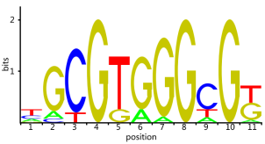
MA0162.2 | EGR1 | 9606 | C2H2 zinc finger factors | 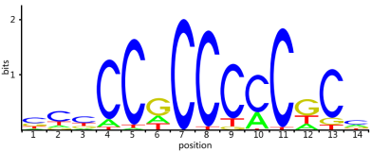
PB0010.1 | Egr1-1 | 10090 | Zinc-coordinating | 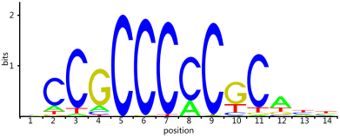
PB0114.1 | Egr1-2 | 10090 | Zinc-coordinating | 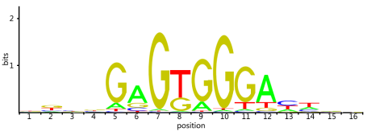
MA0617.1 | Id2 | 10090 | Basic helix-loop-helix factors (bHLH) | 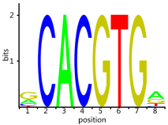
MA0599.1 | KLF5 | 9606 | C2H2 zinc finger factors | 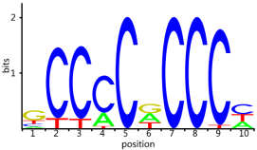
MA0664.1 | MLXIPL | 9606 | Basic helix-loop-helix factors (bHLH) | 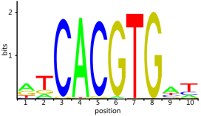
MA0596.1 | SREBF2 | 9606 | Basic helix-loop-helix factors (bHLH) | 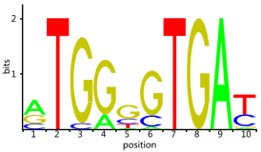
MA0828.1 | SREBF2 | 9606 | Basic helix-loop-helix factors (bHLH) | 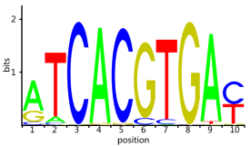
MA0595.1 | SREBF1 | 9606 | Basic helix-loop-helix factors (bHLH) | 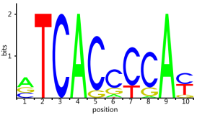
MA0829.1 | Srebf1 | 10090 | Basic helix-loop-helix factors (bHLH) | 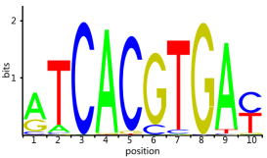
MA0106.1 | TP53 | 9606 | Zinc-coordinating | 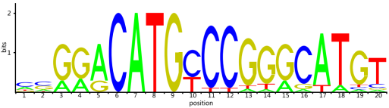
MA0106.2 | TP53 | 9606 | Zinc-coordinating | 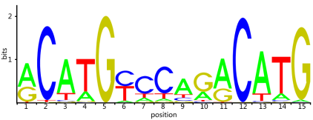
MA0106.3 | TP53 | 9606 | p53 domain factors | 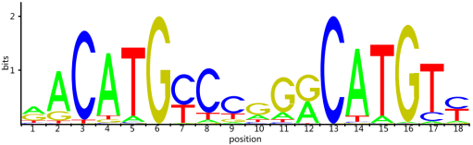
¹Species: The species based on predicted transcription factor binding sites. The 10090 and 9606 represent Mus musculus and Homo sapiens, respectively.

