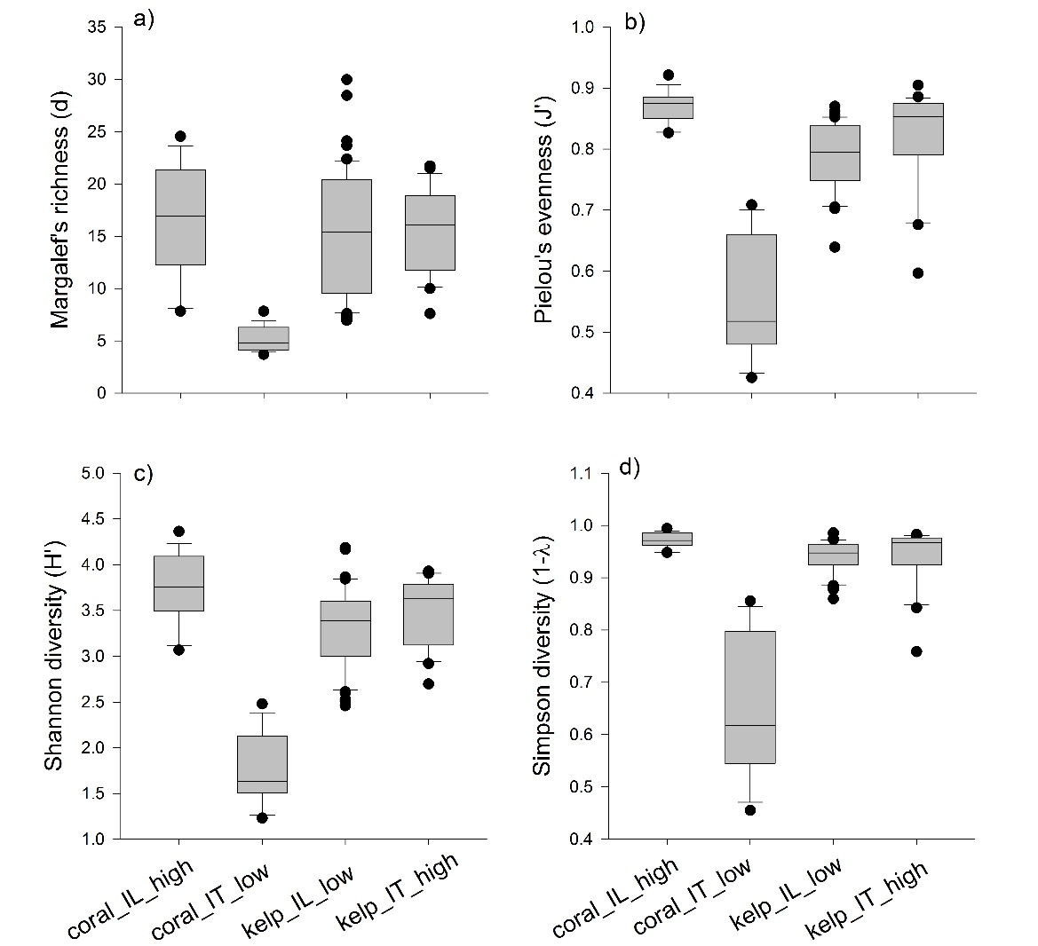
Supplementary Figure 1. Representation of microbial diversity using, (a) genus richness, (b) genus evenness, (c) Shannon diversity, and (d) Simpson diversity of the four projects, which are represented on the x axis. The box represents 50 % of the data ranges around the median. The outliers for each case are represented as black dots.

