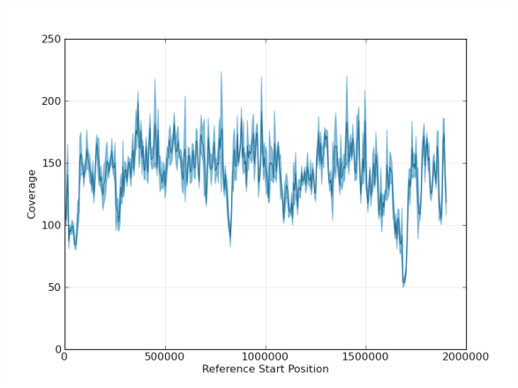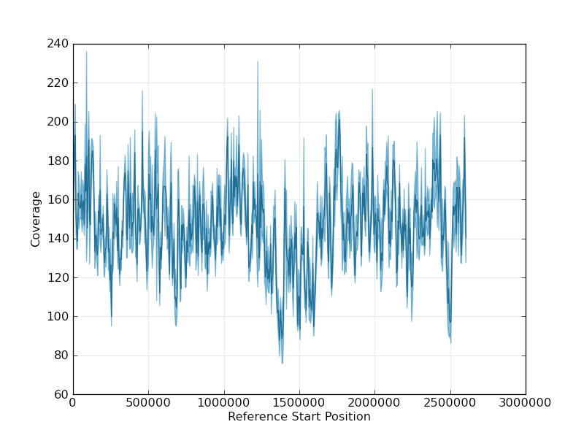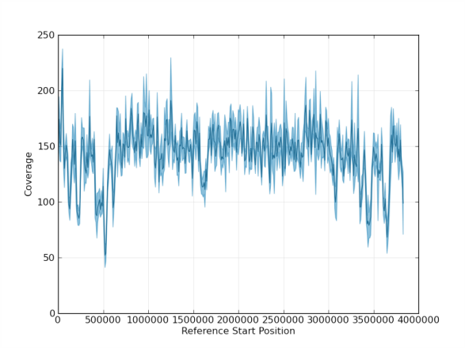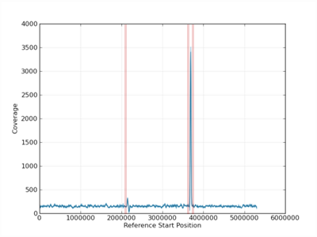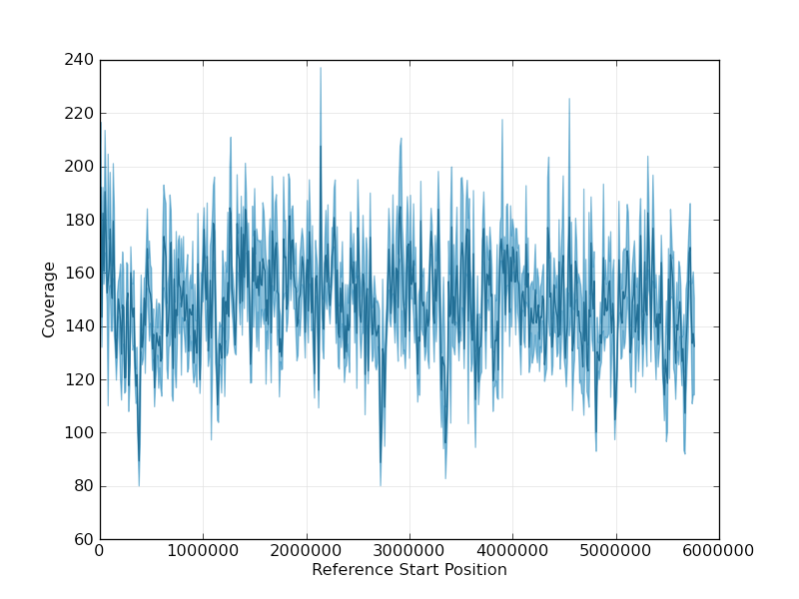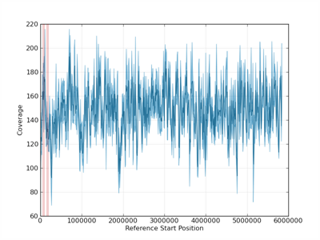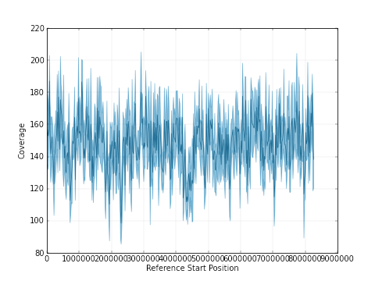
GD
F
E
D
C
B
A
Figure S1: Coverage across chromosomes from SMRT analysis resequencing protocol assembly. A. Chromosome I, B. Chromosome II, C. Chromosome III, D. Chromosome IV, E. Chromosome V, F. Chromosome VI, G. Chromosome VII. Areas where chromosomes were manually assembled, based on sequence homology are shown by the regions highlighted in pink (D, F). Chromosomes shown in A, B, C, E, and G were assembled in whole from telomere to telomere prior the manual curation and resequencing protocol.

