Figure S3. Expression profiles of ADAR and APOBEC enzymes in HBE cells infected with H1N1.
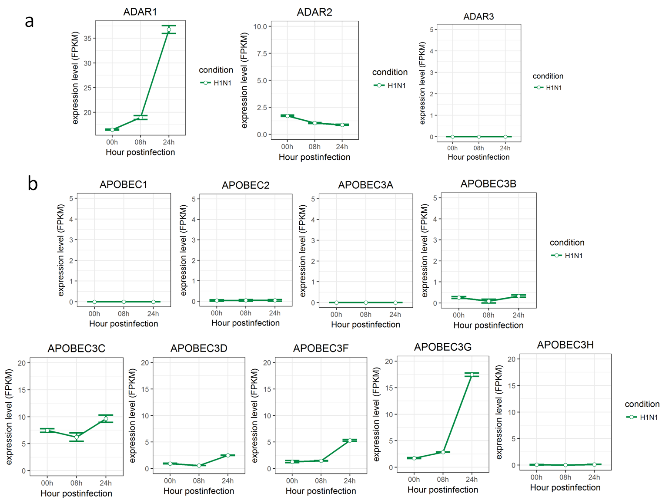

Figure S4. Expression profiles of Pattern Recognition Receptors in HBE cells infected with H1N1.

