Additional file 1:
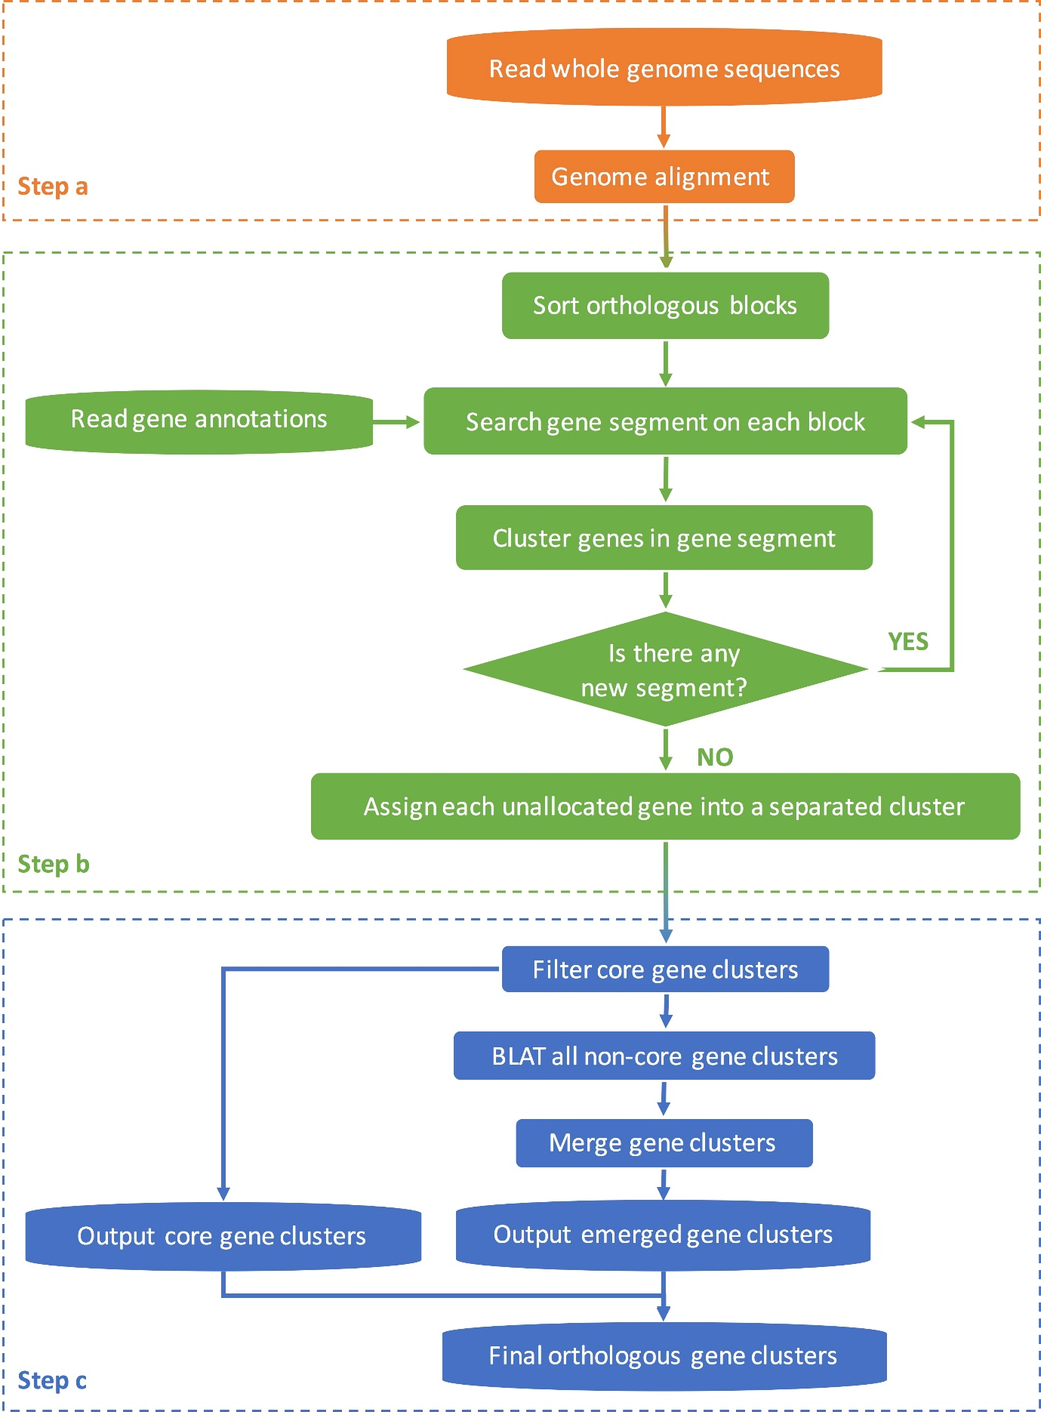

Fig. S1: The flowchart for the strategy of ortholog identification.

