Additional file 3:
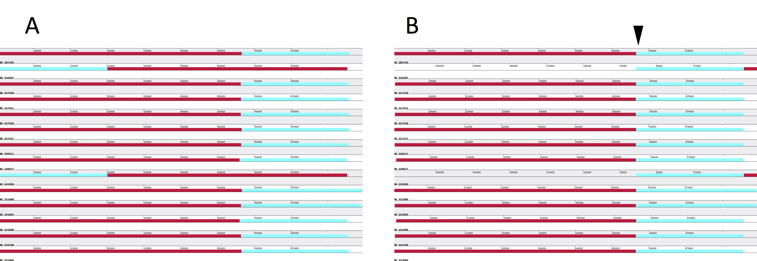

Fig. S2: The whole genome alignment result among 14 C. trachomatis strains.
(A) is the default alignment result data, and (B) is the re-aligned results based on the center of the clicked sites. Colored blocks are different homologous genomic fragment regions in each strain, and all DNA genomic fragments are marked with the same color with the corresponding homologous genomic fragment regions in other strains. Blocks below the center line indicate that regions are aligned in the reverse complement orientation (inversion).

