Additional file 6:
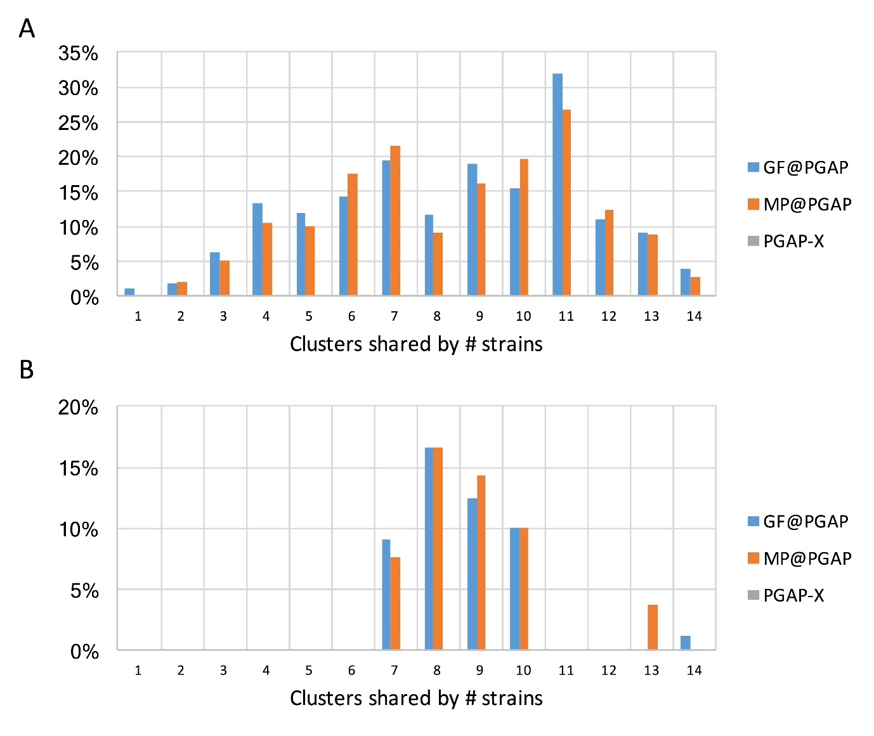
Fig. S3: Percentage of orthologous clusters with paralogs among orthologous clusters from PGAP-X and PAGP (MP and GF). A and B show the results from 14 S. pneumonia strains and 14 C. trachomatis strains respectively. MP (using the option --method MP to clustering orthologous genes) and GF (using the option --method GF to clustering orthologous genes) methods in PGAP are presented as GF@PGAP and MP@PGAP.

